Prenatal exposure levels of polybrominated diphenyl ethers in mother-infant pairs and their transplacental transfer characteristics in Uganda (East Africa)

Patrick Ssebugere, DSc, Makerere University, Uganda

Henry Matovu, MSc, Gulu University, Uganda

Abstract

Polybrominated diphenyl ethers (PBDEs) are ubiquitous environmental pollutants with adverse effects on the fetus and infants. The aim of the present study was to assess in utero exposure levels and transplacental transfer characteristics of BDE congeners in mothers from Kampala capital city, Uganda. Paired human samples (thirty placenta and twenty nine cord blood samples) were collected from mothers at St. Francis Hospital Nsambya between April and June, 2018 and analysed for a suite of 24 tri- to deca-BDE congeners. Extraction was carried out using liquid-liquid extraction and sonication for cord blood and placenta samples, respectively. Clean-up was done on a solid phase (SPE) column and analysis was performed using gas chromatography/mass spectrometer (GC/MS). Total (∑) PBDEs were 0.25-30.9 ng/g lipid weight (lw), (median; 7.11 ng/g lw) in the placenta and 1.65-34.5 ng/g lw (median; 11.9 ng/g lw) in cord blood serum. Statistical analysis showed no significant difference between the levels of PBDEs in cord blood and placenta samples (Wilcoxon signed rank test: Z = -0.433, p = 0.665), possibly due to poor xenophobic metabolism by the fetus. BDE-209 was the dominant congener in both matrices (contributed 40.5% and 51.2% to ∑PBDEs in placenta and cord blood, respectively), suggesting on-going maternal exposure to deca-BDE formulation. No apparent correlation was observed between BDE congeners and meat consumption probably due to multiple sources of PBDEs. Based on absolute concentrations, the extent of transplacental transport (TPT) was high for higher congeners (BDE-209, 206 and 207) than for lower ones (such as BDE-47) suggesting alternative TPT mechanisms besides passive diffusion.

Image
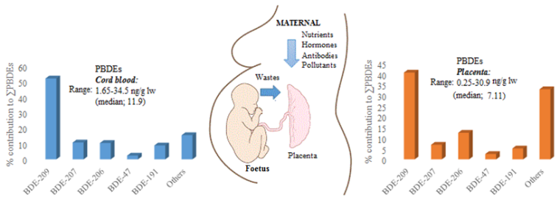
Recent Publications
- Chen Z-J, Liu H-Y, Cheng Z, Man Y-B, Zhang K-S, Wei W, . . . Wang, H-S (2014). Polybrominated diphenyl ethers (PBDEs) in human samples of mother–newborn pairs in South China and their placental transfer characteristics. Environment international 73:77-84.
- Costa LG, Giordano G (2007). Developmental neurotoxicity of polybrominated diphenyl ether (PBDE) flame retardants. Neuro Toxicology 28(6):1047-1067. Room R, BaborT, Rehm J (2005) Alcohol and public health. Lancet 365: 519-530.
- Matovu H, Sillanpää M, Ssebugere P (2019). Polybrominated diphenyl ethers in mothers' breast milk and associated health risk to nursing infants in Uganda. Science of the Total Environment, 692:1106-1115.
- Müller M, Polder A, Brynildsrud O, Lie E, Løken K, Manyilizu W., . . . Nonga H (2016). Brominated flame retardants (BFRs) in breast milk and associated health risks to nursing infants in Northern Tanzania. Environment international 89:38-47.
- Ssebugere P, Sillanpää M, Matovu H, Mubiru E (2019). Human and environmental exposure to PCDD/Fs and dioxin-like PCBs in Africa: A review. Chemosphere, 223, 483-493.


Biography (150 word limit)
Patrick Ssebugere completed his D.Sc in Green Chemical Technology from Lappeenranta University of Technology in 2015. He is a Lecturer of Physical Chemistry at the Department of Chemistry, School of Physical Sciences, Makerere University. He has published more than 17 papers in reputed journals and has supervised more than 8 master’s students to completion. His research group is involved in modeling and risk assessment of organic pollutants in the tropics. The group is also studying the prevalence and fate of organic chemical contaminants in the environment, their sources and climate change-energy-public health nexus and sustainability of ecosystems.

Email: ssebugere@cns.mak.ac.ug

