Synthetic cannabinoids-ethyl esters: new biomarkers of concomitant ethanol/synthetic cannabinoid abuse?
Dr Abbate, Vincenzo PhD, King’s College London, UK

Abstract (300 word limit)
Statement of the Problem: Synthetic cannabinoids (SCs) represent the most widely abused class of novel psychoactive substances and have caused a number of fatal and non-fatal intoxications. Polydrug use including combination of SCs and ethanol misuse is also quite common. However, there have been no reports presenting evidence of transesterification between SCs and ethanol in vitro or in-vivo. Methodology & Theoretical Orientation: The in vitro metabolism of the several carboxylate SCs in the presence of ethanol using human liver microsomes with and without appropriate enzyme inhibitors was studied. Newly identified SC ethyl esters were chemically synthesised and fully characterised. The activity of these SCs and their ethanol transesterification products were assessed using cannabinoid receptor (CB1 and CB2) activation assays. Findings: SCs/ethanol transesterification products were detected and studied using liquid chromatography–high-resolution mass spectrometry. We have shown that the SC ethyl ester formation is mediated by human carboxyl esterase enzymes. However, for certain SCs, chemical transesterification was also observed. Selected ethyl esters exhibited a reduced activity for the CB receptors compared with their parent compounds. Conclusion & Significance: These novel ethyl esters may be useful additional markers of SCs/ethanol concomitant administration, and especially so if they prove to have longer half-lives than their parent compounds. Clinical and forensic laboratories should screen for the potential presence of these new potential markers during toxicological analyses.
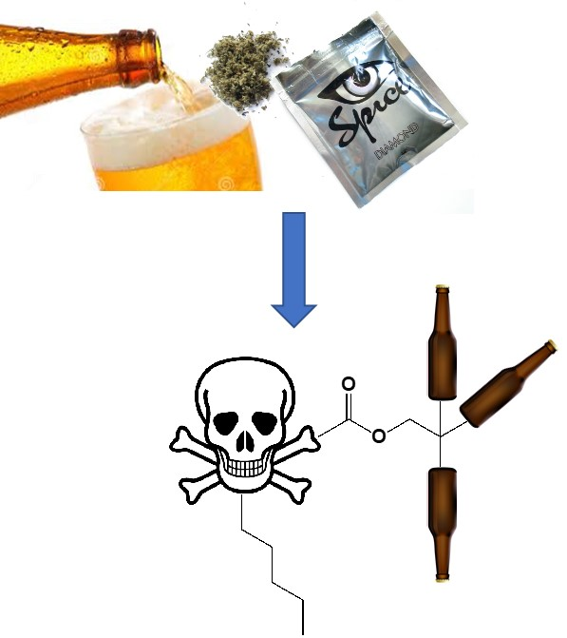
Recent Publications
- Evidence of enzyme-mediated transesterification of synthetic cannabinoids with ethanol: potential toxicological impact. Apirakkan, O., Gavrilovic, I., Floresta, G., Pierre, C., Cannaert, A., Stove, C., Dargan, P. I., Cowan, D. A., Couchman, L. & Abbate, V., 13 Jul 2019, In : Forensic Toxicology.
- Structure-based approach for the prediction of mu-opioid binding affnity of unclassified designer fentanyl-like molecules. Floresta, G., Rescifina, A. & Abbate, V., 10 May 2019, In : International Journal of Molecular Sciences. 20, 9, 2311.
- Stability of mephedrone and five of its phase I metabolites in human whole blood. Czerwinska, J., Parkin, M. C., Dargan, P. I., George, C., Kicman, A. T. & Abbate, V., 20 Oct 2018, In : Drug Testing And Analysis.
- The ongoing challenge of novel psychoactive drugs of abuse. Part I. Synthetic cannabinoids (IUPAC Technical Report). Abbate, V., Schwenk, M., Presley, B. & Uchiyama, N., 28 Aug 2018, In : PURE AND APPLIED CHEMISTRY. 90, 8
5. Discovery of High-Affinity Cannabinoid Receptors Ligands through a 3D-QSAR Ushered by Scaffold-Hopping Analysis/ Floresta, G., Apirakkan, O., Rescifina, A. & Abbate, V., 2018, In : Molecules (Basel, Switzerland).
6. Analytical characterization of three cathinone derivatives, 4-MPD, 4 F-PHP and bk-EPDP, purchased as bulk powder from online vendors. Apirakkan, O., Frinculescu, A., Shine, T., Parkin, M. C., Cilibrizzi, A., Frascione, N. & Abbate, V., 18 Jul 2017, In : Drug Testing And Analysis.

Photograph


Biography
Dr Vincenzo Abbate completed his Pharm. D. in 2004 at Federico II University of Naples (Italy). He then moved to the UK to undertake a PhD in Chemistry and Analytical Sciences at The Open University. In 2008 he was awarded a prestigious Maplethorpe Fellowship of the University of London for the promotion of teaching and research in the pharmaceutical area. Abbate is currently a Senior Lecturer in Analytical Toxicology within King’s Forensics at King’s College London (UK), where he leads the Analytical Toxicology research group and serves as Director of the Analytical Toxicology MSc programme. Abbate is a Titular Member of the IUPAC Division of Chemistry and Human Health and the Chair of the IUPAC Subcommittee on Toxicology and Risk Assessmen. He is member of the RSC, ACS, SOT, BTS and TIAFT, a Chartered Chemist (CChem) and Chartered Scientist (CSci) and is author/co-author of over 50 peer-reviewed publications.
Email: vincenzo.abbate@kcl.ac.uk

Notes/Comments:

