The role of apiaqupuncture therapy, royal jelly and honey bee’s bread on a woman with left breast cancer – A case therapy

Prof. Dr. C.P Abdolrasoul Aleezaadeh
Full Professor (An International Faculty) in: Brooklyn Central University – the U.S.A
Associate Professor (An Expert Faculty) in: Green Lake and, Pacific Albion Universities – the U.S.A
Assistant Professor in: U.A.S.T / P.N.U Universities – I.R. of Iran
Clinic 112, Sofia, Bulgaria (http://clinic112.com/aleezaadeh)
Doctor Base, a Kareo (Platform) Company, Berlin Area, Germany

Abstract
Statement of the Problem:
Based on the breast anatomy, each breast contains 15 to 20 lobes of glandular tissue, arranged like the petals of a daisy. The lobes are further divided into smaller lobules that produce milk for breast-feeding. Small tubes (ducts) conduct the milk to a reservoir that lies just beneath women nipple. Also, Breast cancer is cancer that develops from breast tissue. Signs of breast cancer may include a lump in the breast, a change in breast shape, dimpling of the skin, and fluid coming from the nipple, a newly inverted nipple or, a red or scaly patch of skin. In those with distant spread of the disease, there may be bone pain, swollen lymph nodes, shortness of breath, or yellow skin.
Based on her laboratory pathology analysis sampling – both in macroscopic and, microscopic laboratory pathology report - after taking about 3670 honey bee stings – or, bee venom therapy – in a 4 month period and, fluid coming – like clotted milk – from the left nipple; plus 1 tsp. royal jelly, in the morning; 30 mins. before having breakfast and, 2 tsp. 5 mins. after taking royal jelly; there was occur good prognosis in the malignant lymph nodes edema. It must be tell that this case was a candidate for mastectomy and, its chemotherapy after it.

Image
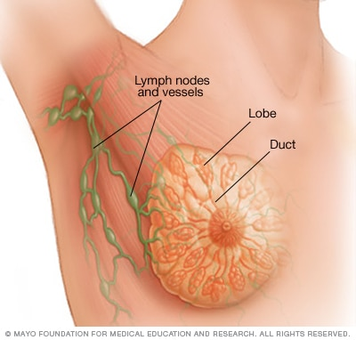
Recent Publications
Please, visit the below items in the internet:
- Prof. Dr. C.P C.P.Eng P.M.E A. Aleezaadeh P.M C.P.M
- Prof. Dr. C.P Abdolrasoul Aleezaadeh
- Dr. Abdolrasoul Aleezaadeh
- www.clinic112.com/aleezaadeh
- And, so on.

Photograph

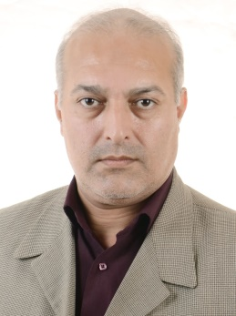

Biography
Prof. Dr. C.P Abdolrasoul Aleezaadeh completed his Post Doctorate in (Psychology) at Approach of: Applied Clinical Cognitive Neuropsychology from USA. Prof. Dr. Aleezaadeh Completed his PhD Degrees in Psychology at the USA. He completed his master's Degree in Clinical Psychology at I. R. of the IRAN and bachelor's Degree in General Psychology at I. R. of the IRAN. He is Full Expert International Faculty Professorship Member in the Brooklyn Central University, the USA, Associate Expert International Faculty Professorship Member in the University of Pacific Albion, the USA and, Associate Expert International Faculty Professorship Member in the Green Lake (GreenLake) University, the USA. Now he is working as an Assistant Professor at P.N.U and, U.A.S.T Universities; I.R. of IRAN.

Research Interest (s)
Cognitive Sciences, Cognitive Neurosciences, Neuroimaging, Applied Clinical Neuropsychology, Brain ( Cranial ) Imaging, Traditional Medicine, Homeopathic Medicine and, Combination of Medical And, Psychological trends for eradicating illnesses / sicknesses, Psychology, Cognitive Neuropsychology/Neurosciences
Email: abdolrasoul_alizadeh@yahoo.com and, abdolrasoul.aleezaadeh@gmail.com

Notes/Comments:

