Stem cell therapy for the treatment of severe tissue damage after radiation exposure
A Chapel¹, A Semont¹, N Mathieu¹, C Linard¹, L Douay², NC Gorin², M Mothy², JM Simmon³, H Rouard², JJ Lataillade⁴, J Voswinkel³, and M Benderitter¹
1 Radiological Protection and Human Health Division, Institute of Radiological Protection and Nuclear Safety, Fontenay-aux-Roses, France
2 Department of Hematology, Saint Antoine Hospital APHP and UPMC University, UMRS 938, Paris, France;
3 Department of Radiation Oncology, Pitie-Salpetriere University Hospital, Paris, France;
4 Blood Transfusion Center of Army, Percy Military Hospital, Clamart, France

Abstract
The late adverse effects of pelvic radiotherapy concern 5 to 10% of them, which could be life threatening. However, a clear medical consensus concerning the clinical management of such healthy tissue sequelae does not exist. Our group has demonstrated in preclinical animal models that systemic MSC injection is a promise approach for the medical management of gastrointestinal disorder after irradiation. We have shown that MSC migrate to damaged tissues and restore gut functions after irradiation.
The clinical status of four first patients suffering from severe pelvic side effects resulting from an over-dosage was improved following MSC injection in a compassional situation. A quantity of 2x106 - 6x106 MSC /kg were infused intravenously to the patients. Pain, hemorrhage, frequency of diarrheas and fistulisation as well as the lymphocyte subsets in peripheral blood were evaluated before MSC therapy and during the follow-up. Two patients revealed a substantiated clinical response for pain and hemorrhage after MSC therapy. In one patient pain reappeared after 6 months and again substantially responded on a second MSC infusion. A beginning fistulisation process could be stopped in one patient resulting in a stable remission for more than 3 years of follow-up. The frequency of painful diarrhea diminished from an average of 6/d to 3/d after the first and 2/d after the 2nd MSC injection in one patient. In all patients, prostate cancer remained in stable complete remission. A modulation of the lymphocyte subsets towards a regulatory pattern and diminution of activated T cells accompanies the clinical response in refractory irradiation-induced colitis. No toxicity occurred.
MSC therapy was safe and effective on pain, diarrhea, haemorrhage, inflammation, fibrosis and limited fistulisation. For patients with refractory chronic inflammatory and fistulising bowel diseases, systemic MSC injections represent a safe option for salvage therapy. A clinical phase II trial will start in 2017.

Image
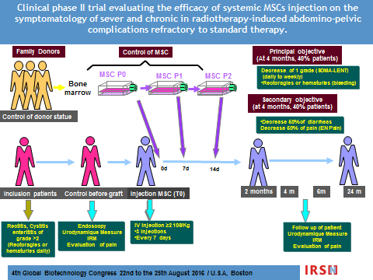
Recent Publications (minimum 5)
- Management of fibrosis: the mesenchymal stromal cells breakthrough. Usunier B, Benderitter M, Tamarat R, Chapel A. Stem Cells Int. 2014;2014:340257. 2.806 Impact Factor
- Generation of Multipotent Early Lymphoid Progenitors from Human Embryonic Stem Cells. Larbi A, Mitjavila-Garcia MT, Flamant S, Valogne Y, Clay D, Usunier B, l'Homme B, Féraud O, Casal I, Gobbo E, Divers D, Chapel A, Turhan AG, Bennaceur-Griscelli A, Haddad R. Stem Cells Dev. 2014 Jul 29. 4.202 Impact Factor
- Long-Term Quantitative Biodistribution and Side Effects of Human Mesenchymal Stem Cells (hMSCs) Engraftment in NOD/SCID Mice following Irradiation. François S, Usunier B, Douay L, Benderitter M, Chapel A. Stem Cells Int. 2014; 2014: 939275. 2.806 Impact Factor
- Innovative cell therapy in the treatment of serious adverse events related to both chemo-radiotherapy protocol and acute myeloid leukemia syndrome: the infusion of mesenchymal stem cells post-treatment reduces hematopoietic toxicity and promotes hematopoietic reconstitution. Fouillard L, Francois S, Bouchet S, Bensidhoum M, Elm'selmi A, Chapel A. Curr Pharm Biotechnol. 2014 Oct; 14(9): 842-8. 3,40 Impact Factor
- Stem cell therapies for the treatment of radiation-induced normal tissue side effects. Benderitter M, Caviggioli F, Chapel A, Coppes RP, Guha C, Klinger M, Malard O, Stewart F, Tamarat R, Luijk PV, Limoli CL. Antioxid Redox Signal. 2014 Jul 10;21(2):338-55.8,20 Impact Factor

 Biography (150 word limit)
For 25 years, he has been developing gene and cell therapy using non-human primates, immune-tolerant mice and rats to protect against the side effects of radiation. He collaborates with clinicians to develop strategies for treatment of patients after radiotherapy overexposures. He has participated in the first establishment of proof of concept of the therapeutic efficacy of Mesenchymal stem cells (MSCs) for the treatment of hematopoietic deficit, radio-dermatitis and over dosages of radiotherapy. He has contributed to the first reported correction of deficient hematopoiesis in patients (graft failure and aplastic anemia) thanks to intravenous injection of MSCs restoring the bone marrow microenvironment, mandatory to sustain hematopoiesis after total body irradiation. He is scientific investigator of Clinical phase II trial evaluating the efficacy of systemic MSC injections for the treatment of severe and chronic radiotherapy-induced abdomino-pelvic complications refractory to standard therapy (NCT02814864Hirsch Index 26
Email: alain.chapel@irsn.fr

