Selected microenvironmental and material factors deciding about scaffold efficienc
Dorota Kolbuk-Konieczny, Piotr Denis, Olga Urbanek, Oliwia Jeznach; Institute of Fundamental Technological Reserach, PAS, Poland

Abstract
The quality of life of millions of patients has been greatly improved by the development and deployment of permanent implants in the clinical setting such as total knee joint prostheses, cardiovascular stents and breast implants, as well as medical devices including plates, screws and nails, and artificial organs [1-3]. The global regenerative medicine market is expected to reach USD 38.70 Billion by 2021 from USD 13.41 in 2016 [4].
In general, all developed materials needs to be biocompatible, nontoxic, and fulfil properties suitable for specific application. Additionally, scaffold for different tissue regeneration need to fulfil different chemical and mechanical requirements. It is because of differences in microenvironmental stimuli between regenerated tissues types.
The aim of this presentation is to show the literature background as well as selected research done in the topic of crucial factors in scaffold development for regenerative medicine.
Main tasks of our group as well as literature about scaffolds requirements dedicated to various tissue types regeneration will be presented. Fundamental research investigations about materials development, structural and surface properties in terms of material-cells interaction will be analysed. The second field of our interest are grafts for knee repair (ligaments, bone and cartilage). In this last interest, specific needs e.g.: mechanical, surface, biological properties and degradation conditions are investigated and some results will be shown during presentation.

Image
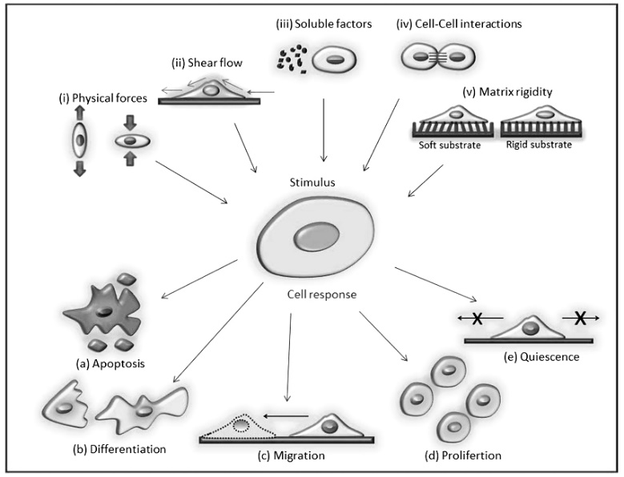
Figure 1. Scheme showing the different factors of cells stimuli in vitro [5].
Recent publications
- Lysaght, M. J., & Tsui, J. (1999). Observations: Risk, reason, and regulation in contemporary medical devices. ASAIO journal, 45(3), 226-228..
- Jagur‐Grodzinski, J. (2006). Polymers for tissue engineering, medical devices, and regenerative medicine. Concise general review of recent studies. Polymers for advanced technologies, 17(6), 395-418.
- Hutmacher, D. W. (2006). Regenerative medicine will impact, but not replace, the medical device industry. Expert review of medical devices, 3(4), 409-412.
- Global Regenerative Medicine Market Analysis & Forecast to 2022; Stem Cells, Tissue Engineering, BioBanking & CAR-T Industries (2018) WiseGuyReports.Com Publish
- Unal, M., Alapan, Y., Jia, H., et.al. (2014). Micro and nano-scale technologies for cell mechanics. Nanobiomedicine, 1(Godište 2014), 1-5

Biography

Dr Dorota Kołbuk-Konieczny is an alumna of Materials Science and Engineering Department at Warsaw University of Technology (PL), doctoral studies at the Institute of Fundamental Technological Research of the Polish Academy of Sciences (PL), the Socrates-Erasmus Program (ILK, DE), the SCIEX Program (EMPA St. Gallen, CH) and Top 500 Innovators Program (UK).
Her professional research currently focuses on the molecular structure of polymers/biopolymers and scaffold development for ligament, cartilage and bone regeneration. She has held several training courses on technology transfer, preclinical research and medical devices regulation, research management and commercialization. Her scientific results have been presented at several international conferences and published in reputable scientific journals..
email:dorotakolbuk@gmail.com

Notes/Comments:

