Abstract Template
Abstract Title: Comparative study of regenerative effects of mesenchymal stem cells derived from placental amnion, chorion and umbilical cord on dermal wounds.

Tuca AC1, Wurzer P1, Kamolz LP2, Lang I3.

1 Division of Plastic, Aesthetic and Reconstructive Surgery, Department of Surgery, Medical University of Graz, Austria
2 Division of Plastic, Aesthetic and Reconstructive Surgery, Department of Surgery, Medical University of Graz, Austria and COREMED- Cooperative Centre for Regenerative Medicine, Joanneum Research Forschungsgesellschaft mbH, Graz, Austria
3 Department of Cell Biology, Histology and Embryology, Gottfried Schatz Research Center, Medical University, Graz, Austria

Abstract (not more than 300 words)

OBJECTIVE:
Mesenchymal stem/stromal cells derived from human term placentas (PMSCs) are novel therapeutic agents and more topical than ever. Here we evaluated the effects of three types of PMSCs on wound healing in an in vivo mouse model: Amnion-derived MSCs (AMSCs), blood vessel-derived MSCs (BV-MSCs) from the chorionic plate and Wharton's jelly-derived MSCs (WJ-MSCs) from the umbilical cord.

METHODS:
We topically applied PMSCs onto skin wounds in mice using the dermal substitute Matriderm® as carrier and evaluated wound healing parameters. In addition, we investigated the effects of all PMSC types under co-application with placental endothelial cells (PLECs). After 8 days, we compared the percent of wound closure and the angiogenic potential between all groups.

RESULTS:
AMSCs, BV-MSCs and WJ-MSCs significantly induced a faster healing and a higher number of blood vessels in the wound when compared to controls (Matriderm®-alone). PLECs did not further improve the advantageous effects of PMSC-treatment. Quantitative data and 3D analysis by high resolution episcopic microscopy confirmed a lower density of vessels in Matriderm®/PMSCs/PLECs co-application compared to Matriderm®/PMSCs treatment.

CONCLUSION:
Results indicate that all three PMSC types exert similar beneficial effects on wound closure and neovascularization in our mouse model.

PRACTICE:
Using Matriderm® as carrier for PMSCs propagates rapid cell migration towards the wound area that allows a fast and clinically practicable method for stem cell application.

IMPLICATIONS:
These promising effects warrant further investigation in clinical trials.
These instructions give you guidelines for preparing papers for conference. Use this document as a template if you are using Microsoft Word. Otherwise, use this document as an instruction set. Define all symbols used in the abstract. Do not cite references in the abstract. Insert images/graphs if any.

Keywords—Skin, Stem cells, wound healing, wounds;

Professional Biography (100-150 words)
Lars-Peter Kamolz has studied Medicine at the University of Vienna, Medical School, Vienna, Austria (M.D.). Moreover, he has studied Quality and Process-Management at the Department for Knowledge and Communication Management at Danube University in Krems, Austria (M.Sc.). He is a Board-Certified Plastic, Aesthetic and Reconstructive Surgeon (ÖGPÄRC). In 2012, he became Professor for Plastic, Aesthetic and Reconstructive Surgery at the Division of Plastic, Aesthetic and Reconstructive Surgery, Department of Surgery, Medical University of Graz and Head of the Division of Plastic, Aesthetic and Reconstructive Surgery, Department of Surgery, Medical University of Graz, Austria. Furthermore, he is the Head of the Research Unit for Safety in Health and Deputy Chief Medical Officer of the LKH-University Hospital in Graz. Since 2018 he is also the Director of COREMED- Cooperative Centre for Regenerative Medicine, Joanneum Research Forschungsgesellschaft mbH, Graz, Austria.

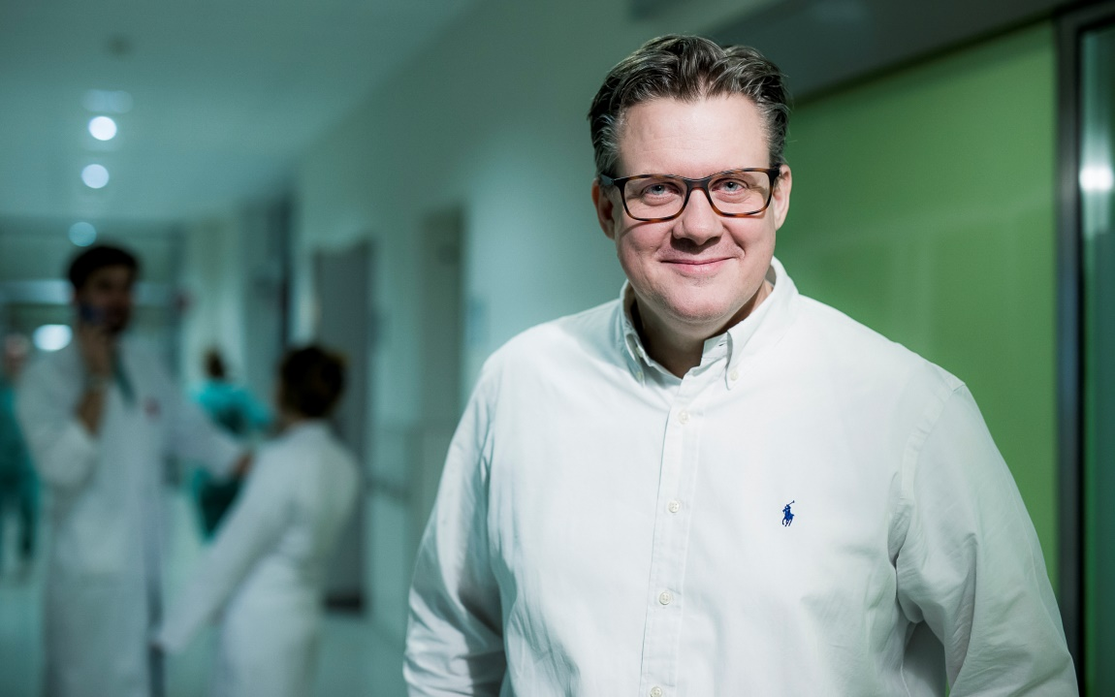
Email Id: lars.kamolz@medunigraz.at

Any Comments:

