Multidrug-Resistant Tuberculosis in Portugal: patients’ perception of the challenges faced during treatment

Marcela Bhering, MSc, School of Medicine, Federal University of Rio de Janeiro, Rio de Janeiro, Brazil
Vicente Sarubbi Junior, School of Medicine, Mato Grosso do Sul State University, Mato Grosso do Sul, Brazil
Afrânio Kritski, PhD, School of Medicine, Federal University of Rio de Janeiro, Rio de Janeiro, Brazil
Fabiana Assumpção, PhD, School of Nursing, Federal University of Rio de Janeiro State, Rio de Janeiro, Brazil
Raquel Duarte, PhD, EPIUnit, Public Health Institute, University of Porto, Porto, Portugal

Abstract

Introduction: The increase in drug-resistant TB threatens global progress on the elimination of TB, and constitutes a major challenge for patients, health care workers and health care services. Treatment for multidrug-resistant tuberculosis (MDR-TB) can last almost two years, being more expensive, more toxic, and less effective than TB with drug-sensitive bacilli. This study aims to analyze patients’ narratives about the challenges they face during the MDR-TB treatment and identify the support factors that help patients during their treatment in the most populous district of Portugal. Methods: Semi-structured interviews were conducted with patients under multidrug-resistant tuberculosis treatment. The interviews were coded using thematic analysis. They were audio-recorded, transcribed, and transported into NVivo version 12, for data management and coding. Results: The results revealed that depression, social discrimination, and the side effects of drugs are the main challenges faced by patients with MDR-TB. A good relationship of the patients with the health team, emotional support, and a supervised treatment stand out as factors that generate a better adherence and treatment success. Conclusion: In addition to modern diagnostic techniques and new treatments, multidrug-resistant tuberculosis can be fought by focusing on patient care and needs. Thus, we suggest that the Lisbon tuberculosis program adopts the following measures: building health team capacity to identify symptoms of depression early, increasing public awareness of the disease, expanding the multidisciplinary team, and expanding the possibilities of individualized social support for patients.
Image
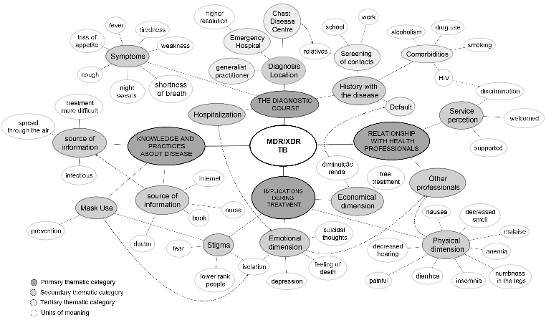
Recent Publications (minimum 5)
- WHO. Global Tuberculosis Report 2018. Geneva: World Health Organization. 2018.
- Zão I, Ribeiro AI, Apolinário D, Duarte R. Why does it take so long? The reasons behind tuberculosis treatment delay in Portugal. Pulmonology. 2019;25(4):215–22.
- Bhering M, Kritski A, Nunes C, Duarte R. Multidrug-resistant tuberculosis in Lisbon: unsuccessful treatment and associated factors, 2000-2014. Int J Tuberc Lung Dis. 2019;23(10):1075-81
- Oliveira O, Gaio R, Carvalho C, Correia-Neves M, Duarte R, Rito T. A nationwide study of multidrug-resistant tuberculosis in Portugal 2014-2017 using epidemiological and molecular clustering analyses. BMC Infect Dis. 2019;19(1):1–10
- Günther G, Van Leth F, Alexandru S, Altet N, Avsar K, Bang D, et al. Clinical management of multidrug-resistant tuberculosis in 16 European countries. Am J Respir Crit Care Med. 2018;198(3):379–86.

Photograph

Biography
Dr. Bhering has experience in epidemiological surveillance of tuberculosis. in his doctorate he compared the epidemiological surveillance systems of Brazil and Portugal. In addition to quantitative studies, he carried out qualitative studies on the main challenges in the treatment of multidrug-resistant tuberculosis by interviewing patients and health professionals. He is currently a researcher at the Professor Hélio Fraga reference center, specializing in the care of patients with TB-MDR, from the Oswaldo Cruz Foundation, where he develops research on tuberculosis and other infectious diseases.

Email: marbhering@gmail.com

Notes/Comments:

