Malfunction of a Multilumen Access Catheter Via the Left Internal Jugular Vein
Dr Eun Hwa Jun, Department of Anesthesiology and Pain Medicine, St. Vincent Hospital, College of Medicine,
The Catholic University of Korea, Republic of Korea
Dr Su Jung Chu, Department of Anesthesiology and Pain Medicine, St. Vincent Hospital, College of Medicine,
The Catholic University of Korea, Republic of Korea

Abstract (300 word limit)

We present a case of MAC malfunction due to bending after ultrasound-guided catheter insertion during a cadaveric donor liver transplantation.

A 51-year-old woman came to the operation room for a cadaveric liver transplantation surgery. Because she had a hemodialysis catheter in the right internal jugular vein, MAC was inserted through the left internal jugular vein (IJV) using ultrasonography for Swan-Ganz pulmonary artery catheter (PAC) and fluid resuscitation. The catheter was tested with blood aspiration and saline flushing. During that time, blood was aspirated through the 9 Fr, but not enough the 12-gauge line. Moreover, PAC was not advanced through the MAC from 15 cm. Liver transplantation was done without PAC. Any malposition was not seen in the ultrasonography. However, post-op chest AP X-ray showed kinking of the MAC at the neck level. The catheter was removed at post-operative day 7. No other complications were seen.

In conclusion, anesthesiologists should consider kinking of MAC when an obstruction occurs just after catheterization. A large-bore catheter sheath insertion needs to be more safely performed with real-time ultrasound guidance and confirmation with radiologic examinations.
Image
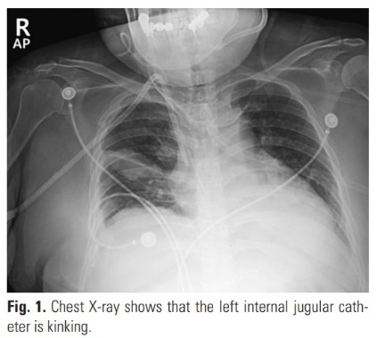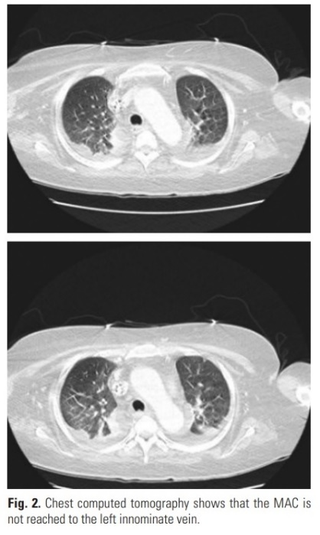
Recent Publications (minimum 5)
- Y.S. Jeon, E.H. Jun, J.H. Kim, S.T. Choi, J.H. In (2020) Effect of aminophylline on restoration of spontaneous respiration and recovery profiles during anesthesia without using muscle relaxants in patients undergoing brief gynecological procedure. Clin. Exp. Obstet. Gynecol. 2020, 47(4) 524-529.

Photograph

Biography (150 word limit)
Email: chucry@naver.com

Notes/Comments:

