Title: COMPARISON OF ULTRASOUND-GUIDED PENG BLOCK WITH FEMORAL NERVE BLOCK FOR POSITIONING BEFORE SPINAL ANESTHESIA AND POSTOPERATIVE ANALGESIA OF PROXIMAL FRACTURE FEMUR PATIENTS

Affiliation: Dr Sarmistha Panigrahi, MBBS, DNB Anesthesiology, FIPM Daradia, (EDAIC)

Abstract
Statement of the Problem: Fracture femur is a very painful condition and this is further aggravated by movements. The purpose of this study is to explain how peripheral nerve blocks in lower extremities are increasingly being recommended for the control of pain in patients with fracture femur as it reduces pain, time to first rescue analgesia, need for systemic analgesics, and incidence of delirium and shortens the duration of hospital stay. Methodology & Theoretical Orientation: A prospective, randomized double-blinded controlled study was conducted with 60 patients admitted to Apollo Hospital, Kakinada, between the period of February 2021 and September 2022, after satisfying the inclusion and exclusion criteria, aged between 18 and 80 years undergoing elective surgery for fracture femur were included in the study.
Findings: Baseline demographics were similar. Postoperatively in recovery (day 0), the PENG group experienced less pain compared with the FNB group. (In the PENG group, 63% experienced no pain,27% mild pain, and 10% moderate to severe pain. In comparison, 30% of the FNB group reported no pain, 27% mild pain, and 36% moderate to severe pain; p=0.04).
Conclusion & Significance: Patients receiving a PENG block for intraoperative and postoperative analgesia during hip fracture surgery experience less postoperative pain in the recovery room with no difference detected by postoperative day 1. Quadriceps strength was better preserved with the PENG block. Anaesthesiologist satisfaction remained the same for both during positioning.
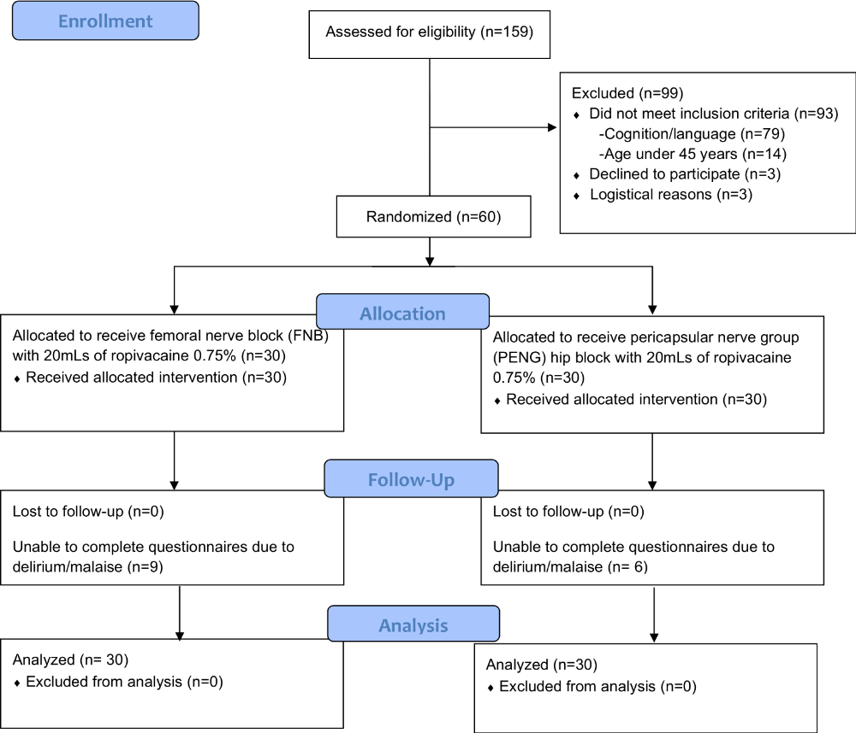

Recent Publications
- Jain N, Mathur PR, Patodi V, Singh S. A comparative study of ultrasound-guided femoral nerve block versus fascia iliaca compartment block in patients with fracture femur for reducing pain associated with positioning for subarachnoid block. Indian J Pain 2018;32:150-4.

- Ahiskalioglu A, Aydin ME, Celik M, et al. Can high volume pericapsular nerve group (PENG) block act as a lumbar plexus block? J Clin Anesth 2020;61:109650.

- Ritcey B, Pageau P, Woo MY, Perry JJ. Regional nerve blocks for hip and femoral neck fractures in the emergency department: A systematic review. CJEM 2016;18:37-47.

- Sharma S, Iorio R, Specht LM, et al. Complications of femoral nerve block for totalknee arthroplasty. Clin Orthop Relat Res 2010;468:135–40.

- Ghimire A, Bhattarai B, Koirala S, Subedi A. Analgesia before performing subarachnoid block in the sitting position in patients with proximal femoral fracture: A comparison between fascia iliaca block and femoral nerve block. Kathmandu Univ Med J (KUMJ) 2015;13:152-5.

Email: sarmistha.luckyfeb@gmail.com


Biography
Dr Sarmistha has her expertise in dealing high-risk surgeries, difficult intubations and mastered regional blocks and ICU procedures. Her unwavering dedication to patient safety, coupled with her prowess in intricate procedures, has solidified her position as a trailblazer in the field of anaesthesiology.

