ABSTRACT
TITLE : Burning the sensory nerve is ‘silencing the messenger ‘while Burning the disc may temporarily address the cause ? – Evidence based presentation on RFA in discal pain.

Presentor and main author :Dr.V S Kiran Kumar Nandivada (Main Author),

Orthopedic Surgeon & Rheumatologist .

Co researchers :*Dr.Raghavendra N .S ,

Orthopedic Surgeon & Rheumatologist .

Dr.Nikhil Bharadwaja Nandivada,

General Practitioner .

Dr.Moola Sohith Maha deva Reddy

Medical undergraduate student .

AIM :
To point out that RF ABLATION of the spinal nerves/ DORSAL NERVE ROOT GANGLION in a MASSIVE disc herniation scenario is not the best option when many other more effective alternative methods are existent .

Objective :

Summarising various publications and research studies as a means to justify this red flag.

Material & Methods :

Evidences were collected from various retrograde studies and research papers as it has mixed evidence as on 2023.

Discussion :
BASICALLY RFA -DESTROYS THE SENSORY NERVE SO THAT THE BRAIN DOES NOT PERCEIVE THE PAIN SENSATION ,,but is the root cause of pain addressed here. ‘NO’. A destructive HEAT LESION is created and the sensory nerve carrying pain sensation is destroyed .

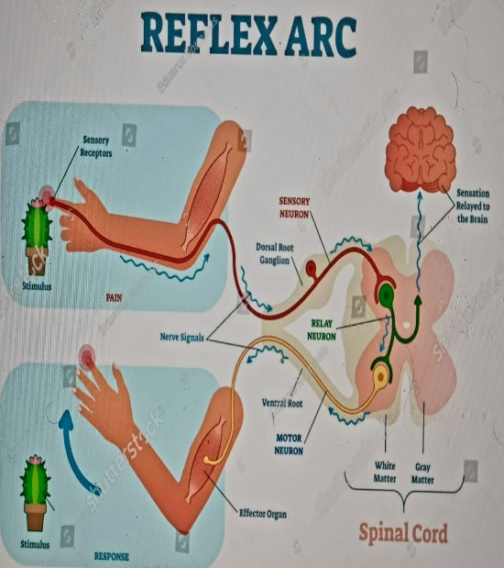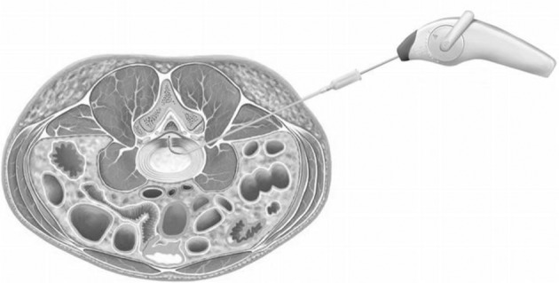

Radiofrequency ablation is of three types :1)-Pulsed radiofrequency ablation, 2)-Water-cooled radiofrequency ablation, and 3)-Cryoneurolysis

RF ablation is being done in many intractable pain conditions in other non-spinal conditions as well for example - heart, abdomen, skin, uterus ,intractable terminal cancers and others.

However In Patients with massive disc herniations after RFA they become unaware of the pain which is a protective body mechanism while the compression goes on and the RFA is not held answerable.

5)Are better options available ? Yes !.

1)SEMI INVASIVE DIRECT DISC ABLATION which addresses the main cause of compression.

2) Physiotherapy mode of spinal cord decompression .

CONCLUSION :
1)So by giving R F Ablation for short term relief ,basically the patient continues to damage self just like patients with CONGENITAL ABSENCE OF PAIN OR NEUROPATHY PATIENTS WHO HAVE LOST PAIN SENSATION.

References :

1)Kidd VD, Strum SR, Strum DS, Shah J. Genicular Nerve Radiofrequency Ablation for Painful Knee Arthritis: The Why and the How. JBJS Essent Surg Tech. 2019 Mar 13;9(1):e10. doi: 10.2106/JBJS.ST.18.00016. PMID: 31333900; PMCID: PMC6635137.
2)Leggett LE, Soril LJ, Lorenzetti DL, Noseworthy T, Steadman R, Tiwana S, Clement F. Radiofrequency ablation for chronic low back pain: a systematic review of randomized controlled trials. Pain Res Manag. 2014 Sep-Oct;19(5):e146-53. doi: 10.1155/2014/834369. Epub 2014 Jul 28. PMID: 25068973; PMCID: PMC4197759.
3)Yam MF, Loh YC, Tan CS, Khadijah Adam S, Abdul Manan N, Basir R. General Pathways of Pain Sensation and the Major Neurotransmitters Involved in Pain Regulation. Int J Mol Sci. 2018 Jul 24;19(8):2164. doi: 10.3390/ijms19082164. PMID: 30042373; PMCID: PMC6121522.
4) Wray JK, Dixon B, Przkora R. Radiofrequency Ablation. [Updated 2022 Sep 7]. In: StatPearls [Internet]. Treasure Island (FL): StatPearls Publishing; 2022 Jan
Available from: https://www.ncbi.nlm.nih.gov/books/NBK482387/
5)-Eric R. Cosman, Jr, PhD, Joseph R. Dolensky, BS, Ryan A. Hoffman, BS, Factors That Affect Radiofrequency Heat Lesion Size, Pain Medicine, Volume 15, Issue 12, December 2014, Pages 2020–2036, https://doi.org/10.1111/pme.12566.
6) Cosman ER Jr, Dolensky JR, Hoffman RA. Factors that affect radiofrequency heat lesion size. Pain Med. 2014 Dec;15(12):2020-36. doi: 10.1111/pme.12566. Epub 2014 Oct 14. PMID: 25312825.

