Title: Alteration of Protein Conformation by Ionizing Radiation and Possible Protection by Anti-Oxidants

Name: Turban Kar
Affiliation: Department Of Biochemistry, University Of Calcutta, India
Co-authors – Dr.Pijush Basak, Mr.Rittick Kr. Ghosh, Prof. Maitree Bhattacharyya

Abstract
Curcumin, a dietary antioxidant has been identified as a wonder molecule to possess therapeutic properties protecting the cellular macromolecules from oxidative damage.
Gamma rays, in its increasing concentration, results in structural disorientation of the protein and superoxide radical generation. Curcumin, on the other hand, mitigates the damage, which is supported in our results.
This study explores the possibility for protection by curcumin during the molecular and structural changes of HSA exposed to gamma irradiation. We used a combination of spectroscopic methods to probe the conformational ensemble of the irradiated HSA and finally evaluated the extent of restoration by curcumin. SDS-PAGE study unfolded the formation of cross linked aggregates as a con-sequence of increasing exposure of gamma radiation. CD and FTIR spectroscopy indicated significant decrease in the alpha helix content of HSA from 57% to 15% with increasing radiation doses. Steady state and time resolved fluorescence studies complemented the spectroscopic measurements, when lifetime decay was significantly reduced from 6.35 ns to 0.37 ns. Hydrophobic study showed the effectiveness of curcumin for protection at low dose of gamma irradiated HSA samples under increasing gamma radiation and estimated the same in presence of curcumin.
Moreover, bityrosine and hydrophobic profiling of gamma irradiated HSA in presence and absence of curcumin provided light on the formation of ROS species generation and the protective role of curcumin. Curcumin mitigates the erroneous effect of gamma irradiation on HSA by a mechanism yet unknown, though a possible explanation has been proposed in this work using Thioflavin T assay. It was elucidated, that when HSA is irradiated at low dose of gamma radiation in presence of curcumin, it is capable of retaining the native characteristic properties to a higher extent indicating stabilization of molecular structure.

Biography
Mr. Turban Kar is currently pursuing his Ph.D. from the Department Of Biochemistry, University Of Calcutta, India. Till now he has two publications as a first author. .He completed his Master`s Degree from the department of Biochemistry, University Of Calcutta, India.

Email ID: turbankar@gmail.com

Presenter Name: Turban Kar.

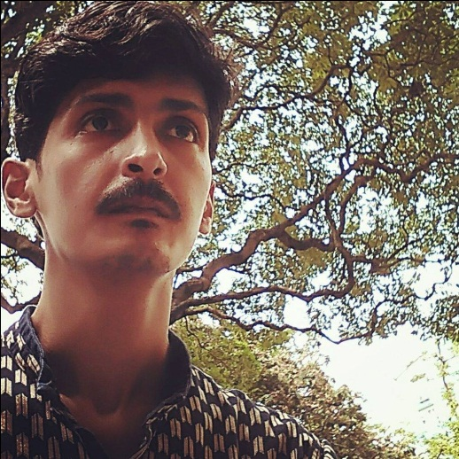
Type of Presentation: Speaker
Contact Nu mber: +91 99031-63591

