Abstract Template
Abstract Title: Ubiquitin to Ribosomes – Analyzing the broad dynamic range of protein structures using origami levers on the switchSENSE platform
Thomas G. Weber¹, Lukas Traxler², Andreas Heerwig³, Michael Mertig³, Ulrich Rant²

¹ Dynamic Biosensors Inc (San Diego, CA, USA)
² Dynamic Biosensors GmbH (Martinsried, Germany)
³ Kurt-Schwabe-Institut (Waldheim, Germany)

Abstract (not more than 300 words)

SwitchSENSE is the only biosensor that can measure - complementary to molecular interaction analysis - the hydrodynamic friction and, thus, the shape of protein complexes based on the switching speed changes of the protein-loaded levers. This unique measurement mode allows a comprehensive biophysical characterization of the test system in terms of protein size, stability, structure, and conformational change.
More recently, we have utilized DNA origami structures to analyze the structure and the size of many different proteins. Origami levers are up to six times longer and wider than our standard 48mer double-stranded DNA nanolevers. This bigger, more rigid lever constitutes a more robust sizing tool that is almost independent from any buffer salt concentrations and that can measure big protein complexes even in the megadalton range.
Here, we show that origami levers can be easily functionalized and actuated accurately on the switchSENSE biosensor surface at minimal sample consumption. Using the same assay set-up, we could determine the size of small proteins starting in the single digit kDa range, such as ubiquitin, up to ribosome megadalton complexes. Moreover, the monomeric, dimeric or tetrameric oligomerization state of ubiquitin could be distinguished in a straightforward way.
The utilization of origami levers is a very versatile and robust tool for structural investigations of protein complexes of any size and complexity.

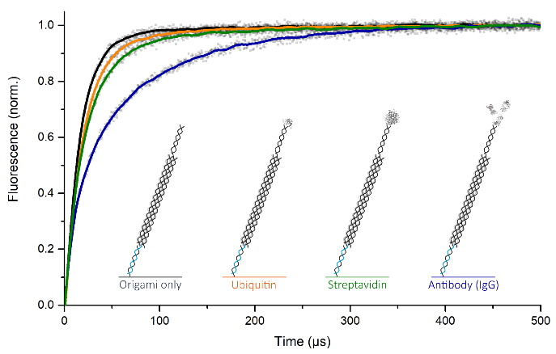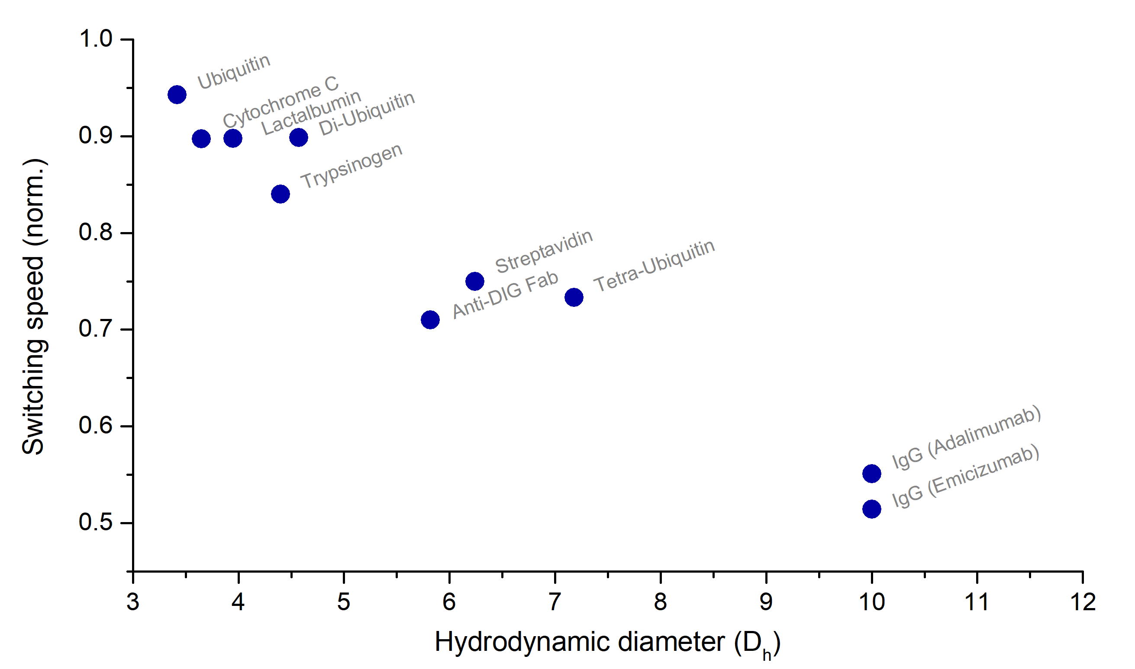

Keywords—Origami, Single digit kDa to MDa, Sizing, switchSENSE

Professional Biography (100-150 words)

Dr. Thomas Weber studied Molecular Medicine at the University of Erlangen, Germany and received his PhD in Biochemistry focusing on Molecular Imaging. Before and after a PostDoc at the UCSD at the Sanford Consortium for Regenerative Medicine, Thomas worked in the research & development departments of Roche and U3 Pharma. He went on to become an expert in the biophysical characterization of protein interactions at Dynamic Biosensors, where he now is the Applications Team Leader for all evaluation and customer projects in the USA.

Recent Publications (up to 5)

- Blocquel D, Sun L, Matuszek Z, Li S, Weber TG, Kuhle B, Kooi G, Wei N, Baets J, Pan T, Yang XL (2019). Charcot-Marie-Tooth disease severity correlates with structural opening of histidyl-tRNA synthetase but not loss of tRNA aminoacylation. PNAS, accepted for publication.
- Vo MN, Terrey M, Lee JW, Roy B, Moresco JJ, Sun L, Fu H, Liu Q, Weber TG, Yates JR 3rd, Fredrick K, Schimmel P, Ackerman SL (2018). ANKRD16 prevents neuron loss caused by an editing-defective tRNA synthetase, Nature 557:510-515.
- Weber TG, Osl F, Renner A, Pöschinger T, Galbán S, Rehemtulla A, Scheuer W (2014). Apoptosis imaging for monitoring DR5 antibody accumulation and pharmacodynamics in brain tumors noninvasively, Cancer Research 74:1913-1923.
- Weber TG, Pöschinger T, Galbán S, Rehemtulla A, Scheuer W (2013). Noninvasive monitoring of pharmacodynamics and kinetics of a death receptor 5 antibody and its enhanced apoptosis induction in sequential application with doxorubicin, Neoplasia 15:863-874.


Email Id: weber@dynamic-biosensors.com
Presenting author details
Full name: Thomas Weber
Contact number: +49 176 45 97 06 14
Twitter account: -
Linked In account: https://www.linkedin.com/in/thomas-weber-87878aa7/
Session name/ number: Track 2 Analytical Techniques
Category: Oral presentation

Any Comments: -

