Title: On the Mechanics of Actomyosin Binding
Name: Dean Culver
Affiliation: Army Research Laboratory, Aberdeen, MD, USA
Name: Bryan Glaz
Affiliation: Army Research Laboratory, Aberdeen, MD, USA

Abstract
Animal skeletal muscle exhibits very interesting behavior at near-stall forces (when the muscle is loaded so strongly that it can barely contract). Near this physical limit, the actin-myosin cross bridges do more work than their energy releasing molecules, Adenosine TriPhosphate (ATP) suggest they can. It has been shown that the advantageous utilization of thermal agitation is a likely source for this increased capacity. Here, we propose a mechanical model to illustrate how this may occur. The physical interpretation of the system energy also informs how Brownian motion and the probability of actomyosin binding are related. This work will open the door for a contractile model of skeletal muscle with variable acceleration that informs the probabilistic nature of rate functions prevalent in existing theories.

Biography
A native of Pittsburgh, Pennsylvania, Dean completed his PhD in mechanical engineering and materials science from Duke University in 2016 focusing on high dimensional dynamics and applied nonlinear dynamics. With publications in metamaterials, fluid flow control, vibration, and numerical techniques for the solution of nonlinear problems, he has a track record for research in a wide selection of areas, now including mathematical biophysics. As a postdoctoral fellow with the Army Research Laboratory, Dean has begun an investigation into the mechanics and energetics of skeletal muscle at the molecular level with the objective of constructing a robust model of muscle for eventual applications in robotics and human augmentation.

Email ID: culver.dean@gmail.com

Presenter Name: Dean Culver
Type of Presentation: Speaker
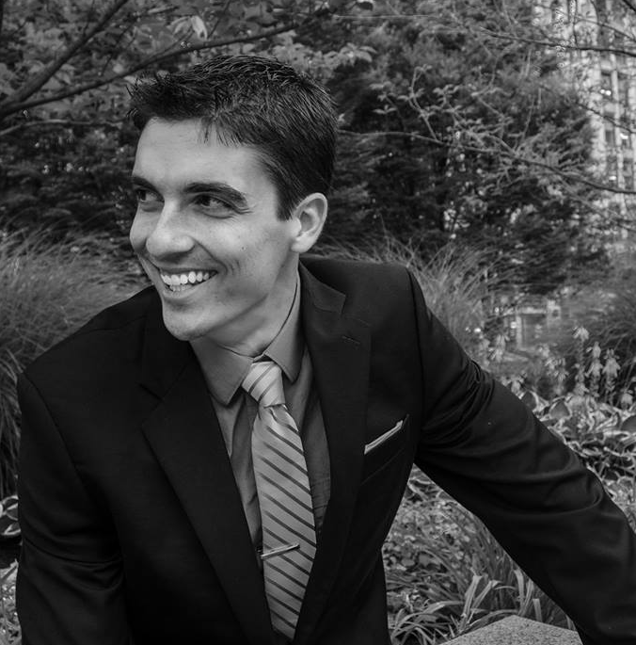
Contact Number: +1 412-680-2591

