JAK2 Exon 12 mutations in Sudanese Patients with Chronic Myeloproliferative Neoplasms

Mr. ELRASHED B. YASIN, MSc (MLS), MLS(ASCP)^{i}, Sudan
lecturer of hematology & senior laboratory scientist at faculty of applied medical sciences King Abdulaziz University, KSA

Abstract (300 word limit)
The understanding of the pathogenesis of myeloproliferative neoplasms has been aided significantly by the discovery of the JAK2 V617F mutation. Recently, mutations in JAK2 exon 12 have been identified in patients with Polycythemia Vera negative for JAK2 V617F. The aim of this study was to recognised of JAK2 Exon 12 mutations in Sudanese patients with myeloproliferative disorders referred to Fedail Hospital and Radioisotopes Centre Khartoum (RICK) in Khartoum State-Sudan., and to investigate the differences of laboratory parameters between patients with JAK2 Exon 12 positive myeloproliferative neoplasms (MPNs) and JAK2 Exon12 wild type MPNs.
Materials and Methods: A total of 166 patients with MPNs; 76 with polycythemia Vera (PV), 76 with essential thrombocythemia (ET) and 14 with primary myelofibrosis (PMF), and 11 healthy individuals were conducted from 2014 to 2018. DNA was isolated from peripheral blood leukocytes by QIAamp mini kit, and JAK2 Exon 12 mutations gene detected using multiplex polymerase chain reaction (MT-PCR) and Sanger sequencing.
Results: The JAK2 exon 12 mutations were determined to exist in 4.6% of all patients with MPNs. The prevalence of mutations was 9.4% for PV. We found 6 out of 21 JAK2 exons 14 (V617F)-negative PV patients carried JAK2 exon 12 mutations. the presence of JAK2 exon 12 mutations was found to be significantly associated with high Hb concentration (P=.000) and HCT (P=.000) in PV negative V617F exon 14 patients.
Conclusions: The JAK2 Exon 12 mutations could be frequently detected in the Sudanese patients with Polycythemia negative for JAK2 V617F Exon 14.

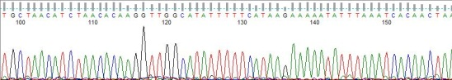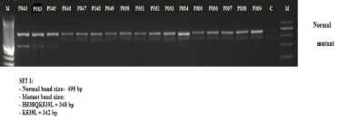

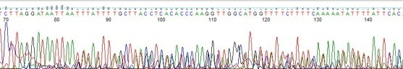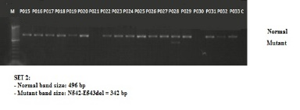

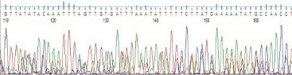
Fig. PCR amplification and sequencing of DNA from patients’ blood samples using multiplex PCR (MT-PCR). A) Represent the normal control wild type sequencing of JAK2 exon 12. B) Represent the set 1 (the specific primers; K539L (342 bp) and H538QK539L (348 bp). C) represent postive mutant deletion sequencing. D) Represent set2 (the specific primer N542-E543 (342 bp)). E) Represent positive mutant deletion sequencing. C = negative control, M = DNA ladder.B) Sanger sequencing of DNA from patients showing mutants by PCR amplification.

Photograph

Biography (150 word limit)
Mr has expertise Laboratory Technologist with a demonstrated history of working in the higher education industry. Skilled in lecturing, medical laboratory, Stem Cells, Sequence Analysis, DNA Sequencing, Real-Time Polymerase Chain Reaction (qPCR), Epidemiology and clinical research. Strong medical laboratory scientist professional with a Master's degree focused in medical laboratory science hematology specialization from University of Medical Sciences & Technology (UMST).
Email: rashed2t@hotmail.com
eyasin@kau.edu.sa

Notes/Comments:

