Carlituculin (CALR) Mutation Screening in Sudanese Patients with Myeloproliferative Neoplasms

Mr. ELRASHED B. YASIN, MSc (MLS), MLS(ASCP)^{i}, Sudan
lecturer of hematology & senior laboratory scientist at faculty of applied medical sciences King Abdulaziz University, KSA

Abstract (300 word limit)
The understanding of the pathogenesis of myeloproliferative neoplasms has been aided significantly by the discovery of the JAK2 V617F mutation. Recently, mutations in calreticulin (CALR) have been identified in patients with myeloproliferative neoplasms negative for JAK2 V617F. CALR is protein with pleiotropic roles related to its distribution in the endosplasmic reticulum and cytosol, and on the cell surface. It has been found to trigger the JAK-STAT pathway in myeloproliferative disorders (MPD). The mutations on CALR gene have been reported in JAK2 V617F- negative patients with essential thrombocthemia (ET) and primary myelofibrosis (PMF). Our study aimed to analyze the CALR common mutations on MPD patients from Sudan region. We investigated CALR in 134 patients with a range of MPD symptoms. Among these patients, 66 (49.3%) were diagnosed with PV, 57 (42.5%) were diagnosed with ET, and 11 (8.2%)were diagnosed with PMF. Those patients were previously screened for JAK2V617F exon 14 and JAK2 exon 12 in the molecular genetic laboratory at CEGMR.
A. TYPE-1 MUTATION (L367fs*46)
Sequencing Results:

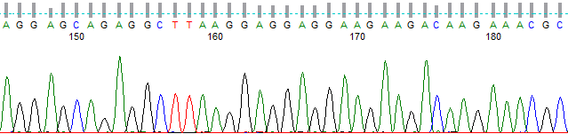
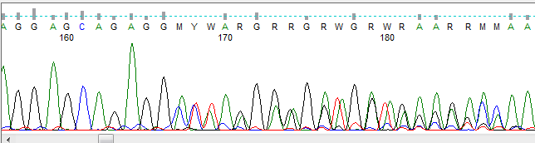

B. TYPE-2 MUTATION (K385fs*47)
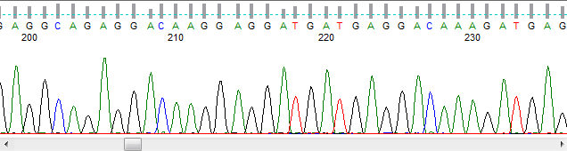
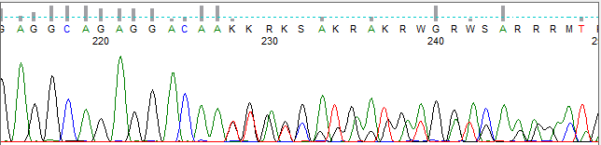
Results
- The patients with CALR mutations were Saudi adult diagnosed with thrombocytosis or MPD and their molecular screening for BCR/ABL were negative.
- In 5 out of 6 CALR positive patients, high platelet count was noted and that is consistent with previous reported finding.
CONCLUSION
- To the best of our knowledge this is the first research Sudan that focused on screening CALR hot spot mutations.
- Our study showed that this mutation is existent; this fact raises the importance of implementing the diagnostic screening on MPD patients, mainly patients with high platelet count.
- Further screening of other predisposing genetic markers may lead to the identification of an important genetic variant that could help in the understanding of disease pathogenesis.

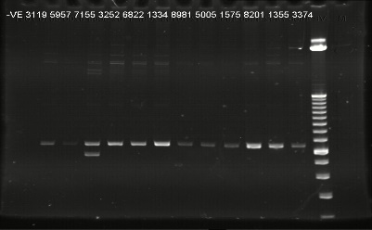
Figure.4: Gel Electrophoresis picture of the CALR test that shows positive (7155); double band, and negative (3119, 3252, 6822, 1334,1575, 8201) samples; one band with the size of 386bp.

Image

Photograph

Biography (150 word limit)
Mr has expertise Laboratory Technologist with a demonstrated history of working in the higher education industry. Skilled in lecturing, medical laboratory, Stem Cells, Sequence Analysis, DNA Sequencing, Real-Time Polymerase Chain Reaction (qPCR), Epidemiology and clinical research. Strong medical laboratory scientist professional with a Master's degree focused in medical laboratory science hematology specialization from University of Medical Sciences & Technology (UMST).
Email: rashed2t@hotmail.com
eyasin@kau.edu sa

Notes/Comments:

