Receptor binding of a novel bifunctional TGF-$β$1/PD-L1 fusion protein elicited a down-regulated immune signature
Marvin I. De los Santos^{1,2} & Samuel D. Bernal^{2,3}
¹University of the Philippines Diliman, Quezon City, Philippines
²GlobeTek Science Foundation, Makati City, Philippines
³Cedars-Sinai Medical Center, Section of Hematology & Oncology, Los Angeles, California, USA

Abstract
Statement of the Problem: There are more than 80 clinical distinct types of autoimmune diseases (AID) and their collective global prevalence rate have increased to >10%. Until now, treatment regimen has relied heavily on the use of drugs (i.e. NSAIDs, glucocorticoids and DMARDs) that down-regulate the entire body’s immune response. High-dose and long-term medication with these drugs have been found to correlate with susceptibility to infections and tumorigenesis. Preclinical studies targeting the receptors of transforming growth factor superfamily such as TGF-$β1$ has implicated possible use of this molecule in AID management and treatment. However, researchers have reported several drawbacks of targeting TGF-$β1$ signaling, as they found its involvement in prevention but not reversal of AID. Another group of immune checkpoint protein, the PD-1/PD-L1 axis, has been found to down-regulate immune response and have clinical implications for treatment of the disease. This study aims to utilize the combinatorial immune-downregulating activities of TGF-$β1$ and PD-L1 by generating a fusion product which has never been described before. Methodology: We were able to previously successfully clone and generate a fusion gene construct of TGF-$β1$ and PD-L, validated by DNA sequencing. The study focused next on characterizing the bifunctional binding of the proteins with their respective receptors by co-immunoprecipitation (co-IP) and reverse co-IP experiments coupled with pathway analysis by qRT-PCR. Findings and Results: A 70 kDa TGF-$β1$/PD-L1 fusion protein was demonstrated to bind TGF-$β1$receptors such as TGF-$β$receptor 1 and PD-L1 target receptor, PD-1, in co-IP and reverse co-IP experiments. Gene expression analysis showed that these interactions are functional and elicit gene expression signature that is seen in suppressed immunity using a cell line model. Conclusion and Significance: TGF-$β1$/PD-L1 fusion protein may represent a new class of immunotherapy for treatment and management of autoimmune diseases in the future.

Image

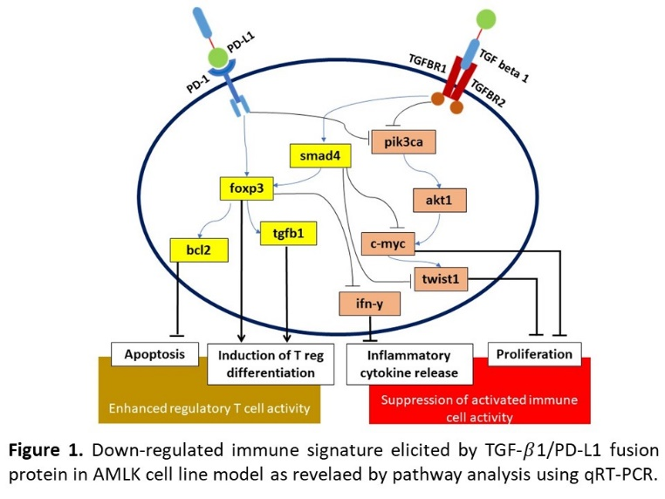

Recent Publications
- Cooper, G. and Stroehla, B. (2002). The epidemiology of autoimmune diseases. Autoimunity Reviews, 2: 119-125.
- Cooper, G., Bynum, M. and Somer, E. (2009). Recent insights in the epidemiology of autoimmune diseases: Improved prevalence estimates and understanding of clustering of diseases. Journal of Autoimmunity, 33: 197-207.
- Autoimmune diseases research plan. (2002). Autoimmune Diseases Coordinating Committee, Department of Health and Human Services. National Institute of Health, USA.
- Oh, S. and Li, M. (2013). TGF-B: Guardian of T cell function. J Immunol., 191 (8): 3973-3979.
- Tinoco, R., Alcalde, V., Yan, Y. Sauer, K. & Zuniga, E. (2011). TGF-B signaling in T cells is essentail for CD8 T cell suppression and viral persistence in vivo. Immunity, 31 (1): 145-157.
- Li, M., Wan, Y. and Flavell, R. (2007). T cell-produced transforming growth factor B1 controls T cell tolerance and regulates Th1- and Th17-cell differentiation. Immunity, 26 (5): 547-549.
- Sledzinska, A., Hemmers, S., Mair F., ... Buch T. (2013). TGF-B signalling is required for CD4 T cell homesotasis but dispensable for regulatory T cell function. PLos Biol., 11 (10): doi:10.1371/journal.pbio.1001674.
- Aoki, C., Borchers, A., Li, M., ... Gershwin, M.E. (2005). Transforming growth factor B (TGF-B) and autoimmunity. Autoimmunity Reviews, 4: 450-459.
- Flippi, C., Juedes, A., Oldham, J. ... Herrath, M. (2008). Transforming growth factor-B supresses the activation of CD8 T-cells when naive but promotes their survival and function once antigen experienced. Diabetes, 57 (10): 2684-2692.
- Ishigame, H., Zenewics, L., Sanjabi, S., ... Flavell, R. (2013). Excessive Th1 responses due to the absence of TGF-B signaling cause autoimmune diabetes and dysregulated Treg cell homeostasis. PNAS, 10 (17): 6961-6966.
- Boussiotis, V. (2016). Molecular and biochemical aspects of the PD-1 checkpoint pathway. N Eng J Med., 375 (18): 1767-1778.
- Amarnath, S., Mangus, C., Wang, J., ... Fowler, D. (2011). The PDL1-PD1 axis converts human Th1 cells into regulatory T cells. Sci Transl Med, 3 (111); doi:10.1126/scitranslmed.3003130.
- Lagasse, H., Alexaki, A., Simhadr, V., ... Kimchi-Sarfaty, C. (2017). Recent advances in (therapeutic protein) drug development. F1000 Research, 6 (113):doi: 10.12688/f1000research.9970.1

Photograph

Biography
Marvin has passion in research, education and technology innovation. He is currently a senior scientist at Globetek Science Foundation based in the Philippines and currently working as a thesis student at the Protein Structure and Immunology Laboratory of National Institute of Molecular Biology and Biotechnology, UP Diliman. As a scientist at Globetek, he is supervising projects in biological therapeutics, molecular testing, clinical diagnostics and medical biotechnology. He is part of very enthusiastic teams who establish competitive molecular tests for patients using optimized, validated methods for clinical application in disease diagnosis. He works with hardworking scientists who conduct extensive works in genetic manipulation, cell and tissue culture, cellular and immune engineering and molecular analyses to come up with biological therapeutics and innovate potential biotechnological tools for medical, environmental and industrial applications.

Email: midelossantos1215@gmail.com

Notes/Comments:

