Association of circle of willis variants with stroke and aneurysm: insights from a tertiary hospital in Ethiopia
Dr Molla Asnake (MD, ECFMG certified, Ass. professor)

Correspondent author

Abstract (300 word limit)
Anatomical variations within the CoW are prevalent and can have significant clinical implications, particularly concerning strokes, aneurysms and other cerebrovascular disorders. This study aimed to assess the anatomical variations of the CoW in the Ethiopian population presenting with neurological symptoms and to explore the factors associated with these variations. A facility-based cross-sectional study was conducted among adult patients undergone brain CT angiography at St. Paul’s Hospital Millennium Medical College. A simple random sampling technique was employed to select participants. Multivariate binary logistic regression analyses were performed to determine relationships between dependent and independent variables. Statistical significance was assessed with a p-value < 0.05. This study of 86 participants (mean age 48.3 years) found that 56 (65.12%) had a complete CoW. Incomplete CoW was more common in females (OR = 3.5, p = 0.007) and was significantly associated with stroke (OR = 15.4, p < 0.001). Aneurysms had a higher but non-significant association with incomplete CoW (OR = 3.2, p = 0.14). Hypoplastic arteries were present in 30% of participants. Hypoplastic arteries are more frequently observed in the posterior portion of the CoW than in the anterior portion. Most importantly, the incompleteness of the CoW is significantly associated with female sex and stroke.

Image
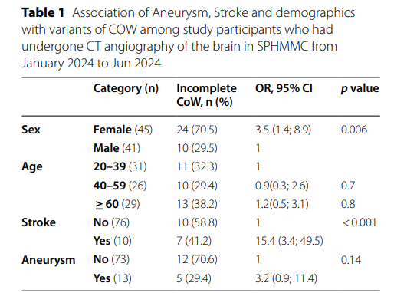
Recent Publications (minimum 5)
- Ismail SA, Kebede MA, Wondafrash G, Ambachew R, Abdi RA, Ahmed ET, Belete MW, Eshetu MA, Yesuf SA. Impact of optimal anti-proteinuric therapy on the prevention of diabetic kidney disease progression. 15(1):25791.
- Numaro YT, Kebede MA, Mariam SN, Abebe NS, Gossaye BT, Shenga SD, Addi HA, Melak MM, Abadiga TA, Kassa HB. Clinical anastomosis leakage and determinant factors among patients who underwent intestinal anastomosis in two Ethiopian tertiary hospitals.25(1):610.
- Worku AB, Kebede MA, Abate AD, Admassie SH, Girma M, Zewde BW, Dessie M, Negatie HM, Techane AG, Wudineh AA. Clinical outcomes and management of tibial plateau fractures in Ethiopia: 20(5):e0323956.
- Zigale TA, Tekle AB, Kebede MA, Berhanu MT, Jemal A, Akloge E. Predictors of immediate survival in Emergency Department cardiac arrest in Ethiopia: Insights from a resource-limited setting. African Journal of Emergency Medicine. September 2025; 15(4):100906
- Kebede MA Tekle AB Eshetu MA Shash EP Berhanu MT Ahmed ET Negatie
HM. Guillain-Barré syndrome following falciparum malaria infection: acase
report. 25(1):37.



Biography
Dr. Molla Asnake, a physician and researcher with broad experience in emergency and critical care medicine, presents an in-depth evaluation of Circle of Willis (CoW) anatomical variations and their clinical significance in stroke and aneurysm. Drawing from his experience in both clinical practice and academic research, Dr. Molla applies an open and contextual evaluation framework rooted in responsive constructivism and Fourth Generation Evaluation (Guba & Lincoln, 1989). His approach values stakeholder perspectives and integrates data-driven insights with clinical relevance. This study, conducted at a tertiary hospital in Ethiopia, explores the frequency, patterns, and potential associations of CoW variants with cerebrovascular events, highlighting implications for early diagnosis and targeted prevention in low-resource settings. Through this work, Dr. Molla aims to strengthen neurovasc
research capacity in Ethiopia and promote evidence-based strategies to reduce stroke-related morbidity and mortality
Email: mollaasnake75@gmail.com

Notes/Comment. Thank you for considering my abstract for presentation

