Abstract Title: Our experience of endovascular treatment of complex AVMs
V. Kiselev¹, A. Perfilev¹, A. Sosnov¹, R. Gafurov¹

¹ Federal Neurosurgical Center (Novosibirsk, Russian Federation)

Abstract:

Introduction: Treatment of cerebral arteriovenous malformations (AVMs) is one of the most controversial and debated topics in modern neurosurgery and neuro interventional radiology around the world.

Purpose: to increase the rate of complete obliteration and to reduce the frequency of hemorrhagic complications in the postoperative period by using a different technique in the treatment of cerebral АVMs

Materials & Methods: From 06.2014 till 06.2018, 523 patients with cerebral AVMs were endovascularly operated in the department of vascular neurosurgery. Most were supratentorial. In all cases, we performed operations through arterial and venous femoral accesses. Evaluation of AVM occlusion grade was based on control angiograms immediately after the intervention and 3 months later. A modified Rankin outcome scale was used to assess the functional result.

Results: Favorable outcome (mRs 0-1) of treatment was obtained in more than 80% of patients. Complete occlusion rate was achieved in 50,3% in adults and 67,5% in children. Postoperative complications - 4.8%. Intraoperative complications - 2.1%. Mortality 1 (0,2%) patient.

Conclusion: Multi-stage endovascular treatment allows you to get a higher complete obliteration, especially in patients with large and giant AVM, without increasing the risk of intra and postoperative complications. The use of transvenous approach in the endovascular surgery of cerebral arteriovenous malformations allows performing interventions on hard-to-reach for traditional transarterial embolization malformations. The high efficiency of the method, first of all, is due to the appropriate selection of patients. Combined approach raises the radical nature of surgical intervention, allowing to exclude residual filling of the malformation compartment.

Keywords— Arteriovenous malformation (AVM), Squid, Embolization, Transvenous approach

Professional Biography

Vitaly Kiselev has completed his PhD at the age of 32 years from Russian Research Neurosurgical Institute named after A.L.Polenov in Saint-Petersburg, Russia. He is the chief of endovascular division in department of vascular neurosurgery in Federal Neurosurgical Center (Novosibirsk, Russia). Over the last 5.5 years, while working in Novosibirsk, he performed more than 2,500 endovascular operations in the pathology of cerebral and spinal vessels. He has published more than 35 papers in reputed journals in Russian Federation. He is a member of EANS, EANR, SibNeuro, Russian Neurosurgical Society

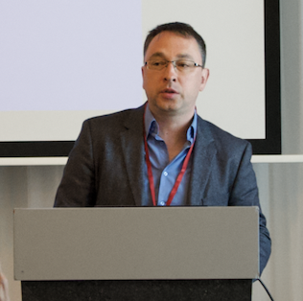

Email Id: neuro-surgeon@yandex.ru

Phone: +79119341469

