Abstract Title: Cirsoid Aneurysm, Case Report

Edgar Eduardo Rodriguez Lopez, M.D(1), Kevin Estuardo Vicente, M.D.(2), Pedro Javier Brol, M.D.(3)

¹ Universidad de San Carlos de Guatemala, Guatemala
² Universidad de San Carlos de Guatemala, Guatemala
³ Universidad de San Carlos de Guatemala, Guatemala

Abstract

INTRODUCTION
Arteriovenous malformations of the scalp, known as cirsoid aneurysms, are rare vascular malformations that consist on abnormal fistulous communications, associated with dilated drainage vessels that grow through time, and have a tendency to bleed massively and cause skin lesions. Clinically they produce significant cosmetic deformity, skin necrosis, pulsatile pain and constant noise. They differ from other vascular lesions such as hemangiomas, sinus pericranii, aneurysm bone cysts and lymphangiomas, in that they require a different therapeutic approach. Classically they are described as either congenital or acquired. In light of the size of the lesions and low frequency of appearance, the publications of these cases is very relevant; he rareness of the pathology justifies reporting and discussing such managements to determine which of the surgical options is best.

CASE DESCRIPTION
The patient is a 36 year old female referred from Neurology, who presented a history of headaches that grew in intensity, and a pulsating scalp deformity associated with significant cosmetic alteration. She also had a history of high blood pressure. The lesion presented as a 15x5 cm mass that extended from the left to the right occipital scalp, irregular in shape, and with an evident perceptible murmur to auscultation, and thrill to palpation.
Brain angiotomography revealed a vascular malformation compatible with a cirsoid aneurysm (Fig 1-3).

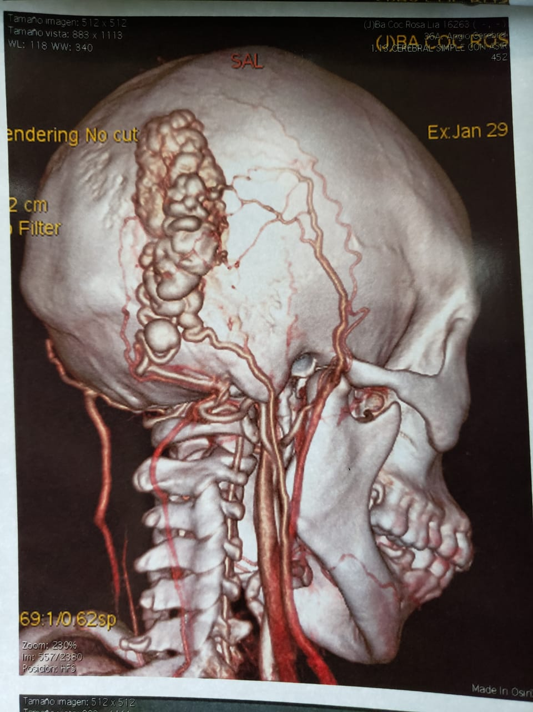
Fig 1.
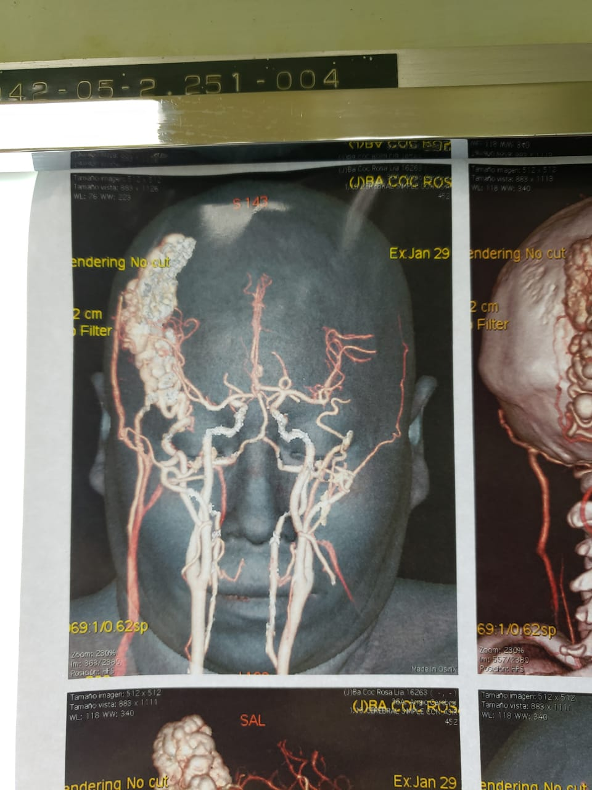
Fig 2.

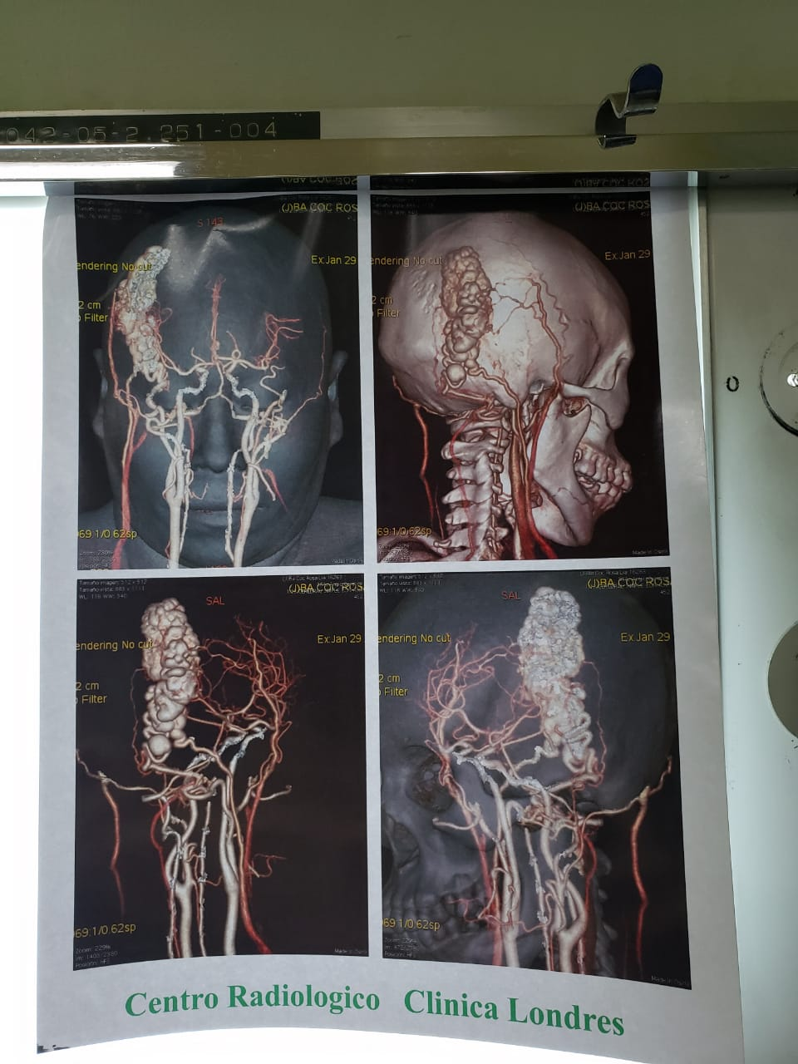
Fig 3.

She was taken to surgery where we performed an italic S incision with the patient in the Concorde prone position. We performed a clipping of the efferent vessels (arteries, and venous drainage) to perform a bloc resection through a cutaneous flap (Fig 4-6).

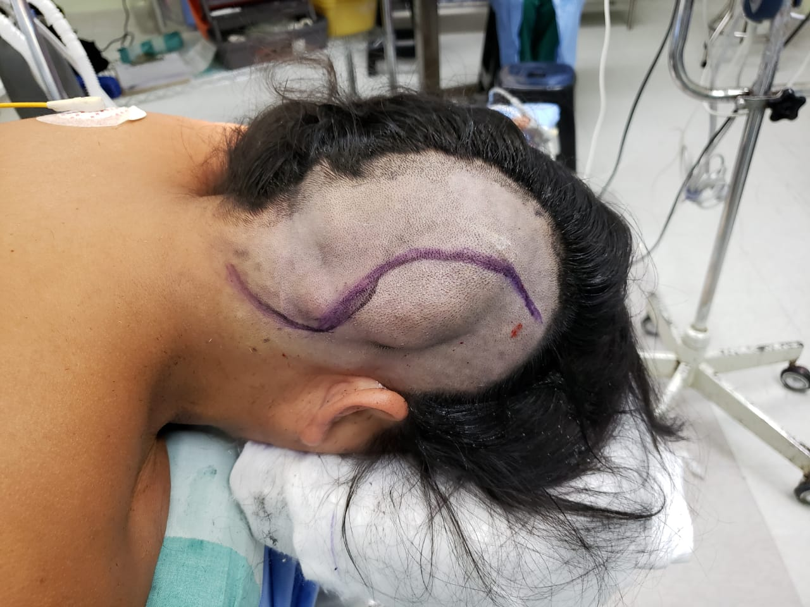
Fig 4.

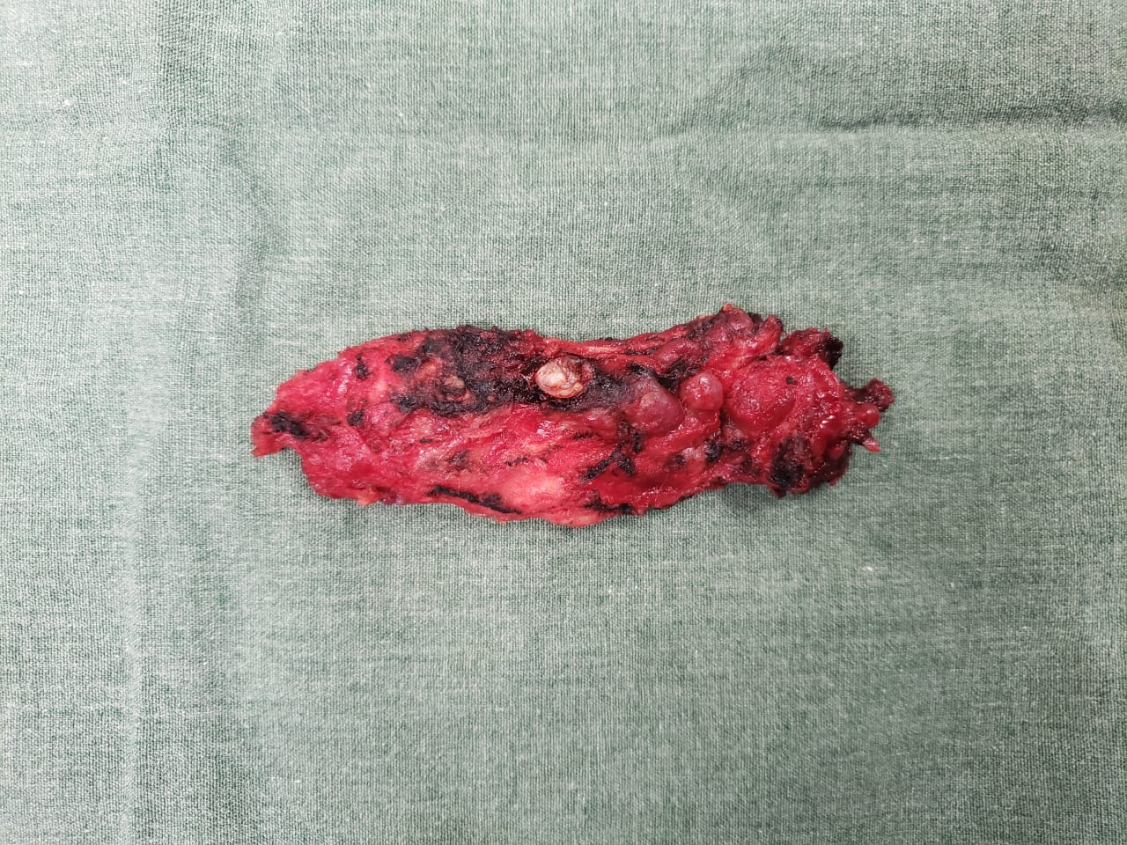
Fig 5.
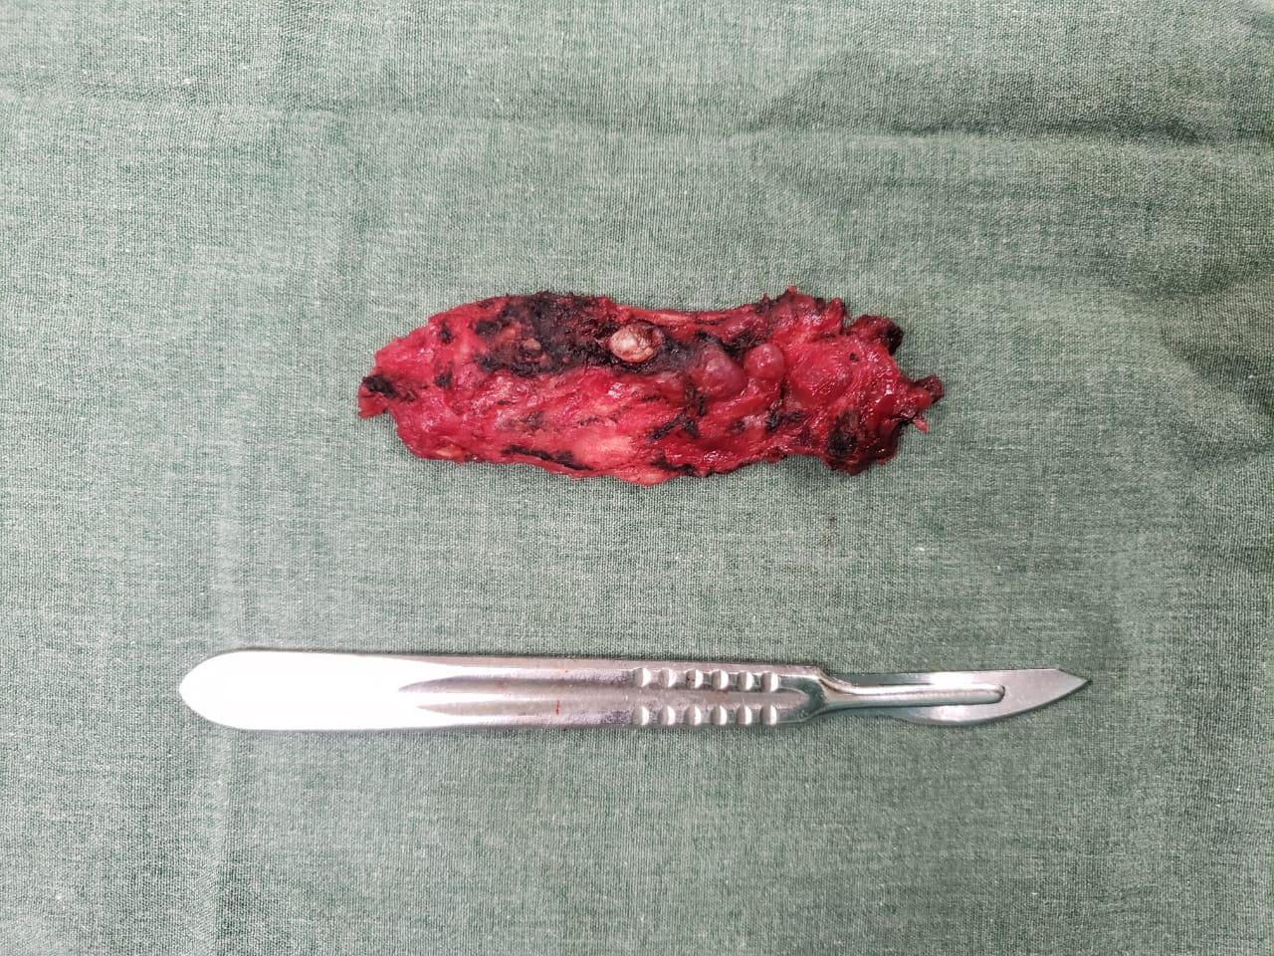
Fig 6.

RESULTS
Cirsoid aneurysms are vascular malformations frequently associated with congenital cardiac problems. However, in the present case there was no documented abnormality of the ECG or Echocardiogram, nor there were intracranial lesions. There was an adequate neurological outcome, the skin flap was without vascular changes, and hospital discharge was given on the third post operative day.

Key words: Vascular malformation; Cirsoid aneurysm; Concorde, Scalp.

Professional Biography

Dr. Edgar Eduardo Rodriguez Lopez is completing his Neurosurgery training in the Hospital San Juan de Dios teaching hospital, from the Universidad de San Carlos of Guatemala. He concluded his surgical residency and was Chief Resident from 2011 to 2014 at the Institute of Social Security.

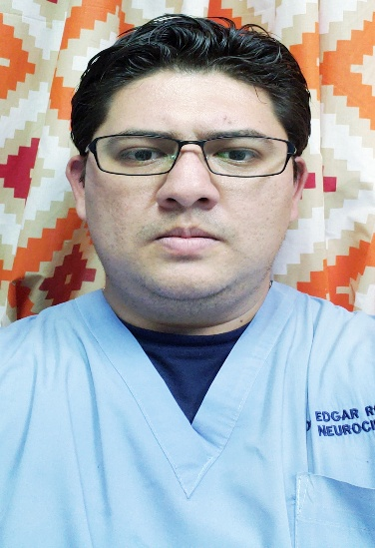
Email Id: neuromop@gmail.com

