Abstract Title: Pure Endoscopic excision of Parenchymal Brain Tumours: Feasibility, Risks, Advantages & Realities: A Beginners Perspective
Manish Kumar#, Ashis Pathak#, Rahat Brar*,
# Department of Neurosurgery Fortis Hospital Mohali, India
*Department of Radiology Fortis Hospital Mohali, India

Objective: To report the experience of surgical excision of parenchymal brain tumors, in selected cases, using pure endoscopic approach and to discuss it’s feasibility, technical benefits risks and comparison with conventional microscopic excision.
Method: Six patients of variable age group with parenchymal brain tumors were operated upon by a single surgeon and followed up with period varying from 6months to 2 years. Data regarding operating time, illumination, clarity of the field, size of craniotomy, blood loss and course of recovery was evaluated. All tumors were resected via mini or smaller standard craniotomy using rigid high definition zero and 30 degree endoscope.
Results: Out of six cases 5 had lesions in supra-tentorial and one in infra-tentorial location. The age group ranged from 27 to 74 yrs. Near to gross total resection was achieved in all cases. All patients recovered well without any significant morbidity or mortality. Hospital stay was reduced
Conclusion: Excision of parenchymal brain tumors via pure endoscopic method is a safe and efficient procedure. Though there is an initial period of learning curve but its not steep for those already practicing neuroendoscopy but the approach has its advantages over usual open microscopic technique.

Keywords – Advantages, Learning curve, Misconceptions, Neuroendoscopic.

Professional Biography

Manish Kumar attained his MCh in Neurosurgery from the prestigious Post Graduate Institute of Medical Education & Research, Chandigarh, India. He has attended and presented papers in many national conferences and has won award on national platform. He is presently working as a Consultant Neurosurgeon in a well reputed hospital in Chandigarh, India and has received his training under stalwarts of Neurosurgery in India. He has a keen interest in Neuroendoscopy.

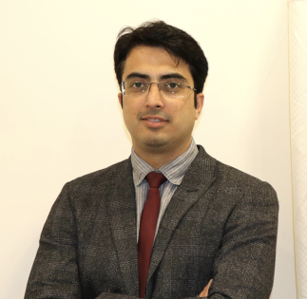

Email Id: dr.manibudhiraja@gmail.com

