Features of shaping of movement violations in migraine stroke
¹Gulova Munisakhon, (Bukhara State Medical Institute, Uzbekistan)
²Sanoyeva Matlyuba Phd, (Bukhara State Medical Institute, Uzbekistan)
Keywords: migraine, motor dysfunctions, movement violations
Migraine can be independent factor risk of stroke from 1 to 25 % costs among patients younger than 50 years.
The aim was explores degree of shaping movement violent in patients with migraine stroke.
58 (100%) patients with migraine stroke were examined, the age was 16 to 46 years. 36 (62.1%) of them had migraine with aura (average age 34.7 ± 2.1y.) (1-group), 22 (37.9%) had migraine without an aura (mean age 47.6 ± 1.6y.) (2-group). A comparison the neurological deficit with the results of MRI and MRA.
The frequency migraine attacks revealed in 51 (87.9%) patient. Those surveyed in people under 40 years, migraine-associated stroke was more frequent (12.3%) compared to patients older than 40 years (3.8%). A rare sudden onset of stroke was noted in all 58 (100%) patients. Hemianopia was revealed in 32 (88.9%) 1-group and 13 (59.1%) of the 2-group, hemi-hemisthesia was observed in 19 (52.8%) 1-group and 5 (22.7%) of the 2-group, hemi-hyperesthesia in 12 (33.3%) 1-group and 3 (13.6%) of the 2-group, proximal hemiparesis in 18 (50%)1-group and 8 (36.4%)of the 2-group, distal hemiparesis in 6 (16, 7%) 1-group and 7 (31.8%) of the 2-group, monoplegia was observed in 3 (8.3%) 1-group and 5 (22.7%) patients of the 2-group. Frequent attacks migraine with aura (more than 2 times in 1 month) led to the development of more persistent and serious motor and visual impairments. The MRA of the brain showed a decrease in blood flow in the corresponding areas of the brain without visible atherosclerotic and occlusive lesions of the vessels, and the ischemia on the opposite side of the neurological deficit on the brain MRI.
Thus, migraine is a risk of developing a stroke with the formation of motor deficits, depending on the localization of brain damage, due to deterioration of blood circulation.

Title | Master of 1-degree of Bukhara State Medical Institute
First Name | Munisakhon
Last Name | Gulova
 | 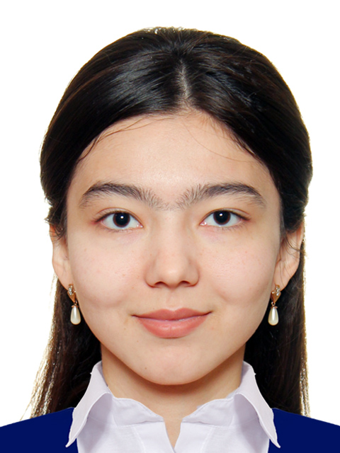
Affiliation | Bukhara State Medical Institute, Department of Neurology and Psychiatry, Master of 1-degree
EDUCATION: | 2001-2012  Secondary School № 17 (Bukhara, Uzbekistan).  2013-2018  Bukhara State Medical Institute, faculty of Medicine  2019 of September Master of 1-degree of Neurology and Psychiatry Department of Bukhara State Medical Institute
Training: | I was member of the 19th World Festival of Youth and Students from 14 until 22 October 2017 in the Russian Federation, Sochi
Fields of clinical and research interest: | The main fields of my clinical research interest are neurology diseases, headaches, and vascular disorders, motor dysfunction of patients. I am the first scholarship student named after Islam Karimov. In future, I am going to work with patients with neurologic motor problems.

e-mail: matlyubadoct70@mail.ru

