Some motor dysfunctions and rehabilitation approach of patients with migraine stroke
¹Gulova M. A., (Bukhara State Medical Institute, Uzbekistan)
²Sanoyeva M. J., (Bukhara State Medical Institute, Uzbekistan)
³Saidvaliyev F.S., (Tashkent Medical Academy Uzbekistan)
Keywords: migraine, motor dysfunctions, rehabilitation approach
Migraine stroke often develops due to malnutrition, sedentary lifestyle and hereditary predisposition.
We studied the ways of rehabilitation of movement disorders for patients with migraine stroke.
58 (100%) patients with migraine stroke were examined. The age of patients were 16 to 46 years. Amount them 36 (62.1%) patients had a history of migraine with aura, the average age of which was 34.7 ± 2.1 years (group 1), and 22 (37.9%) had migraine without an aura the mean age was 47.6 ± 1.6 years (2-group). They studied the methods of rehabilitation of motor disorders for the early rehabilitation of the lost function.
On migraine with aura, there was a frequent development of migraine stroke and a deep, persistent motor deficiency. The presence of a visual deficit without an impellent defect indicated the localization of the focus of ischemia in the occipital region according to MRI. The prospect of recovery of patients after a migraine stroke depended on the volume and localization of the lesion, the severity of the primary neurologic deficit, the concomitant pathology, and the time at which the rehabilitation measures began. Developed and controlled a phased withdrawal from bad habits, practiced gymnastics and mechanical massage for the distal and proximal parts of the limbs, determining the level of exercise, more time was forced into the fresh air, and bedridden patients periodically changed air in the ward, isolated from stressful situations and overwork, provided natural hyperventilation of the lungs (by deep inhalation and exhalation). These procedures helped to restore the impellent, visual deficit on the background of drug therapy patients better controlled their mental status, the frequency of migraine attacks decreased 2.5 times.
Thus, timely initiated rehabilitation will improve the clinical, social, mental state of patients and restore motor deficits associated with the distal and proximal parts of the limbs.

Title | Master of 1-degree of Bukhara State Medical Institute
First Name | Munisakhon
Last Name | Gulova
 | 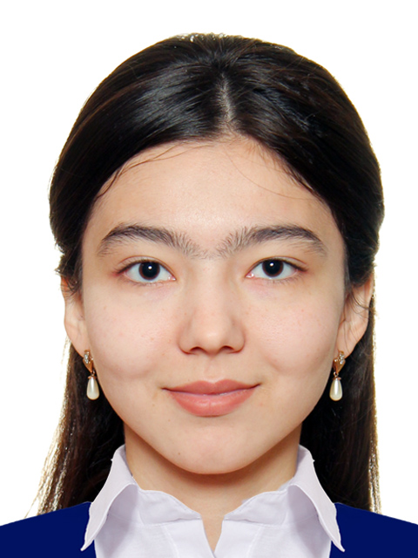
Affiliation | Bukhara State Medical Institute, Department of Neurology and Psychiatry, Master of 1-degree
EDUCATION: | 2001-2012  Secondary School № 17 (Bukhara, Uzbekistan).  2013-2018  Bukhara State Medical Institute, faculty of Medicine, Master of 1-degree  2019 of September Master of 1-degree of Neurology and Psychiatry Department of Bukhara State Medical Institute
Training: | I was member of the 19th World Festival of Youth and Students from 14 until 22 October 2017 in the Russian Federation, Sochi
Fields of clinical and research interest: | The main fields of my clinical research interest are neurology diseases, headaches, and vascular disorders, motor dysfunction of patients. I am the first scholarship student named after Islam Karimov. In future, I am going to work with patients with neurologic motor problems.

e-mail: matlyubadoct70@mail.ru

