Biofilm prophylaxis: Drugs vs material science
Mr S V V S Narayana, Assistant professor, Aditya Engineering College, India

Abstract
Loss of efficacy of conventional antibiotic therapies and significant impact of infections associated with biomaterials are urging to find new strategies for effective prophylaxis of biomaterial-associated infections. The obsolescence of implant material bulk properties change and limitations in advanced antibiotic delivery methods to fight biofilms paved way for the paradigm-shifting developments to treat or prevent biofilm. Multifunctional surfaces and coatings can prevent biofilm formation and can become a novel strategy to fight biofilm. In this review, attention is focused on different surface modification techniques, surface coatings, and their current manufacturing methods to produce antibacterial biomaterials using surface engineering and nanobiotechnology.

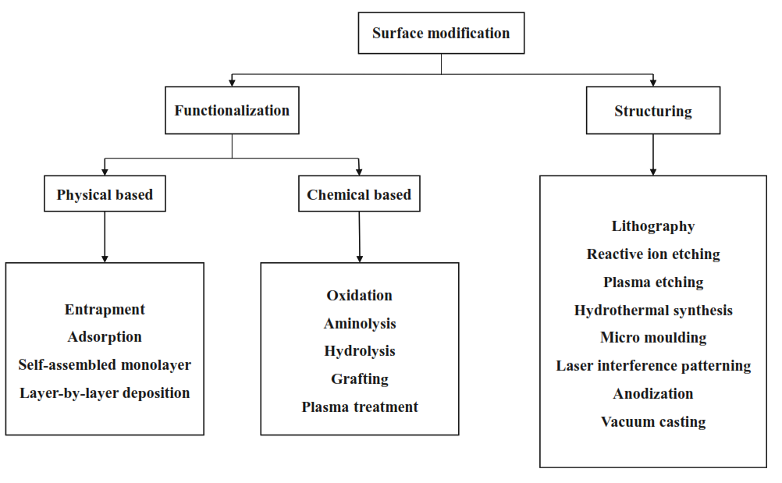
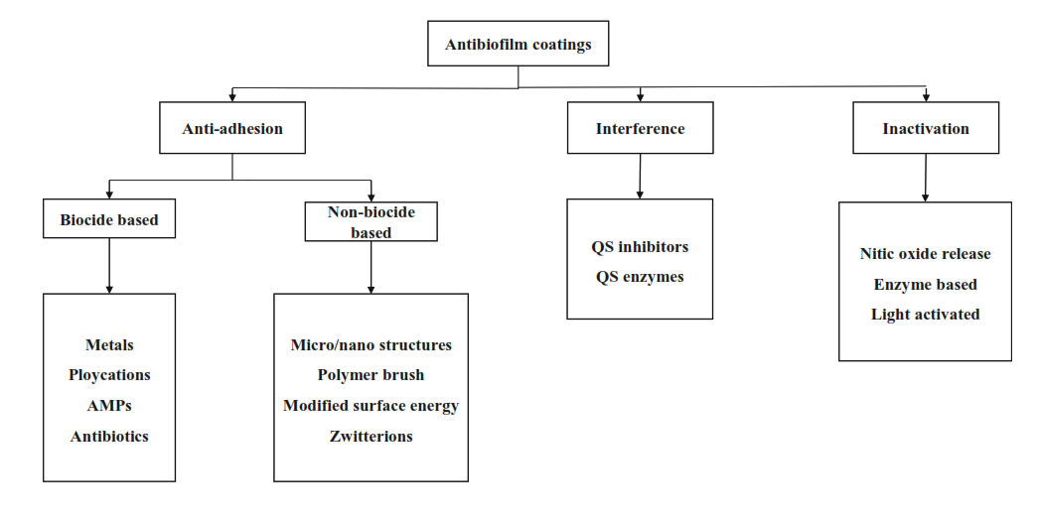
Figure: Surfaces and coatings to fight biofilm
Recent Publications
- S V V S Narayana P, S V V Srihari P (2019) A Review on Surface Modifications and Coatings on Implants to Prevent Biofilm. Regenerative Engineering and Translational Medicine. https://doi.org/10.1007/s40883-019-00116-3
- S V V S Narayana P, S V V Srihari P (In production) Biofilm Resistant Surfaces and Coatings on Implants: A Review.
Materials Today: Proceedings.


Mr Narayana has immense interest in finding alternative medicine to prevent biomaterial associated infections. He is currently working on material sciences related to biomaterials and nanotechnology to find an efficient biofilm resistant coating that can prevent or effectively reduce ESKAPE pathogens biofilm formation. Apart from this, he has deep knowledge in different domains of mechanical engineering.
Email: psvvs.narayana@aec.edu.in

Notes/Comments: The publications listed are only topic related.

