Gradient photothermal field for precisely directing cell sheet detachment
Prof. Qinghua Lu, School of chemistry and chemical engineering, Shanghai Jiao Tong University. China

Abstract
Traditional cell-based medical therapeutics are usually performed with the enzymes (trypsin) to transfer cells from culture dishes to the wounds, which destroy the extracellular matrix (ECM) and reduce cell efficacy, cell activity and cell integrity. Technologies for transferring cell sheets with a completely integrated ECM and intact cell–cell junctions have been established for applications in surgical operations and regenerative medicine, such as ocular regeneration, cardiac tissue regeneration and bladder augmentation. Developments of cell sheet engineering are in progress aimed at commercial applications. However, there are still a lot of problems in terms of practical operation. For example, the resultant cell sheets are easily crumpled, wrinkled and tangled due to the uncontrollable detachment and disturbance from hydrodynamic forces. For more delicate clinical trials, a unifying cell sheet operation with careful detaching direction could facilitate consistent, ordered, and reproducible production. Strategies to harvest cell sheets along a predetermined direction are significant to address this issue but still in the infancy.
A PEDOT film with gradient thickness was designed to provide a gradient photothermal field for locally dissolving a type I collagen layer. Type I collagen is comprised of cross-linked tri-helical peptides and forms a gel at relatively low temperature, which promptly dissolves on heating beyond 42 °C. Its dissociation rate is linearly related to temperature. Here, under a gradient photothermal field, precisely directed collagen dissolution was expected to guide detachment of the cell sheet. Intuitively, as this novel scenario provides an opportunity for precisely directing cell sheet detachment, it can be envisaged as greatly facilitating broader commercial application of next-generation cell sheet engineering.

Image
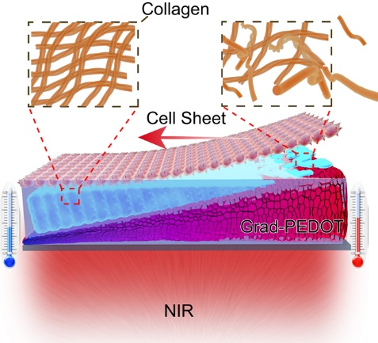
Figure 1: Scheme of gradient photothermal surface for precisely directing cell sheet detachment.
Recent Publications
- Jiange Jing, et al. (2019) Gradient photothermal field for precisely directing cell sheet detachment. Advanced Biosystems. 201800334.
- Shenglei Hou, et al. (2019) Dual-responsive polyphosphazene as a common platform for highly efficient drug self-delivery. Journal of Materials Chemistry B. 3, 4319.
- Xuemin Lu, et al (2018) Double-Helical Nanostructures with Controllable Handedness in Bulk Diblock Copolymers. Angewandte Chemie International Edition, 57, 15148.
- Lianyi Xu, et al. (2019) Durable Superamphiphobic Silica Aerogel Surfaces for the Culture of 3D Cellular Spheroids. National Science Review, nwz095.

Photograph

 Biography
Qinghua Lu is a proferssor of Tongji University. He received his Ph.D. from Shanghai Jiao Tong University in 1999. During his doctoral study, he was the visiting scholar of Hitachi Chemistry, Swiss Federal Institute of Technology in Lausanne and Max Planck Institute for Polymer Research. He has been a professor in Shanghai Jiao Tong University from 2000 to 2017. His research interests focus on biointerface for regulating cellular behaviors, mesoporous materials and multi-functional polyphosphazene nanoparticles
Email: qhlu@sjtu.edu.cn

