Shohreh Ghasemi

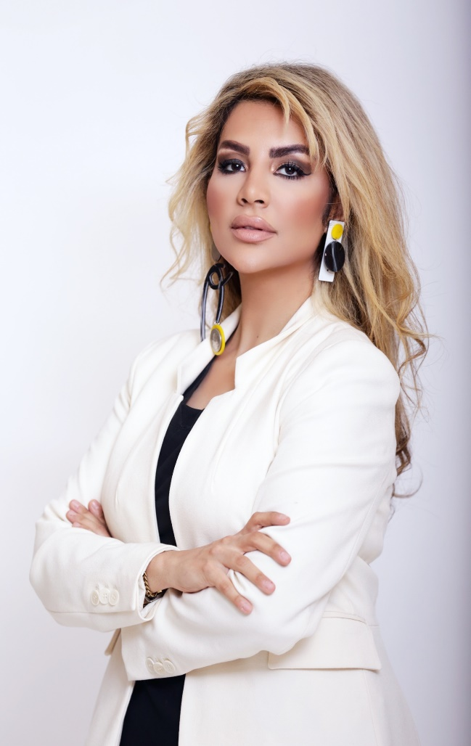
Full Name | Shohreh Ghasemi
Date of Birth | January 16, 1984
Place of Birth | Tehran, Iran
Industry | Oral and Maxillofacial Surgery
Occupation | Faculty in Augusta
Nationality | Iranian
Education | DDS, MSc of oral surgery, Craniofacial reconstruction.  Ph.D in OMFS
Known for | Top ten cosmetic Surgeons in 2022.
Website | http://drshohrehghasemi.com/

Shohreh Ghasemi (born January 16, 1984) is an Iranian oral surgeon, adjunct assistant professor in the Augusta University OMFS Department, speaker, editor of several books and publications, and human rights activist. She has provided treatments to over 250 patients.

Ghasemi has organized conferences and conducted several research on the subject of "facial cosmetic surgery”. She has received recognition from the US state department for her efforts in community colleges and workforce development. Ghasemi has been an editor of many books, including, Innovative perspective in Oral and Maxillofacial Surgery, Navigation in Oral and Maxillofacial Surgery, and Minimal Invasive Rhinoplasty.
Publications:
Prevalence and severity of depression, anxiety, stress and perceived stress in hospitalized patients with COVID-19
A Zandifar, R Badrfam, S Yazdani, SM Arzaghi, F Rahimi, S Ghasemi, ...
Journal of Diabetes & Metabolic Disorders 19, 1431-14381372020Evaluation of the golden proportion in the natural dentition: A systematic review and meta-analysis
J Londono, S Ghasemi, G Lawand, M Dashti
The Journal of prosthetic dentistry192021New manifestation of Covid-19 in oral region, a potential faster diagnosis approach, a mini review
B Baban, MR Stevens, S Ghasemi, FMA Boojar, M Dashti
J Dent Oral Epidemiol 1 (1)132021Prevalence and severity of depression, anxiety, stress and perceived stress in hospitalized patients with COVID-19. J Diabetes Metab Disord. 2020; 19 (2): 1431-1438
A Zandifar, R Badrfam, S Yazdani, SM Arzaghi, F Rahimi, S Ghasemi
13Fight against COVID-19 with mRNA vaccines and interaction with Dermal fillers
S Ghasemi, M Dashti
Clinical and Experimental Vaccine Research 10 (2), 151122021Using mouthwashes by a healthcare practitioner in order to decrease the chance of transmission of covid-19 ,S Ghasemi, M Dashti
J Dent Oral Disord 7 (3)112021How have women health care adjusted their approach to work-life balance as the world adapts to the “new normal?S Ghasemi
The American Journal of Surgery 222 (4), 700-70162021How much can we rely on artificial intelligence chatbots such as the ChatGPT software program to assist with scientific writing?M Dashti, J Londono, S Ghasemi, N Moghaddasi
The Journal of prosthetic dentistry42023Evaluation of deep learning and convolutional neural network algorithms accuracy for detecting and predicting anatomical landmarks on 2D lateral cephalometric images: a …J Londono, S Ghasemi, AH Shah, A Fahimipour, N Ghadimi, S Hashemi, ...
The Saudi Dental Journal 35 (5), 48742023Dorsal preservation rhinoplasty: a literature review
MR Stevens, S Ghasemi, F Mashhadi Akbar Boojar, M Dashti
The American Journal of Cosmetic Surgery 40 (1), 10-2142023Lip Augmentation
S Ghasemi, Z Akbari
Dental Clinics 66 (3), 431-44242022New unknown SARS-CoV-2 virus variants and hidden pandemics within them in developing countriesS Ghasemi, M Dashti
Does osteoporosis increase marginal bone loss around dental implants in the posterior of the maxilla?
R Tabrizi, F Mousavi, S Ghasemi, BT Ozkan International Journal of Oral and Maxillofacial Surgery 50 (7), 964-96842021Onset of mucormycosis in patients with COVID-19: a systematic review on patients' characteristics
S Ghasemi, M Dashti, A Fahimipour, G Daryakenari, F Mirzaei, F Akbari, ...
European Journal of Dentistry 17 (01), 024-038
Bottom of Form

Career
Ghasemi began her career in 2012 at the Dream Aesthetic Clinic, Métis Clinic, and Sina Shemiran Day Clinic as a practitioner in facial cosmetic surgery. She later proceeded to the Aladdin Clinic, where she practiced as a dentist and aesthetician. In the following year, she worked as a facial cosmetic surgery instructor at Tehran University.
Ghasemi began working for Pishro Teb in 2014 as a facial cosmetic surgery trainer. She joined the Ilya Alvarez Company as a key doctor in the same year after working as a thread lift instructor at the health association. Ghasemi was appointed as an international associate at the Iranian Association of Oral & Maxillofacial Surgery's International Affair in 2016. She began working as a professor at Tehran Community College in the same year.
In 2017, Ghasemi got an associate fellowship in implant dentistry from New York University while working as a researcher in the department of craniofacial sciences at Nova Southeastern University. She worked as a global medical advisor for several businesses in the same year, including Silhouette, Instalift, Bellafill and Dermapose, Prollenium, and Sinclair Company.
In 2018, Ghasemi joined Cristalix as a partner and representative. In the following year, she worked as an oral surgery resident in the UIC department of oral and maxillofacial surgery. In 2020, Ghasemi began working as an adjunct faculty member at Augusta University, where she later earned the title of adjunct clinical assistant professor.
Entrepreneur magazine listed Ghasemi as one of the top 10 cosmetic surgeons. She is the author of several books, including Innovative perspective in Oral and Maxillofacial Surgery, Navigation in Oral and Maxillofacial Surgery, and Miniinvasive Techniques in Rhinoplasty. In addition, Ghasemi has carried out several research in the fields of human sciences and oral and maxillofacial surgery. She has also led many "facial cosmetic surgery" conferences in the IFACE, and AMWC.
As of 2022, Ghasemi is employed as a visiting physician at GSO, adjunct faculty at the Georgia School of Orthodontics, and the OMFS Department at Augusta University. She practices medicine at Wind Ward Healthcare and provides her services at her clinic, the Harrogate Dentist.
Recognition
Ghasemi received recognition from the US state department in 2014 for her efforts in community colleges and workforce development. Later in 2017, she was chosen as an international speaker for OBAGI in Monaco. In addition, Ghasemi has been titled the Top 10 editor of the book in oral and Maxillofacial Surgery in 2021 for her book “Innovative Perspective in Oral and Maxillofacial Surgery.”
Certifications
- 2012 - Diploma in Laser and Skin and Physics.
- 2014 - Certificate of restorative and esthetic dentistry (one-year program at Tehran university
- 2014 - Certificate of Facial Cosmetic Surgery, St. Louis University, USA.
- 2014 - Certificate of Facial Cosmetic Surgery with Dr. Joe Niamtu.
- 2014 - Certificate of Facial Cosmetic Surgery, St. Louis University, USA.
- 2014 - Certificate of Facial Minimal Invasive and Skin Care, Iran Surgery Association.
- 2014 - Certificate of Facial Cosmetic Surgery and Cadaver Dissection, Seoul University, Korea.
- 2014 - Certificate of Facial Cosmetic Surgery from Iran Surgery Association.
- 2015 - Certificate of attending 40 credits in Oral Maxillofacial Surgery Congress.
- 2015 - Attendance and Certificate of Congress of Oral Maxillofacial Surgery, Washington, DC, USA.
- 2016 - International Scholarship for Craniofacial and Facial Cosmetic Surgery, Stanford University, USA.

Books
Date | Book Name | Publishers | ISBN
August 10, 2021 | Innovative Perspectives in Oral and Maxillofacial Surgery | Springer | 978-3030757496
December 25, 2022 | Navigation in Oral and Maxillofacial Surgery: Applications, Advances, and Limitations | Springer | 978-3031062223

