Engineering of MSCs sheet for the prevention of ischemic myocardial tissue
Dr. Dehua Chang, MD Ph.D., Department of Cell Therapy in Regenerative Medicine, The University of Tokyo Hospital, Japan

Abstract
The cell sheet is a newly developed tissue engineering technology that has brought scaffold-free tissue and shows great application potential in regenerative medicine and cell therapy. Mesenchymal stem cells (MSCs) have been used to improve cardiac function and prevent ischemic myocardial tissue through paracrine effects and immunoregulation functions. Using cell sheet technology, MSCs can be easily transplanted to the ischemic area, and the long-term retention of MSCs in the affected area was realized and significantly improved the curative effect. Currently, many types of MSCs can be used to prepare the cell sheets, such as bone marrow-derived MSCs (BM-MSCs), adipose-derived MSCs (AD-MSCs), skeletal myoblasts (SMs), umbilical cord-derived MSCs (UC-MSCs), and cardiomyocytes derived from induced pluripotent stem cells (iPS-CM). Since UC-MSCs have few human leukocyte antigen-II and major histocompatibility complex class I molecules and are easy to isolate and culture, UC-MSCs have been widely used due to their multipotency, broad range of sources, and compliance with standard amplification. UC-MSCs sheets were fabricated by UC-MSCs from a cell bank established by a standard operation process and quality control. Cytokine secretion, immunoregulation, and angiopoiesis were evaluated in vitro. Porcine myocardial infarction (MI) models were established by constriction of the left circumflex, and UC-MSCs sheets were transplanted onto the ischemic area of the heart tissue. In vivo, safe results showed that the UC-MSCs sheet had no oncogenicity and was mainly distributed on the surface of the ischemic myocardial tissue. Echocardiography showed that UC-MSCs sheets effectively improved the left ventricular ejection fraction (LVEF), and the LVEF significantly changed in the UC-MSCs sheet transplantation group compared with the MI group. Allogeneic source UC-MSCs sheets have been proposed as an effective cell therapy method for clinical applications to ischemic heart disease.

Image
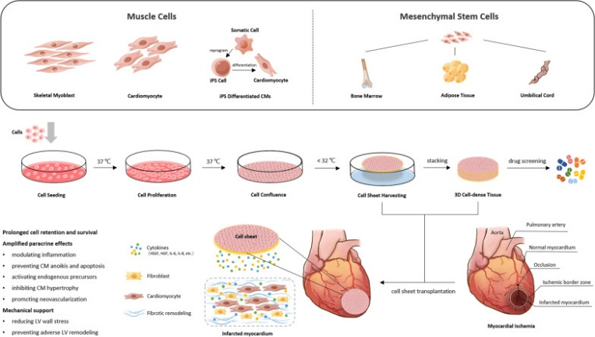
The schematic diagram illustrates the fabrication of cell sheets using different cell types from various sources and their potential applications in treating ischemic heart disease.
Recent Publications
- Miyagawa S, Saito A, Sakaguchi T, Yoshikawa Y, Yamauchi T, Imanishi Y, Kawaguchi N, Teramoto N, Matsuura N, Iida H, et al: Impaired myocardium regeneration with skeletal cell sheets--a preclinical trial for tissue-engineered regeneration therapy. Transplantation 2010, 90(4):364-372.
- Gheorghiade M, Vaduganathan M, Fonarow GC, Bonow RO: Rehospitalization for heart failure: problems and perspectives. Journal of the American College of Cardiology 2013, 61(4):391-403.
- Kim J-H, Joo HJ, Kim M, Choi S-C, Lee JI, Hong SJ, Lim D-S: Transplantation of Adipose-Derived Stem Cell Sheet Attenuates Adverse Cardiac Remodeling in Acute Myocardial Infarction. Tissue Engineering Part A 2017, 23(1-2):1-11.
- Guo R, Wan F, Morimatsu M, Xu Q, Feng T, Yang H, Gong Y, Ma S, Chang Y, Zhang S et al: Cell sheet formation enhances the therapeutic effects of human umbilical cord mesenchymal stem cells on myocardial infarction as a bioactive material. Bioactive Materials 2021, 6(9):2999-3012.
- Kawamura M, Miyagawa S, Fukushima S, Saito A, Toda K, Daimon T, Shimizu T, Okano T, Sawa Y: Xenotransplantation of Bone Marrow-Derived Human Mesenchymal Stem Cell Sheets Attenuates Left Ventricular Remodeling in a Porcine Ischemic Cardiomyopathy Model. Tissue Eng Part A 2015, 21(15-16):2272-2280.

Photograph

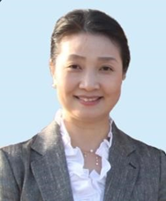
Dr. Dehua Chang has graduated from a clinical medical university and teaching and administration both at the University of Tokyo. She has been engaged in basic research, clinical application, and industrial development of stem cells in regenerative medicine and tissue engineering for many years. Master in the preparation, quality control, quality management, and clinical application of cell sheets from various cell sources and their clinical applications in ischemic myocardium, lower limb ischemic lesions, knee arthropathy, etc. Proficiency in polymer chemistry 3D cell culture technology and practical application.
Email: dehua_chang@yahoo.com

Notes/Comments:

