

In vitro effects of melatonin on colonization of neonate mouse spermatogonial stem cells in a three-dimensional soft agar culture system

Shadan Navid¹, Mehdi Abbasi¹* and Yumi Hoshino²
¹ First Author Affiliation (Gonabad University of Medical Sciences, Gonabad, Iran)
²Second Author Affiliation (Tehran University of Medical Sciences, Tehran, Iran)
³Third Author Affiliation (Hiroshima University, Hiroshima, Japan)

Abstract
Background: Melatonin is a pleiotropic hormone with powerful antioxidant activity both in vivo and in vitro. The present study aimed to investigate the effects of melatonin on the proliferation efficiency of neonatal mouse spermatogonial stem cells (SSCs) using a three-dimensional soft agar culture system (SACS) which has the capacity to induce development of SSCs similar to in vivo conditions.
Methods: SSCs were isolated from testes of neonate mice and their purities were assessed by flow cytometry using PLZF antibody. Isolated testicular cells were cultured in the upper layer of the SACS in αMEM medium in the absence or presence of melatonin extract for 4 weeks.
Results: The identity of colonies was confirmed by alkaline phosphatase staining and immunocytochemistry using PLZF and α6 integrin antibodies. The number and diameter of colonies of SSCs in the upper layer were evaluated at days 14 and 28 of culture. The number and diameter of colonies of SSCs were significantly higher in the melatonin group compared with the control group. The levels of expression of ID-4 and Plzf, unlike c-kit, were significantly higher in the melatonin group than in the control group.
Conclusions: Results of the present study show that supplementation of the culture medium (SACS) with 100 μm melatonin significantly decreased reactive oxygen species (ROS) production in the treated group compared with the control group, and increased SSC proliferation. Keywords: Spermatogonial stem cell, Melatonin, Colonization, Three-dimensional soft agar culture system, Proliferation

Keywords: Spermatogonial stem cell, Melatonin, Colonization, Three-dimensional soft agar culture system, Proliferation.
Professional Biography
I was graduated from University of Tehran in PhD anatomical sciences and have published more than 12 papers in reputed journals and has been serving as an editorial board member of reputed journals.

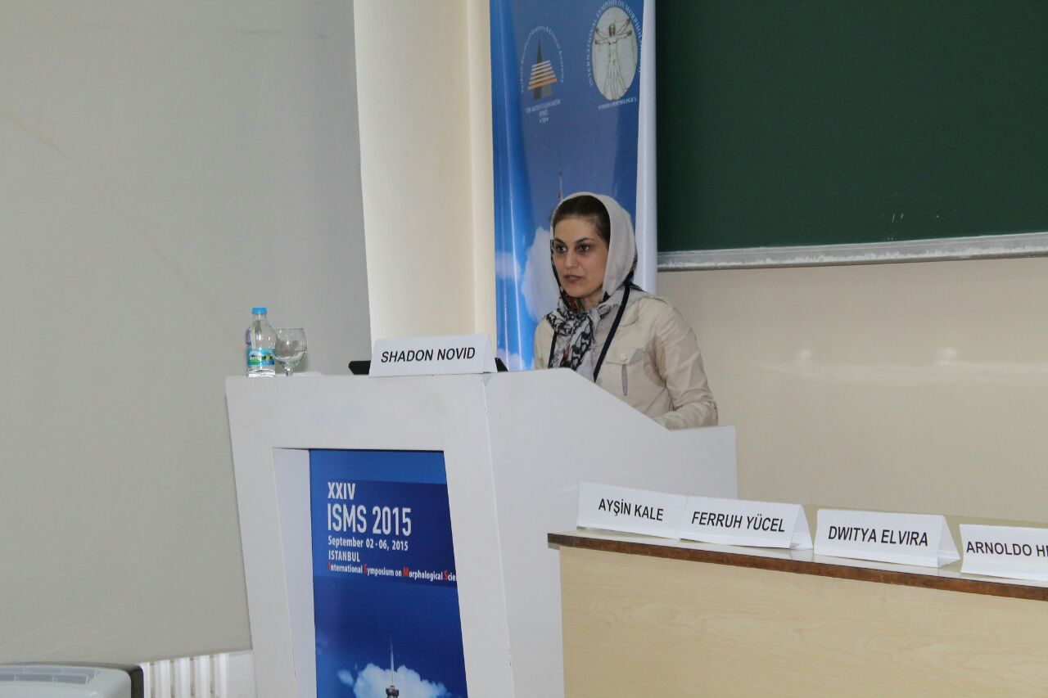

Email Id: navideshadan@yahoo.com

