Systemic umbilical cord blood mononuclear cell therapy of asthenic syndrome in patients with schizophrenia and evaluation of brain activation patterns using fMRI imaging.
Yana V. Morozova ¹, Dmitriy V. Ustyuzhanin¹, Vladimir A. Smirnov³, Mirab A. Shariya¹, Anatoliy B. Smulevich², Vladimir N. Smirnov¹
1 – National Medical Research Center of Cardiology, Moscow, Russia.
2 – Mental Health Research Center, Moscow, Russia.
3 – N.V. Sklifosovsky Research Institute of Emergency Care, Moscow, Russia.

Asthenic syndrome in patients with schizophrenia, also indicated as schizoastenia, is one of the major symptoms of the disease combined in many cases with apathetic-abulic and emotional disorders. Schizoastenia significantly decrease adaptation potential of patients with schizophrenia and concomitant disorders, prevents their social and professional functioning. Efficiency of the current therapy for schizophrenia is significantly limited. The most perspective treatment for schizoastenia is regenerative therapy including cell therapy. Cord blood mononuclear cells have several advantages comparing to other cell types while their efficiency remains high.
Clinical study phases I and IIa were performed assessing safety and primary efficiency of cord blood systemic therapy for treatment of hypodynamy and comorbid negative frustration in schizophrenia. Brain activation patterns were also assessed using fMRI. 15 patients (males, aged 20-40 years) with schizophrenia were included into the study. Remission status with a predominance of asthenic disorders was confirmed by psychiatric examination. Patients received intravenous infusions of mononuclear cord blood cells (250 X 10⁶ viable cells per infusion) for 4 injections with 2 week intervals. Standard neuroleptics therapy was maintained.
Evaluation of primary efficiency was performed using psychopathological, psychometric (PANSS, CGI, MFI-20 adynamy scales) and pathopsychological (MCCB battery, Beck depression scale) methods. Safety was assessed using revealed adverse events (CTCAE v5.0). Functional visualization (fMRI) was also performed.
Significant improvement according to PANSS subscale was revealed. Cell therapy reduced asthenic symptoms (fatigue, general weakness, fixation on somatic frustration), increased activity level resulting in reduction of therapeutic resistance. These effects are supposed to have triggering nature and revealed themselves as activation of intellectual activity, acceleration of information processing, correction of mnestic functions, higher levels of attention/vigilance and a considerable increase in social intelligence resulting in life quality improvement. The efficiency of antipsychotic medication was potentiated. fMRI revealed a significant brain activation in several areas connected to disorder after cell therapy.
Thus systemic cell therapy using hUCBCs promotes the improvement of asthenic disorders, increases the level of general activity and reduces cognitive disorders. The efficacy of both typical and atypical antipsychotics is potentiated. Functional MRI revealed significant changes of brain activation patterns in patients with schizophrenia underwent cells therapy. This data is important for further evaluation of the pathophysiology of stem cell exposure in patients with schizophrenia.

Professional Biography
Vladimir A. Smirnov, MD, PhD, specialized in orthopedic surgery and spine neurosurgery, completed PhD in 2019 at the age of 31 from Sklifosovsky Emergency Care Institute, Moscow, Russia by the topic of “Systemic application of mononuclear cord blood cells for treatment of severe spinal cord contusion in an animal model”. Has completed the series of experimental studies using cord blood stem cells in animal model of spinal cord injury. In 2015-2018 completed I/IIa phases of clinical studies in patients with severe spinal cord injury. Has published more than 17 papers in reputed Russian and foreign journals.

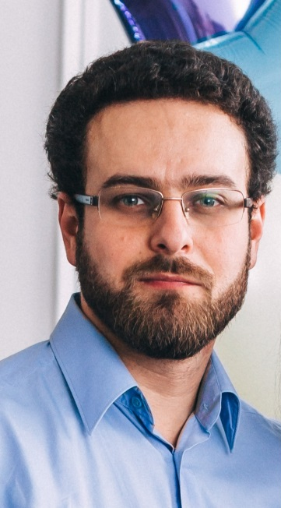
E-mail: vla_smirnov@mail.ru.

