Treatment of acute severe contusion spinal cord injury utilizing systemic infusions of human mononuclear cord blood cells (hUCBCs): phase I/IIa pilot randomized open-label clinical study of safety and primary efficiency.

Vladimir A. Smirnov¹, Andrew A. Grin’¹, Vladimir V. Krylov², Sergey I. Ryabov³, Marina A. Zvyagintseva³, Vladimir N. Smirnov³

¹ Department of Neurosurgery, Sklifosovsky Emergency Care Institute, Moscow, Russia;
² Clinical Medical Center, A.I. Evdokimov Moscow State Medical Stomatological Institute, Moscow, Russia;
³ Stem Cell Division, National Medical Institute of Cardiology, Moscow, Russia

Spinal cord injury (SCI) is a severe injury of CNS resulting in disability and significant decrease in quality of life. The uncomplicated injury of spine is easily and effectively treated in all cases using current surgical techniques, but in SCI no effective treatment is currently available.
We reported earlier the results of a preclinical study utilizing human mononuclear UCBCs in animal models of SCI. This study demonstrated high efficiency of systemic cell therapy resulted in regression of motor deficit up to 53-62% comparing to placebo and decrease in myelopathy size according to 7,0 Tl MRI assessment.
Further phase I/IIa pilot randomized open-label clinical study in patients with acute contusion SCI and ASIA A/B neurological deficit was carried out. 20 patients were included to the study divided into 2 groups. Treated patients obtained 4 iv infusions of 300 x 10⁶ mononuclear hUCBCs weekly. Follow-up period reached 1 year. No complications or side effects of cell therapy were observed in all patients (analysis using CTCAE classification was performed). The conducted analysis demonstrated restoration of spinal cord functions and improvement of outcomes comparing to standard therapy. The mean increase of ASIA scale in experimental group reached 2.2 while in control group it was 0.9. Total index of motor scale in upper extremities (UEMS) and lower extremities (LEMS) in treated group reached 77 ± 19 points while in control group it was 33 ± 21.6. 78% of treated patients were able to stand and walk autonomously and only 30% in control group. Cell therapy has also decreased the spasticity level in lower extremities assessed by modified Ashworth scale and promoted the improvement in self-urination ability in patients with neurological urinary retention.
Thus systemic cell therapy utilizing mononuclear human UCBCs is safe and effective method of regenerative therapy on acute contusion SCI.

Key words: cell therapy, cord blood, neurorestoration, spinal cord injury.

Professional Biography
Vladimir A. Smirnov, MD, PhD, specialized in orthopedic surgery and spine neurosurgery, completed PhD in 2019 at the age of 31 from Sklifosovsky Emergency Care Institute, Moscow, Russia by the topic of “Systemic application of mononuclear cord blood cells for treatment of severe spinal cord contusion in an animal model”. Has completed the series of experimental studies using cord blood stem cells in animal model of spinal cord injury. In 2015-2018 completed I/IIa phases of clinical studies in patients with severe spinal cord injury. Has published more than 17 papers in reputed Russian and foreign journals.

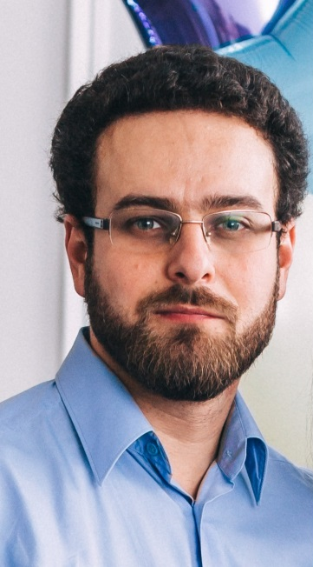
E-mail: vla_smirnov@mail.ru.

