Characterization and application of Stromal Vascular Fraction cells encapsulated in 3D fibrin-collagen hydrogels with intrinsic vascular network for skin tissue engineering

Mahsa Mollapour Sisakht^{1, 2}, Mohammad Amir Amirkhani¹, Javad Verdi^{2, 3}, Farzaneh Sharifzad², Mohammad Ali Nilforoushzadeh^{1∗}

¹ Skin and Stem Cell Research Center, Tehran University of Medical Sciences, Tehran, Iran.
² Applied Cell Sciences Department, Kashan University of Medical Science, Kashan, Iran.
³ Department of Tissue Engineering and Applied Cell Sciences, School of Advanced Technologies in Medicine, Tehran University of Medical Sciences, Tehran, Iran.

Abstract

Introduction: In this study we aimed to investigate the potential of freshly harvested SVF cells to generate functional capillary networks in a fibrin-collagen scaffold containing the main cells of epidermal and dermal layer of skin with respect to their potential of use in the clinic. In confirmation of previous studies, we report for the first time, the use of autologous dermal-epidermal skin grafts with intrinsic vascular network in a clinical setup on a background of advancements in scaffold design and assays for examining neovascularization in diabetic wounds.

Method & material: Fibrin gels were prepared by crosslinking fibrinogen in the presence of thrombin and mixing with collagen type 1. Human fibroblasts and keratinocytes were isolated from skin biopsies and SVF cells were obtained from the diabetic donors, cells were seeded on 3D-hydrogel layer by layer. Migration assay, MTT assay, histological analysis, immunocytochemistry and confocal microscopy were performed to characterize scaffold properties. For all patients, the skin substitute was transplanted onto wounds. Dressings were changed twice per week and photographic documentations was performed for patients. After wound healing, the healed skin was analysed using a high resolution skin scanner and skin sonography.
Result: The result of scaffold characterization demonstrated good porosity, potential of swell ability, biodegradability and biocompatibility of scaffold. Significant improvement in the number of capillaries, skin thickness, and density compared to the control group, and resembled normal skin
Conclusion: The preliminary data showed that clinical outcomes were generally satisfactory, suggesting that freshly harvested SVF can used in permanent epidermal-dermal skin like compartments to supply a vascular network in the dermal layer after 21-25 days in hydrogel-based grafts, and are safe for clinical use. Our study proposes the most promising tissue engineering approach to design a new generation of skin substitutes along with an intrinsic vascular network.
Key words: Tissue engineering, Fibrin-collagen hydrogel, Skin substitute, Diabetic foot ulcer

Professional Biography (100-150 words)

I am a last year doctorate student at the skin and stem cell research center, Tehran University of Medical Sciences, working under the supervision of Professor Nilforoushzadeh. I am working under an Iranian council for development of stem cell sciences and technologies grant (grant number: REP210), which funds a research group and includes collaboration with Kashan University of Medical Sciences. I was completed my thesis recently at the age of 33 years. Now, I’m responsible of regenerative medicine and tissue engineering laboratory in skin and stem cell center. I published 5 paper during 2015-2018 in reputed journal and has been serving as a member of Iranian council for development of stem cell sciences and technologies. In addition, I’m active member of The German Stem Cell Network (GSCN).

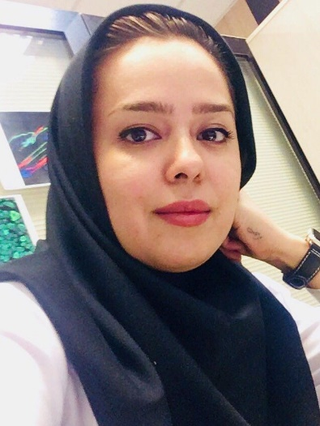

Email Id: Mahsa Mollapur@yahoo.com

https://scholar.google.com/citations?hl=en&view_op=list_works&gmla=AJsN-F4_-BaS0OkV1Xk-wT8-6d4Ze6f0kKMlGkr_3VaurWvTrhJ-IAdTxEHwR-8PMywFoA4TsIITrlkU3deChUHxTj-7Wz9Uhg&user=RhJv5qMAAAAJ

Any Comments:
Dear Sir or Madam,
I wish to apply to attend the Stem Cell conference on Stockholm, Sweden. The conference will be based on Advancing new progression & horizons in Stem Cell research and runs from May 9th to May 10st 2019. I am a last year doctorate student at the skin and stem cell research center, Tehran University of Medical Sciences, working under the supervision of Professor Nilforoushzadeh. I am working under an Iranian council for development of stem cell sciences and technologies grant (grant number: REP210), which funds a research group and includes collaboration with Kashan University of Medical Sciences.
I am looking to attend the Stem Cell conference to talk at the conference. The title of my talk will be Characterization and application of Stromal Vascular Fraction cells encapsulated in 3D fibrin-collagen hydrogels with intrinsic vascular network for skin tissue engineering. The opportunity to talk at the conference would allow me to discuss ideas with world experts in Stem cell and regenerative medicine field. This will be an invaluable experience that will undoubtably shape the future of my Postdoctoral study and allowing us to gain information about where they are focusing their efforts. Thank you for considering this request. Please let me know if you need any additional information that may influence your decision.
I look forward to hearing your response and attending the Stem Cell conference on Stockholm, Sweden, with your financial assistance in providing travel.

