Abstract
Abstract Title: IMPLANT OF AUTOLOGOUS BONE MARROW STEM CELLS IN PATIENTS WITH CONGESTIVE HEART FAILURE, FUNCTIONAL CLASS IV
M.Fernandez Vina¹, R.Fernandez Vina², F. Martinez³, R.F. Fernandez Vina⁴, L.Camozzi⁵, J.Saslavski^{6,}

¹ Clinica San Nicolas (Argentina)
² Clinica San Nicolas (Argentina)
³ Clinica San Nicolas (Argentina)
⁴ Clinica San Nicolas (Argentina)
⁵ Clinica San Nicolas (Argentina)
⁶ Clinica San Nicolas (Argentina)

Abstract (not more than 300 words)

Objetives/Goals:
1) Demonstrate that CD34 + / CD38 (-) Adult Stem Cells in myocardial tissue generate a significant increase in the ejection fraction after implantation.
2) To observe the improvement in the quality of life of the implanted patients, evaluating the reduction of dyspnea and the number of hospitalizations.
Material and methods: A descriptive, observational study of 71 and 88 -year-old patients with a history of CF IV heart failure with severe deteriorated FEY (<30%) who suffered hospitalizations every 15 days, due to biventricular dysfunction. They were submitted to implantation of bone marrow Stem Cells through retrograde venous technique in coronary sinus with balloon occlusion by femoral catheterization. A pre / post implant echocardiogram was indicated for comparisons (7 months) and a post-implant effort ergometry test was performed.
Results:
After a period of 210 days, a significant improvement in the ejection fraction of approximately 8% and 14% was observed with respect to the baseline (P:0.05), and a decrease in both hearts mass of 20% (grams). In addition, it was observed that the patients did not have recurrence in hospital admissions successively every 15-20 days, cause congestive heart failure and that there is a remarkable improvement in the quality of life rapidly after the implantation of Stem Cells. The post-implant ergometry test, at 210 days, turned out to be encouraging, since the patient tolerated the stress test greater than 6 minutes.
Conclusion:
The implantation of Stem Cells generated a favorable decrease in the number of hospital readmissions of the evaluated patients and showed improvement of their quality of life after no dyspnea CF IV. It was corroborated that there is a significant improvement of the ejection fraction, with decrease of the mass of the implanted organ.

Keywords—Stem Cells , Heart Failure, Improvement, Retrograde Technique

Professional Biography (100-150 words)

Dr Matias Fernandez Vina, Argentine, has completed his PhD at the age of 26 years from Universidad Abierta Interamericana Rosario and specialized studies from Universidad Maimonides as Cardiologyst.

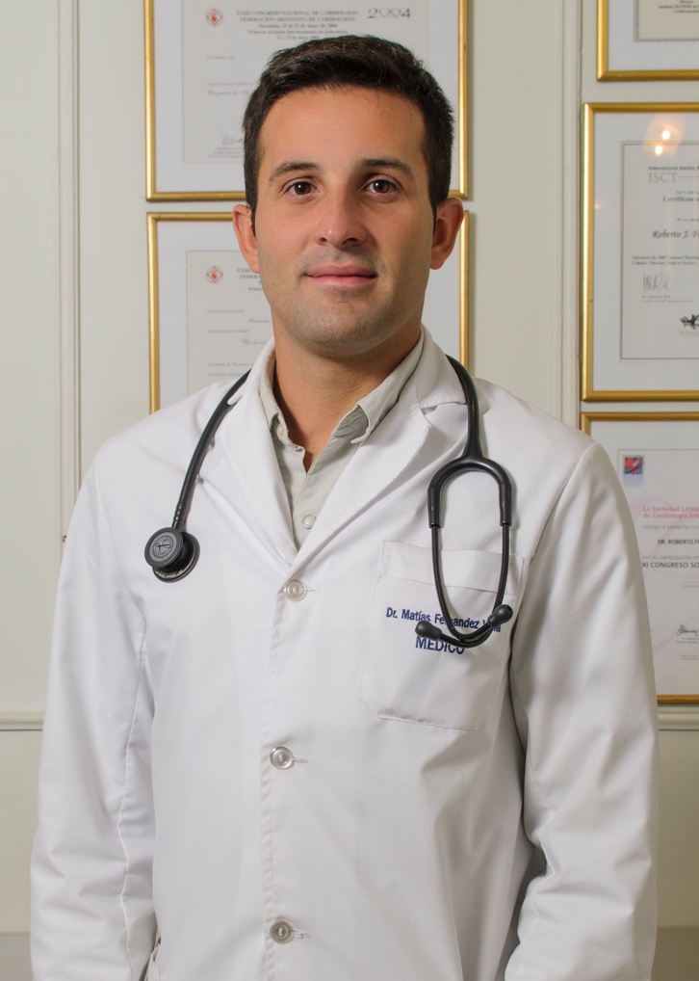

Email Id: matiasfernandezvina@hotmail.com

