Evaluation of Pulmonary Vascular Permeability Following Using Intratracheal of Marrow-Derived Mesenchymal Stem Cells in Experimental Model of Acute Respiratory Distress Syndrome in Sheep
Sadeghian Chaleshtori. Sirous ^{1, 3}, Mokhber Dezfouli. Mohammad Reza ^{1, 3},
Dehghan. Mohammad Mehdi ^{2, 3}, Jabbari Fakhr. Massoumeh ^{3, 4}, Yadollahi. Shokufeh⁴, Abbasi. Javad ⁵, Noori. Afshin ⁶

¹Department of Internal Medicine (University of Tehran, Iran)
²Department of Surgery and Radiology (University of Tehran, Iran)
³Institute of Biomedical Research (University of Tehran, Iran)
⁴Graduated from D.V.M in Veterinary Medicine (University of Tehran, Iran)
⁵Post graduated from D.V.Sc in Veterinary Internal Medicine (University of Tehran, Iran)
⁶Student of Veterinary Medicine (University of Tehran, Iran)

Abstract
The acute respiratory distress syndrome (ARDS), is a clinical complication of severe acute lung Injury. ARDS is characterized by disruption of the lung alveolar–capillary membrane barrier and resultant of pulmonary edema associated with a proteinaceous alveolar exudate. There is no specific treatment strategies for ARDS. The use of mesenchymal stem cells in the treatment and recovery of lung injury has become a promising therapeutic approach. The purpose of this study is to evaluate the performance of bone marrow which derived mesenchymal stem cells (BM-MSCs) in pulmonary vascular permeability in ARDS model.
In this study, ten3-4 months old male sheep were selected and were randomly divided into two groups of treatment and control.
Intratracheal administration of E.coli-lipopolysaccharide strain of O55:B5 was induced in an experimental model of ARDS and was confirmed by registration of clinical signs and radiographic image. Also in the treatment group, BM-MSCs were collected, isolated and cultivated. The number of cells for each sheep was brought to 5×10⁷cells. After 24hours of ARDS-induced, BM-MSCs were autographed as intratracheal in both treatment group and control-group and 10ml intratracheal PBS was injected. In order to evaluate effects of cell therapy, stem cell transplantation or PBS infusion samples of Bronchoalveolarlavage (BAL) were obtained in 0,24,48,72and168 hours after by bronchoscopy from distal airway to measure the concentration of IgM, albumin and total protein by ELISA Kit.
The results showed that transplantation of stem cells can reduce concentration of increased IgM, albumin and total protein in lung inflammation time, significantly. Ratio of IgM to total protein and albumin to total protein showed significant reduction at 72 and 168 hours and total protein was decreased at hours of 48,72,168 compared with inflammation time(P<0.05).These results suggested that BM-MSCs could improve the capillary-alveolar barrier integrity and play a significant role in the repair of lung injury.

Keywords— ARDS, BM-MSCs, BAL, Sheep.

Professional Biography
Afshin Noori DVM Student at the age of 25 years from Tehran University. He is experienced in stem cell transplantation and diffrentition . He is currently working at Royan institute.

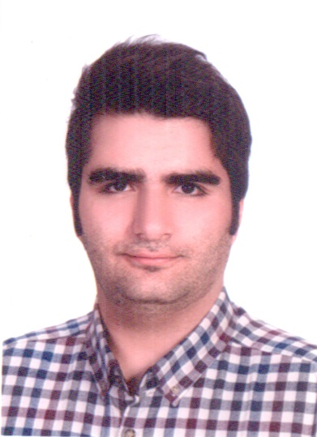

Email Id: Afshin_Noori92@yahoo.com

