CT-Scan an Approach for the Diagnosis and Follow up Stem Cell Therapy of Acute Respiratory Distress Syndrome

Sadeghian Chaleshtori. Sirous ^{1, 3}, Mokhber Dezfouli. Mohammad Reza ^{1, 3},
Dehghan. Mohammad Mehdi ^{2, 3}, Vajhi. Ali Reza ^{2, 3}, Jabbari Fakhr. Massoumeh ^{3, 4}, Mokhtari. Roshanak ², Noori. Afshin⁵

¹Department of Internal Medicine (University of Tehran, Iran)
²Department of Surgery and Radiology (University of Tehran, Iran)
³Institute of Biomedical Research (University of Tehran, Iran)
⁴Graduated from D.V.M in Veterinary Medicine (University of Tehran, Iran)
⁵Student of Veterinary Medicine (University of Tehran, Iran)

Abstract
Acute respiratory distress syndrome (ARDS) is one of the main causes and developing factor of respiratory failure around the world. Specific and common feature of ARDS is loss of aerated lung volume. Chest computerized tomography (CT-scan) is a non-invasive and repeatable technique for diagnosis lung inflammation and edema. CT-scan can measured lung densities and separated aerated from poorly and non-aerated lung regions. The present study showed preclinical data of bone marrow derived mesenchymal stem cells (BM-MSCs) based therapy for ARDS in rabbit.
Experimental model of ARDS were made in 10 male white New Zealand rabbits (n=5 rabbits in each treatment and control group) by intratracheal delivery E.coli-lipopolysaccharide strain of O55:B5 and inflammation confirmed by radiograph image and CT-scan. Then, in treatment group BM-MSCs were isolated and expanded and 10⁷ cells were intratrachealy autographed whereas PBS was intratrachealy injected in the control group. Conventional CT from lung were obtained at 12 h and 1, 2, 3 and 7 days after transplantation. Hounsfield unit and volumes of aerated and non-aerated parts of right and left lung were measurement using a computerized tomographic.
The result demonstrated the Hounsfield unit has increased one day after the inflammation that represent replacement of alveolar air with mucus and inflammatory cells.
The stem cell therapy caused significant decrease in Hounsfield unit at 48 (p = 0.032), 72 (p = 0.036) and 168 (p = 0.025) hours post-transplantation compared with inflammation time which is indicating an increase in air volume of lung in the treatment group. Also, the mean lung volume in both groups increased after inflammation but transplantation of BM-MSCs had decreased in the process at 72 (p = 0.047) and 168 (p = 0.027) hours.

Keywords— ARDS, BM-MSCs, CT-Scan, Lung, rabbit.

Afshin Noori DVM Student at the age of 25 years from Tehran University. He is experienced in stem cell transplantation and differentiation. He is currently working at Royan institute.

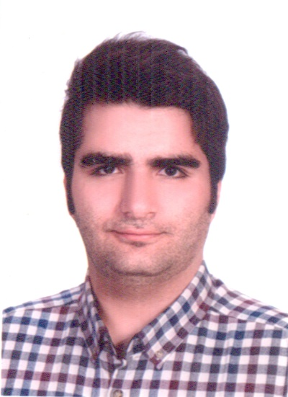

Email Id: Afshin_Noori92@yahoo.com

