Abstract Template
Abstract Title: Control of chaos and stick-slip motions using tuned mass damper
D.C. Tsobgni-Fozap, A. Kenfack-Jiotsa, E. Tala-Tebue, M. Motchongom-Tingue, T.C. Kofané

¹First Author Affiliation (University of Yaoundé I, Cameroon)
²Second Author Affiliation (University of Yaoundé I, Cameroon)
³Third Author Affiliation (University of Dschang, Cameroon)
⁴Fourth Author Affiliation (University of Bamenda, Cameroon)
⁵Fifth Author Affiliation (University of Yaoundé I, Cameroon)

Abstract (not more than 300 words)

A mass fixed on a spring and driven by a conveyor belt is considered. The system exhibits very rich nonlinear dynamics like stick-slip motions, chaotic motions and very low amplitude motions. The control of these behaviors is investigated by using control systems like tuned mass damper. Therefore, chaotic stick-slip is converted into regular stick-slip. For certain tuned mass damper, regular stick-slip is transformed into stick-slip with very small amplitude. In addition, the chaotic motion is converted into regular motion, while very low amplitude motion remains unchanged. In the case of chaotic motion, the largest Lyapunov exponent is evaluated and the stability map obtained confirms the control.

Keywords—Lyapunov exponent, Stability map, Stick-slip motion, Tuned mass damper,

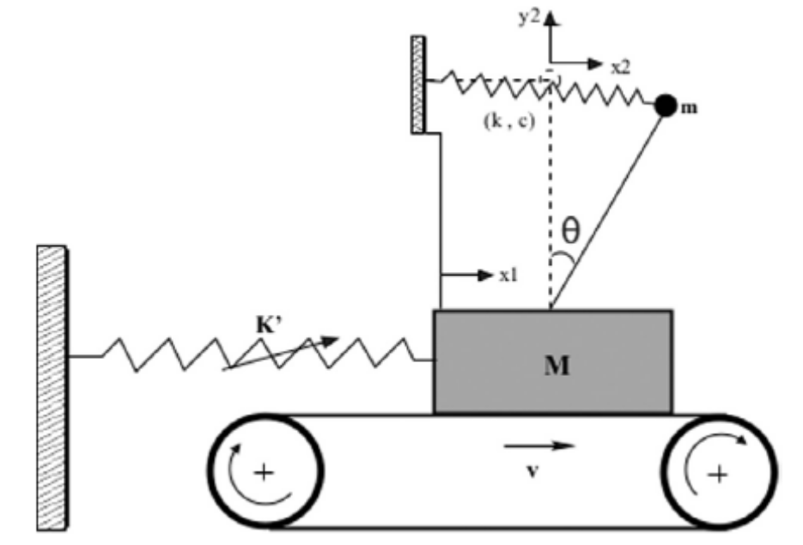

Figure1 : Schematic representation of the model

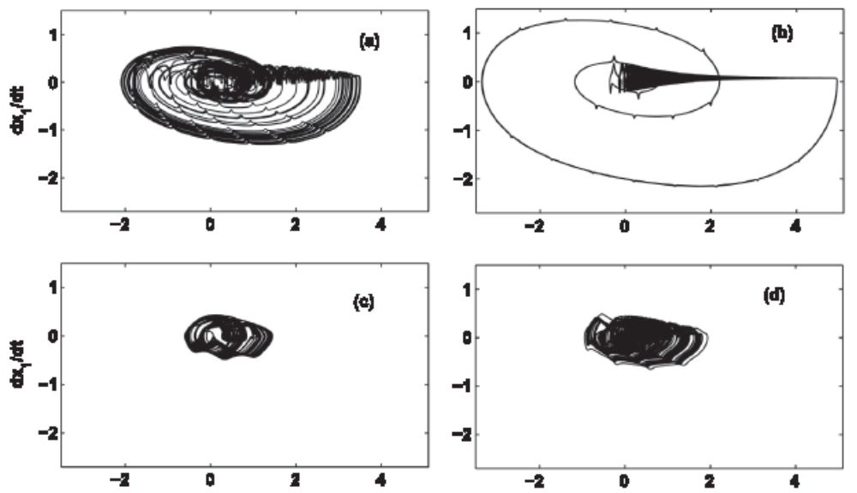

Figure2 : Types of motions exhibited by the uncontrolled system
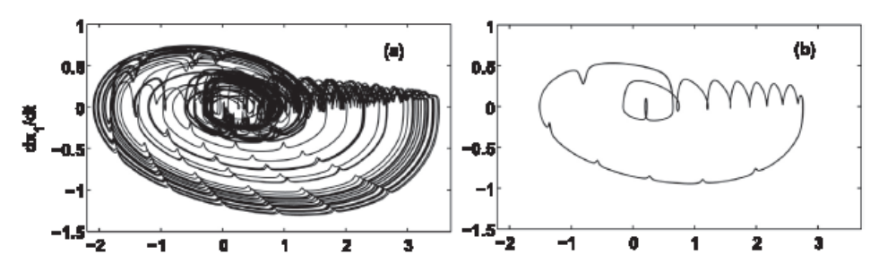

Figure3 : Conversion of chaotic stick-slip into regular stick-slip

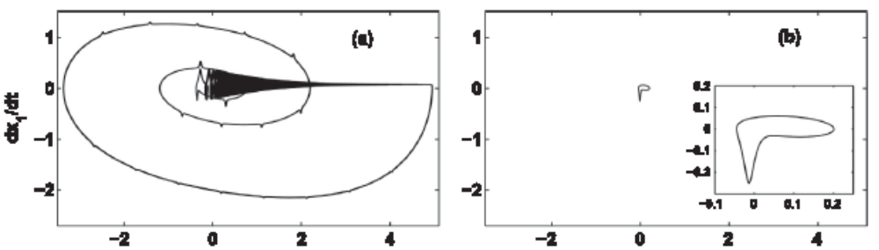

Figure4 : Conversion of regular stick-slip into stick-slip with very small amplitude

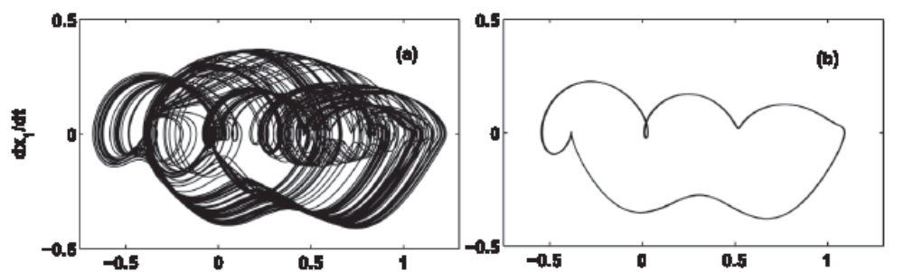

Figure5 : Conversion of chaotic motion into regular motion

Professional Biography (100-150 words)

Dr TSOBGNI FOZAP has completed his PhD at the age of 34 years from Yaoundé I University with the grade: very honorable. He is a member of Nonlinear Physics and Complex Systems Group, a Reseach Group of Higher Teacher Training College of Yaoundé I. He has published more than 5 papers in reputed journals and has been serving as a reviewer in journals like Nonlinear Dynamics, Physics Letters A.



Full Name: TSOBGNI FOZAP Christophe Deschance
Email Id: fozap2002@yahoo.fr
Contact No: +237 699952623
Social Network Details (FaceBook/LinkedIn): Chris Tsobgni

Any Comments:
A great opportunity to me to discuss with others researcher in the field of dynamics and control of structures.

