Abstract Title: Combined Design and Optimisation in Structures Design
J. S. Rao
President Vibration Institute of India
AICTE and INAE Distinguished Visiting Professor
Bangalore

Abstract
Science Revolution began with Optimization as in Brachistochrone problem by Newton in the year 1697. Subsequently Galerkin in the year 1915 provided solution techniques for structures by using solution in series form and employing orthogonalisation. These methods are shown to give the same solution leading to the same solution with the modern high performance computing (HPC) of this century. The presentation deals with Solid Isotropic Material with Penalization (SIMP), Topology Optimization, Weight and Shape optimization of aircraft structures and engines using isotropic as well as composite materials leading to combined design and optimization in the same step and thus reducing product development time. Examples given in this presentation include the following.
- Weight Reduction in Aircraft Engine Blades
- 2D Shape optimization for minimization of local stresses and strains in Blade roots
- Development of Wing Structures from air foil surface using Topology Optimization
- Development of Composite Wing structures from Isotropic Material Structures using Topology Optimization
- Development of Composite Fan Blades of aircraft engines for weight reduction
- 3D shape optimization of last stage steam turbine or first stage LP Compressor blades roots for minimum local stresses and strains
- 3D shape optimization of structural elements to absorb maximum energy in an impact
- Flow path optimization in conjugate heat transfer for maximum heat absorption in Dorsal units
- Flow induced noise and reduction by modification of the flow path

Keywords—Solid Isotropic Material with Penalization (SIMP), Topology Optimization, Weight and Shape Optimization, Flow Path for noise reduction

Professional Biography

J. S. Rao has completed his PhD at the age of 25 years from IIT Kharagpur and postdoctoral studies from University of Surrey and obtained DSc from IIT Kharagpur at the age of 31 years. He is currently in Bangalore as the President of Vibration Institute of India and AICTE and INAE Distinguished Professor and publishes Springer co-publication of Journal of Vibration Engineering and Technologies. He has published more than 400 papers in reputed journals and conferences. He has been serving as an editorial board member of reputed journals across the world.

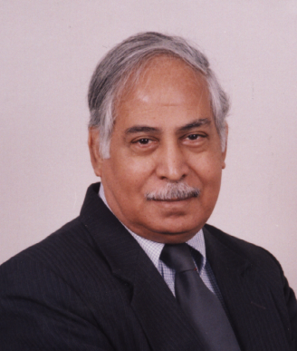
Full Name: Jammi Srinivasa Rao (J. S. Rao)
Email Id: rao_js@yahoo.com
Contact No: +91 98453 46503
On Social Networks of Face Book and / LinkedIn

