HIV Awareness in India : Using Wikipedia as a Tool of Societal Awareness and Transformation
SYED MUZAMMILUDDIN
Gold Medalist in Dip. In HIV & Family Education (IGNOU), Bachelor of Communication and Journalism & MBA (Osmania University)

Statement of the Problem: India is home to the world’s third-largest population suffering from HIV/AIDS after South Africa and Nigeria. This includes commercial sex workers (CSW), men having sex with men (MSM), injecting drug users (IDU) and transgenders as the most vulnerable groups. India’s National AIDS Awareness Control Organization (NACO) and State AIDS Control Societies (SACS) have been concurrently running awareness advertisements in the print media and commercials on the electronic media. However, in the current internet age, Wikipedia along with a host of other websites has emerged as a major source of information. With over 500 million surfers, Internet users in India often seek knowledge through Wikipedia either directly or through Google-search.
Methodology & Theoretical Orientation: This study is a result of an awareness survey done by the presenter on HIV awareness and the use of Wikipedia in India.
Findings: The surveys finds that Wikipedia is probably the most comfortable and handy tool for information. Although medical advice is needed in many complex cases, yet in a country like India where discussions pertinent to sex, birth control, marital problems and most importantly, the issues of HIV and venereal diseases are often viewed as taboo for open public discussion, this online resource largely suffices the void. There is a need to expand the knowledge levels in these areas of information in Indian languages on the lines of the English Wikipedia as many respondents are not well-versed in English.

Image

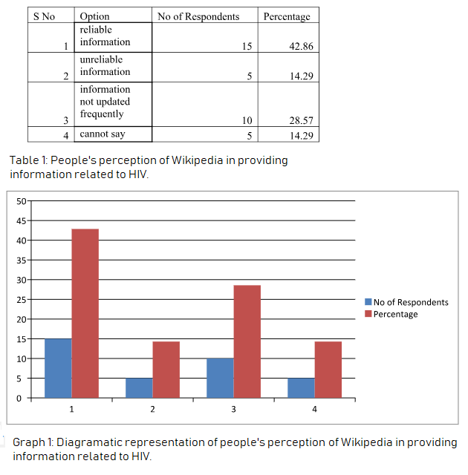
Recent Publications
- SABRI, B; et al. Gender Differences in Factors Related to HIV Risk Behaviors among People Who Inject Drugs in North-East India. PLoS ONE. 12, 1, 1-13, Jan. 18, 2017. ISSN: 19326203.
- SHUKLA, S; MUCHOMBA, FM; MCCOYD, JM. 'Drug adherence levels are falling down again': health worker perceptions of women's service utilization before and after integration of HIV/AIDS services into general care in India. Health Policy & Planning. 33, 5, 623-632, June 2018. ISSN: 02681080.
- NIMKAR, S; et al. Loss to follow‐up and mortality among HIV‐infected adolescents receiving antiretroviral therapy in Pune, India. HIV Medicine. 19, 6, 395-402, July 2018. ISSN: 14642662.
- GUPTA, MK; SENGUPTA, A; VISNEGARWALA, F. Empowerment and engagement of SHG women against HIV/AIDS in India: an interventional study. Journal of Comprehensive Health. 4, 2, 1-9, July 2016. ISSN: 2347498X.
- SEBASTIAN, MP; et al. Service utilization and cost of implementing a comprehensive HIV prevention and care program among people who inject drugs in Delhi, India. Harm Reduction Journal. 14, 1-10, June 14, 2017. ISSN: 14777517.

Photograph

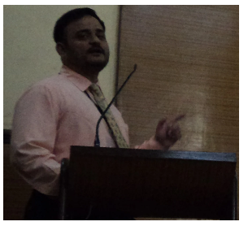
Biography

Syed Muzammiluddin holds a Gold Medal in the Diploma in HIV and Family Education. He is also a graduate in Communication and Journalism and an MBA. He is a member of International AIDS Society (IAS), Switzerland. As a dedicated academician, he holds 19 years of experience teaching to the Students of Healthcare, Pharma and Biotechnology, Communication and Journalism as well as Management. He is quite vocal and proactive in writing on topics related to HIV/AIDS. He has participated in many conferences in India, Nepal, Mexico, Canada and Italy.

Email: muzammil.wikipedia@gmaill.com

