

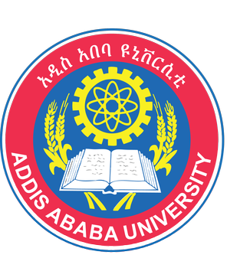
Paste your Logo here
Paste your Photograph Here

Title: Nutritional status and its effect on treatment outcome among HIV infected clients receiving HAART in Ethiopia: a cohort study
Name: Sadikalmahdi Hussen

School of Pharmacy, Addis Ababa University, Ethiopia

The aim of this study was to determine the effects of nutritional status at the start of highly active antiretroviral therapy on treatment outcomes among HIV/AIDS patients taking HAART at Jimma University Specialized Hospital.
We performed a retrospective cohort study involving 340 adults who started highly active anti-retroviral therapy. The patients have been clinically followed for 2 years. Data were extracted from paper based medical charts by trained data collectors from January 30 to February 28, 2014 using data collection format. We entered data into Epi data version 3.1 and then exported to SPSS for windows version 21. Predictors of CD4 change were identified using multivariable linear regression model. Time to an event (death) was estimated by Kaplan–Meier and predictors of mortality were identified by Cox proportional hazard model.
Out of 340 patients, 42 patients died during the follow-up. Twenty-five (59.5 %) deaths were from malnourished group. Age, baseline CD4, sex, baseline HAART and marital status were significant predictors of immunologic recovery at different time points. Malnutrition was associated with lower CD4 recovery and greater hazard of death.
In Conclusion, malnutrition tends to decrease CD4 recovery and predisposes patient to early death.

Biography

Sadikalmahdi has completed his MSc in Clinical Pharmacy from Jimma University, Ethiopia and now studying his PhD at University of Queensland, Australia. He has published more than 10 papers in reputed journals and some others on pipeline.

