
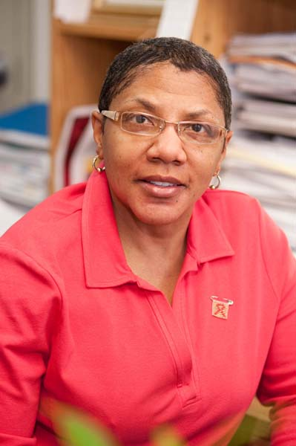

Title: None of Us Will Get Out of Here Alive: The Intersections of HIV Awareness, Risk Perceptions, and Behavior Risk
Lorece Edwards, DrPH, MHS
Morgan State University

The Human Immunodeficiency Virus (HIV) significantly impacts minority emerging adults, among whom the rate of new diagnoses is high and health disparities are more pronounced. Unfortunately, the new emerging adults of today have limited knowledge of the earlier toll of the HIV when it was identified as a “killer” sexually transmitted disease. Among this population, perceptions of risk for HIV are low and sexual risk taking behaviors are high. HIV risk perception has been shown to be significantly related to prior HIV testing behavior; however, current knowledge of determinants related to HIV risk perceptions among college students has been limited. The Get SMART Project is a behavioral HIV intervention aimed to increase the awareness of HIV, provide re-purposed HIV and substance abuse prevention education as well as HIV testing to African American emerging adults ages 18 -24. The project was guided by the Transtheoretical and socio-ecological models as well as a creative blend social networking, social media, social marketing, Fine Arts, and community-based theater. Three hundred and sixty-five emerging adults participated in population-based surveys and eight focus groups were conducted with approximately fifty-seven participants. Findings revealed that HIV testing is low and behavioral health risks are escalated. Gaps in knowledge were reveals, especially regarding sex and gender differences in HIV acquisition. Emerging adults did not see themselves at risk for HIV. Specific risk priorities were identified and survival expectations influence risk behaviors.

Bio:
Dr. Lorece V. Edwards is a native Baltimorean. She is currently the Director of the Center for Sexual Health Advancement and Prevention Education (SHAPE) and Associate Professor in the Department of Behavioral Health Sciences at Morgan State University’s School of Community Health and Policy. She published several papers on HIV primary prevention, and prevention interventions. Dr. Edwards has also received more than three million dollars in HIV funding.

