Vulnerability due to Climate Change of Women and Youth with STDs in Southern Province of Zambia
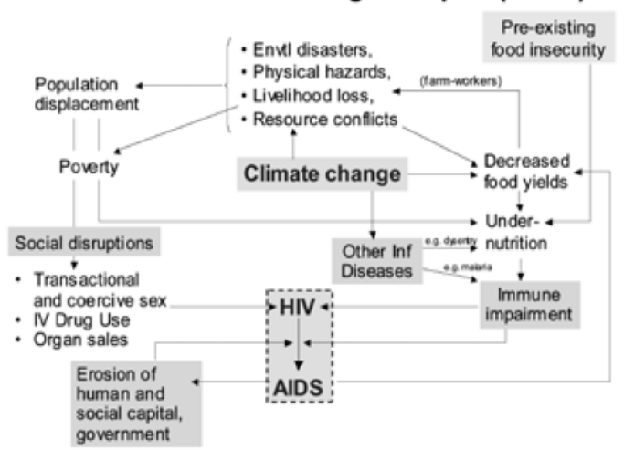

Abstract
The Statement of the Problem: was that rural Women and Youth that have been exposed to environment environmental changes are at risk of not getting an effective Sexual Transmitted. Zambia, with a population of about 17 million, has been experiencing relatively steady economic growth. However, about 67% are still living in poverty. In 2016, 144,000 (12%) of the 1.2 million adults (aged 15 and over) living with HIV in Zambia. Sexually transmitted diseases (STDs) are an increasing public health problem in Zambia. About 200 000 cases of STDs are treated annually in the formal health sector. Young people are the most affected by STDs. High-risk sexual behaviour has been identified as the major risk factor for STDs among young people. THE HIGHER prevalence of Sexually Trans mitted Diseases (STDs) such as syphilis and gonorrhea is one of the health problems among the major diseases in Zambia today in spite of the available medical care for these diseases. In addition there is a new and more serious Autoimmune Deficiency Syndrome (AIDS) among the STDs.
Figure: The HIV and Climate Change Complex, UNEP and UNAIDS, 2010
Lessons Learned
The purpose of this study was to highlight the importance of continued awareness and knowledge sharing in order to address STIs as circumstances has changed over the period when it was first reported to now. The methodological approach used was through semi-structured interviews, focus group interviews and expert experience. The results show that food security was the most affected due to climate change resulting from persistent drought, causing yield reductions, decreasing water availability and increasing risks to pests (e.g. army worms). It was observed that 20% of those talked to were affected with inadequate food and were at higher risk of malnutrition which affects their overall health and immune system. About 15% reported a decline in household incomes declined. In order to raise additional financial resources, about 30% of the youth were engaged in casual sex, resulting into further exposure. It was noted that due to unfavorable conditions, at least 1% of those having STDs moved to new places in search of livelihood, which may result into further spread.
The conclusion and significance of the study is that awareness raising and education need to continue since there are continuous changes in the economic, social and environmental circumstances surrounding those living with HIV. While progress may be made in terms of understanding the spread and treatment of STIs, there is need to understand the environment in which people living with HIV/AIDS in regards to STDs.

References
- Phillimon Ndubani Bengt Höjer
Health Policy and Planning, Volume 16, Issue 1, 1 March 2001, Pages 107–112, https://doi.org/10.1093/heapol/16.1.107
- Kasongo W, Tembo M, Mwakazanga D, Kamanga J, Mwape F, Chelu L (2015). Integrated Biological and Behavioural Surveillance Survey (IBBSS) among Female Sex Workers and Behavioural Surveillance Survey (BSS) among Male Long Distance Truck Drivers in Five Corridors of Hope Project District Sites in Zambia. USAID Report, Lusaka.
- Young T, Tucker T, Galloway M, Manyike P, Chapman A, Myers J (2010). Climate change and health in SADC region: Review of the current state of knowledge. SADC: climate change and health synthesis report. South Africa.
- UNEP and UNAIDS (2010). Climate Change and AIDS: A Joint Working Paper. Nairobi, Kenya.
- Valerie Githinji and Todd A. Crane (2014). Compound Vulnerabilities: The Intersection of Climate Variability and HIV/AIDS in Northwestern Tanzania. American Meteorological Society

Photograph


Georgina Mabezere is a social activist and a social entrepreneur; she is founder of Avier Vintu Vintu a fashion design company. She is Co-Founder of Zambian network of Young People Living & Affected with HIV – ZNYP helps mitigate the impact of Sexual Reproductive Health and HIV among young people. She is passionate about youth work in governance, human rights, education, entrepreneurship, health, gender and peace. She has studied Insurance, Business, Diplomacy and international relations and currently is a 3rd year law student. She aspires to employ a minimum of 1000 Zambian youth by 2030.
Email: georginamabezere@gmail.com

