Antibiotics for treating urogenital Chlamydia trachomatis infection in men and non-pregnant women
Carol Paez-Canro1, Juan Pablo Alzate2, Lina M Gonzalez2, Jorge Andres Rubio-Romero3, Anne Lethaby4, Hernando G Gaitan3
1 Clinical Research Institute, Faculty of Medicine, Universidad Nacional de Colombia, Bogota, Colombia
2 Research Unit, Fundacion Universitaria de Ciencias de la Salud, Hospital Infantil de San Jose, Bogota, Colombia
3 Department of Obstetrics and Gynecology, Faculty of Medicine, Universidad Nacional de Colombia, Bogota, Colombia
4 Department of Obstetrics and Gynaecology, University of Auckland, Auckland, New ZealandDr ABC, RN PhD, TLI Foundation, USA

Abstract (300 word limit)

Background: The genital infection caused by Chlamydia trachomatis (CT) is one of the most common sexually transmitted diseases (STDs) globally. Different antibiotics regimens are recommended in clinical practice guidelines (CPG) for CT urogenital infections.

Objectives

To assess the efficacy and safety of antibiotic treatment for Chlamydia trachomatis genital infection in men and non-pregnant women.

Search methods

We developed the electronic searches in; (CENTRAL, MEDLINE, Embase and LILACS), and two trials registers.

Selection criteria

We included randomised controlled trials of sexually-active non-pregnant women and men with genital CT infection

Analysis

We estimated the pooled risk ratio. Our primary outcomes were microbiological failure and adverse events

Main results

We selected 14 studies.

For azithromycin vs doxycycline in women treated for CT, the effect on microbiological failure was uncertain (RR = 1.71, 95% CI 0.48 to 6.16). In men treated for CT, the risk of microbiological failure was probably higher with azithromycin compared to doxycycline (RR 2.45, 95% CI 1.36 to 4.41). We found that azithromycin probably has less adverse events in both genders compared to doxycycline (RR 0.83, 95% CI 0.73 to 0.95; I2 = 0%).

For tetracyclines vs quinolones, the effect of doxycycline compared to ofloxacin on microbiological failure in women was not estimable and the effect of doxycycline vs ofloxacin also in women on clinical failure was uncertain (RR 0.94, 95% CI 0.39 to 2.25). For men treated for CT the effect of doxycycline compared to ofloxacin at the same doses on microbiological failure was uncertain (RR 8.53, 95% CI 0.43 to 167.3)

Conclusions

Regimens with azithromycin 1 gram single oral dose has probably less efficacy than doxycycline 100 mg twice a day for seven days in men in terms of microbiological failure. However, in men there might be little or no differences in terms of clinical failure.

Image
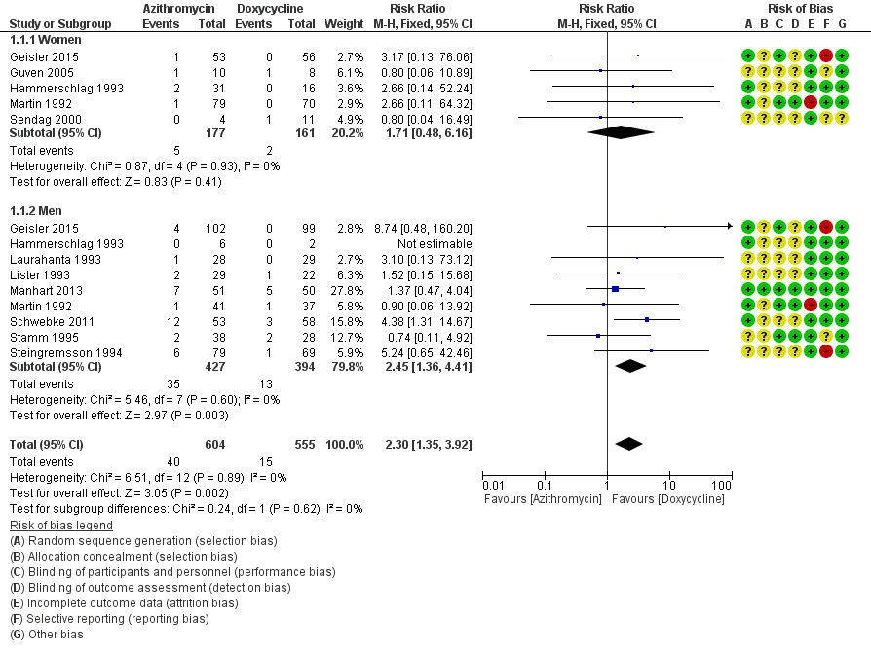

Figure 1. Forest plot of comparison 1. Macrolides. Regimens with azithromycin: azithromycin 1 g-only dose vs doxycycline 100 mg twice a day for 7 days, outcome: 1.1 microbiological failure.

Recent Publications (minimum 5)
- Angel-Müller E, Rodríguez A, Núñez-Forero LM, Moyano LF, González P, Osorio E, et al. The prevalence of and factors associated with C. trachomatis, N. gonorrhoeae, T. vaginalis, C. albicans infection, syphilis, HIV and bacterial vaginosis in females suffering lower genital tract infection symptoms in three healthcare attention sites in Bogotá, Colombia, 2010. Revista Colombiana de Obstetricia y Ginecologia 2012;63(1):14-24.
- Bakken IJ, Skjeldestad FE, Nordbø SA. Chlamydia trachomatis infections increase the risk for ectopic pregnancy: a population-based, nested case-control study. Sexually Transmitted Diseases 2007;34(3):166-9.
- Barbosa MJ, Moherdaui F, Pinto VM, Ribeiro D, Cleuton M, Miranda AE. Prevalence of Neisseria gonorrhoeae and Chlamydia trachomatis infection in men attending STD clinics in Brazil [Prevalência de Neisseria gonorrhoeae e infecção pela Chlamydia trachomatis em homens atendidos em clínicas de DST no Brasil]. Revista da Sociedade Brasileira de Medicina Tropical 2010;43(5):500
- Blanchard A, Bébéar C. The evolution of Mycoplasma genitalium. Annals of the New York Academy of Sciences 2011;1230(1):E61-4.
- Public Health Agency of Canada. Canadian Guidelines on Sexually Transmitted Infections. www.canada.ca/en/public-health/services/infectious-diseases/sexual-health-sexually-transmitted-infections/canadian-guidelines/sexually-transmitted-infections.html 2016;1:1.

Photograph

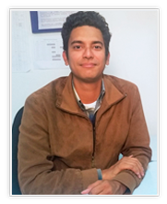 Biography (150 word limit)
Medical Doctor graduated from the National University of Colombia. Master's Degree in Clinical Epidemiology from the National University of Colombia. With an interest in statistical analysis of clinical studies and systematic reviews. Currently he is an assistant instructor in the Research Division. Linked to the FUCS since May 2016.
Email: jpalzategr@fucsalud.edu.co
Notes/Comments:

