Frailty Status and Its Association with Physical Function, and Disability in Elderly Patients with Lumbar Spinal Stenosis: A Cross-Sectional Study
Hanife BAYKAL ŞAHİN, Asist. Prof., Karadeniz Technical University, TÜRKİYE

Abstract
Background: Lumbar spinal stenosis (LSS) is a leading cause of pain, disability, and impaired mobility in older adults. Frailty reflects reduced physiological reserve and may substantially influence functional outcomes in this population. However, the relationship between frailty and functional impairment in elderly patients with LSS has not been sufficiently characterized. Aim: To investigate the association between frailty status and pain, physical function, and disability in elderly patients with LSS. Methodology: This cross-sectional study included 107 patients aged ≥65 years with clinically diagnosed LSS. Frailty was assessed using the Clinical Frailty Scale (CFS) and patients were categorized as non-frail (CFS 1–4) or frail (CFS ≥5). Pain severity was evaluated using visual analog scales (VAS) for low back pain, leg pain, and numbness. Physical function was assessed with the 6-minute walk test (6MWT) and hand-grip strength. Disability was measured using the Oswestry Disability Index (ODI). Multivariable linear regression analyses were performed to examine the independent association of frailty with ODI and 6MWT after adjustment for age, sex, and body mass index. Results: The mean age was 71.8 ± 5.8 years, and 68.2% of participants were female. Frail patients (n=46) were older, more frequently female, had longer disease duration, higher pain scores, lower walking distance, reduced hand-grip strength, and greater disability compared with non-frail patients (all p<0.01). In multivariable analyses, frailty was independently associated with higher disability (β=+18.9, 95% CI 12.9–25.0; p<0.001) and reduced physical function (β=−110.6 m, 95% CI −151.6 to −69.6; p<0.001). Both models demonstrated good explanatory power (adjusted R²=0.57 for ODI and 0.51 for 6MWT). Conclusion&Significance: Frailty is a strong and independent determinant of disability severity and physical function in elderly patients with LSS. Routine frailty assessment may improve risk stratification and help guide individualized management and rehabilitation strategies in this population.
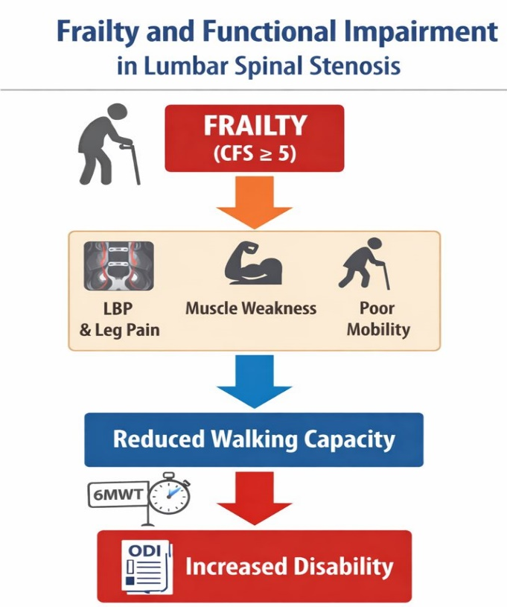

Recent Publications
- Kim, H. J., Park, S., Park, S. H., et al (2019). The prevalence and impact of frailty in patients with symptomatic lumbar spinal stenosis. European spine journal 28(1), 46–54.
- Nagai, S., Kawabata, S., Michikawa, T., et al (2024). Association between frailty and locomotive syndrome in elderly patients with lumbar spinal stenosis: A retrospective longitudinal analysis. Geriatrics&gerontology international, 24(1), 116–122.
- Sugimoto, S., Nagai, S., Ito, et al (2023). The Impact of Frailty on Surgical Outcome of Patients with Lumbar Spinal Canal Stenosis. Spine surgery and related research, 8(2), 188–194.
- Chan, V., Wilson, J. R. F., Ravinsky, R., et al (2021). Frailty adversely affects outcomes of patients undergoing spine surgery: a systematic review. The spine journal : official journal of the North American Spine Society, 21(6), 988–1000.
- Church, S., Rogers, E., Rockwood, K., & Theou, O. (2020). A scoping review of the Clinical Frailty Scale. BMC geriatrics, 20(1), 393.

 Biography
Dr. Hanife Baykal Şahin is a physician specializing in Physical Medicine and Rehabilitation with a clinical and research focus on spine disorders, geriatric rehabilitation, and cardiopulmonary rehabilitation. She is actively involved in clinical research evaluating functional capacity, pain, and quality of life in musculoskeletal conditions, with particular emphasis on aging populations and individualized rehabilitation strategies.
Email: baykalhanife@gmail.com

