ENDOSCOPIC SPINE SURGERY FOR SPINAL STENOSIS AS PALLIATIVE CARE - TRANS-SAP UNDER ANALGOSEDATION
Dr Miguel Loureiro, MD, Hospital das Forças Armadas Porto, Hospital Lusíadas Porto e Braga, Centro Hospitalar Universitário de São João, Porto, Portugal

Abstract (300 word limit)
The author presents a case of severe L5-S1 foraminal stenosis causing hyperalgic sciatic pain in a patient with metastasized breast cancer with co-morbidities precluding general anesthesia and prone position. CT guided foraminal injection was tried, with only about 12 hours relief. A modification of the transforaminal endoscopic approach, the trans-SAP, was performed under erector spinalis block and mild sedation in lateral decubitus position. It envolves docking the access needle on the SAP and not on the foramen an it is safer for stenosis cases where the exiting nerve root is sitting in the lower part of Kambin’s triangle, making a classic transforaminal approach not feasible. The patient tolerated the procedure well with complete pain resolution. The specifics of the surgical technique and analgosedation protocol is described and illustrated. This case demonstrates the feasibility and efficacy of endoscopic spine surgery under analgosedation for frail patients with severe co-morbidities, even those referred to palliative care, to alleviate suffering with a micro-invasive but effective procedure.

Image

Recent Publications (minimum 5)
- Hasan S, White-Dzuro B, Barber JK, Wagner R, Hofstetter CP. The Endoscopic Trans-Superior Articular Process Approach: A Novel Minimally Invasive Surgical Corridor to the Lateral Recess. Oper Neurosurg (Hagerstown). 2020 Jul 1;19(1):E1-E10. doi: 10.1093/ons/opaa054. PMID: 32281629.
- Yeung A, Gore S. Endoscopic foraminal decompression for failed back surgery syndrome under local anesthesia. Int J Spine Surg. 2014 Dec 1;8:22. doi: 10.14444/1022. PMID: 25694939; PMCID: PMC4325507.).
- Kang TH, Kim WJ, Lee JH. Efficacy of the erector spinae plane block with sedation for unilateral biportal endoscopic spine surgery and comparison with other anesthetic methods. Acta Neurochir (Wien). 2023 Sep;165(9):2651-2663. doi: 10.1007/s00701-023-05643-1. Epub 2023 Jun 6. PMID: 37278922.).
- Peng J, Zhang W, Wu Y, Ma Y, Qie W, Xu B. Effects of bilateral erector spinae plane block for posterior lumbar spine surgery in elderly patients. Zhong Nan Da Xue Xue Bao Yi Xue Ban. 2023 Feb 28;48(2):206-212. English, Chinese. doi: 10.11817/j.issn.1672-7347.2023.220151. PMID: 36999467..
5. Qiao L, Liu JY, Tang XB, Liu HT, Wei D, Zhu ZQ, Wang YQ. The Trans-Superior Articular Process Approach Utilizing Visual Trephine: A More Time-Saving and Effective Percutaneous Endoscopic Transforaminal Lumbar Discectomy for Migrated Lumbar Disc Herniation. Turk Neurosurg. 2022;32(4):612-617. doi: 10.5137/1019-5149.JTN.34049-21.3. PMID: 34936072..

Photograph

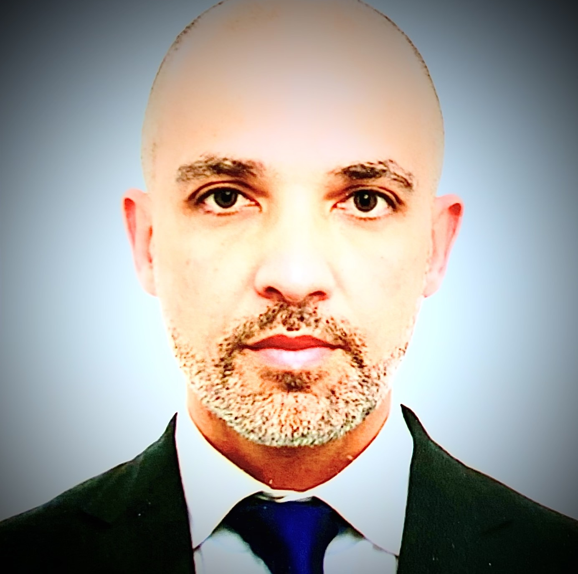Biography (150 word limit)
Dr. Miguel Loureiro is an Orthopedic Surgeon from Portugal specialized in Spine Surgery, with a focus on endoscopy. He is a member and Faculty of ESPINEA, Endoscopic Spine Academy, and works both in public and private setting in the city of Porto. He is the Head of the Orthopedic Department of the Armed Forces Hospital and leads an Endoscopic Spine Unit in Hospital Lusíadas. He has an interest in healthspan, physical exercise and meditation. He is married and the father of three beautiful kids.

Email: amigues.loureiro@icloud.com

Notes/Comments:

