Benefits of the Enhanced Recovery After Surgery Program in Short-Segment Posterior Lumbar Interbody Fusion Surgery
Dr Xin Wang, PhD, Lanzhou University, China

Abstract (300 word limit)
Statement of the Problem: Enhanced recovery after surgery (ERAS) is a multimodal, evidence-based approach to perioperative care that aims to reduce physiological and psychological stress, improve the quality of rehabilitation, and speed up the recovery of patients. Our study aims to investigate the benefits of perioperative use of ERAS for a short-segment posterior lumbar interbody fusion. Methodology & Theoretical Orientation: We selected two 1-year periods: the first from before the establishment of the multidisciplinary ERAS team in January 2017 (pre-ERAS year 2016) and the second period when ERAS was applied widely in our hospital (ERAS year 2019). Data were collected from the electronic medical records of patients who had undergone a short-level posterior lumbar interbody fusion during these 2 periods. The primary outcomes were postoperative complications, length of hospital stay, and off-bed time. Findings: A total of 207 patients were included; 95 patients in the pre-ERAS group were compared with 112 patients in the ERAS group. There was no significant difference between the 2 groups in baseline demographic. Patients in the ERAS group had significantly shorter length of hospital stay, off-bed time, and earlier drainage tube and catheter removal time. The rate of postoperative complications differed significantly between the pre-ERAS and ERAS groups. Patients in the ERAS group had significantly less intraoperative blood loss, financial cost, and opioid consumption than patients in the pre-ERAS group. The visual analog scale and Oswestry Disability Index scores, similar at baseline, were significantly lower in the ERAS group at postoperative day 3. Conclusion & Significance: The benefits of our ERAS protocol for patients undergoing short-level posterior lumbar fusion are evident in terms of reduced hospital stay and time to get out of bed, reduced incidence of postoperative complications, intraoperative blood loss, opioid use and hospital costs, and improved early postoperative pain and dysfunction.
Image
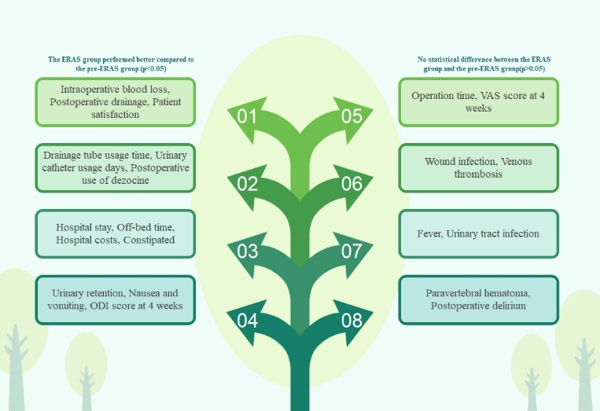
Recent Publications (minimum 5)
- Wang X, Sun J, Tan J, et al. Effect of sIL-13Rα2-Fc on the progression of rat tail intervertebral disc degeneration[J]. Journal of Orthopaedic Surgery and Research, 2019, 14(1): 1-10.
- Wang X, Tan J, Sun J, et al. Transcriptomics Study to Determine the Molecular Mechanism by which sIL-13Rα2-Fc Inhibits Caudal Intervertebral Disc Degeneration in Rats[J]. BioMed Research International, 2020, 2020.
- Shang Z, Li D, Chen J, et al. The Role of Biodegradable Magnesium and Its Alloys in Anterior Cruciate Ligament Reconstruction: A Systematic Review and Meta-Analysis Based on Animal Studies[J]. Frontiers in bioengineering and biotechnology, 2021, 9.
- Shang Z, Li D, Chen J, Wang R, Wang M, Zhang B, Wang X and Wanyan P (2022) What Is the Optimal Timing of Transplantation of Neural Stem Cells in Spinal Cord Injury? A Systematic Review and Network MetaAnalysis Based on Animal Studies. Front. Immunol. 13:855309.
5. Shang Z, Wang R, Li D, Chen J, Zhang B, Wang M, Wang X and Wanyan P (2022) Spinal Cord Injury: A Systematic Review and Network MetaAnalysis of Therapeutic Strategies Based on 15 Types of Stem Cells in Animal Models. Front. Pharmacol. 13:819861.
Photograph

Biography (150 word limit)
Dr. Wang is an expert in the field of spine surgery. He has long focused on the field of minimally invasive spine surgery and has achieved rich research results. After years of dedicated research and practice, he applied the concept of enhanced recovery surgery to the field of spine surgery. This concept has brought more promising treatment methods for patients with degenerative lumbar spine diseases such as lumbar disc herniation and lumbar spondylolisthesis, and has been widely praised by patients. At the same time, he organized this concept into a research paper and communicated with his colleagues, which was widely appreciated.
Email: wangxinldyy@126.com

Notes/Comments:

