Transforaminal injection with autologous platelet-rich plasma in lumbar disc herniation: a single-center prospective study in Vietnam.
Viet-Thang Le MD, PhD, Luan Trung Nguyen Dao MD, Anh Minh Nguyen MD, PhD
Abstract

Statement of the Problem: Lumbar radiculopathy is a major health problem, which often treated by neurosurgery or guided lumbar epidural steroids for pain relief. We used autologous Platelet Rich Plasma (PRP) as a novel pharmaceutical agent that has strongly emerged in recent years to treat patients of lumbar disc herniation. From that, we evaluated the efficacy of PRP via transforaminal route in treatment of radicular pain in patients with lumbar disc herniation. Methodology and Theoretical Orientation: Twenty-five patients were enrolled and injected with 4 ml of autologous platelet rich plasma under fluoroscopic guidance via transforaminal epidural injection into area of affected nerve root. They were followed using Visual Analogue Scale (VAS), Modified Oswestry Disability Index (ODI) and Straight Leg Raising Test (SLRT) for clinical assessment. Findings: Patients who received transforaminal injections with autologous PRP showed statistically significant improvements on all three evaluation tools (VAS, ODI, SLRT). The improvements were sustained over twelve-month follow-up and there were no associated complications. Conclusion & Significance: Transforaminal injection with autologous PRP helps patients relieve chronic pains and be able return to work. Besides, autologous PRP can be considered as a good alternative to epidural steroids in management of lumbar disc herniation.
Image
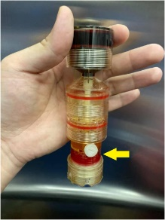
Fig. 1. Autologous Platelet-Rich Plasma (Yellow arrow points out the layer of PRP).
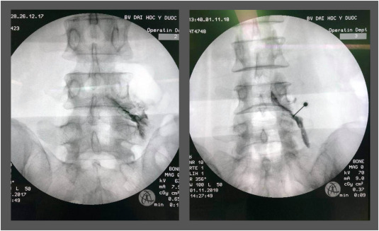
Fig. 2. Transforaminal epidural injections.
Recent Publications
1. Ruiz-Lopez R, Tsai YC. A Randomized Double-Blind Controlled Pilot Study Comparing Leucocyte-Rich Platelet-Rich Plasma and Corticosteroid in Caudal Epidural Injection for Complex Chronic Degenerative Spinal Pain. Pain practice : the official journal of World Institute of Pain. 2020;20(6):639-646.
2. Bise S, Dallaudiere B, Pesquer L, et al. Comparison of interlaminar CT-guided epidural platelet-rich plasma versus steroid injection in patients with lumbar radicular pain. European Radiology. 2020;30(6):3152-3160.
3. Xu Z, Wu S, Li X, Liu C, Fan S, Ma C. Ultrasound-Guided Transforaminal Injections of Platelet-Rich Plasma Compared with Steroid in Lumbar Disc Herniation: A Prospective, Randomized, Controlled Study. Neural Plasticity. 2021;2021:5558138.
4. Centeno C, Markle J, Dodson E, et al. The use of lumbar epidural injection of platelet lysate for treatment of radicular pain. J Exp Orthop. 2017;4(1):38-38.
5. Ashkan K, Jung J, Velicu AM, et al. Neurosurgery and coronavirus: impact and challenges—lessons learnt from the first wave of a global pandemic. Acta Neurochir (Wien). 2021;163(2):317-329.

Photograph

Biography
Dr Viet-Thang Le am working at department of Neurosugery, University Medical Center, Ho Chi Minh City, and Faculty of Medicine, University of Medicine and Pharmacy, Ho Chi Minh City, Vietnam. He is passionate about minimally invasive pain management, with nearly 10 years of experience in the field.
Email: drlevietthang@ump.edu.vn

