Modified lateral approach for foraminal/extraforaminal lumbar disc herniation at L5-S1 level.

Mohammed Mourad¹, Ahmed R. Rizk^{1,2}.
- Department of Neurosurgery, Faculty of Medicine, Benha University, Egypt
- Department of Neurosurgery, der Barmherzigen Brüder Hospital Trier, Germany

Background:
Far-lateral extraforaminal lumbar disc herniation is a rare cause of nerve root compression. The purpose of this study is to focus on L5-S1 foraminal/extraforaminal lumbar disc as well as to analyze the outcome of surgical management via the lateral approach.
Methods:
This study included 42 patients with foraminal or extraforaminal disc herniations at L5-S1 level who underwent unilateral L5-S1 paraspinal decompression from 2016 March to 2020 July at Banha university hospitals and Brüder hospital Trier. All medical charts of the included patients were reviewed and analyzed regarding clinical presentation, complete neurological examination, operative findings, complications, and short-term outcome. Subjective postoperative satisfaction was analyzed based on MacNab classification into excellent (no pain), good (some pain), fair (moderate pain), and poor (unchanged or worse).
Results:
Preoperative sensory and motor deficits show obvious improvement in the majority of patients. At short-term follow-up, major and moderate leg pain had decreased from 100% (42 patients) to 24% (10 patients) and low back pain improved from 69%(29 cases), to 7 % (3 patients). Motor weakness showed significant improvement in 24 patients out of 30 patients (80%).The functional outcome according to McNab criteria was documented in form of; 16 patients showing excellent, 12 patients showing good, and 6 patients showing fair outcome.

Conclusions:
Orientation of the pathology, proper diagnostic imaging as well as familiarity of the approach are significant factors for patient’s improvement. Our modified lateral approach is a minimally invasive and safe procedure with low complication rates.

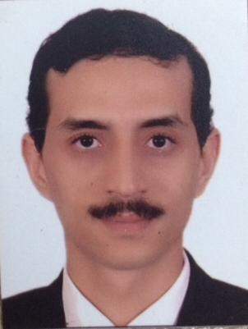

Photograph

Biography:
Dr.Mourad has worked in Banha University hospital since 2008. Now he is occupied lecturer position. He is known as a highly motivated person. He gained respect and appreciation from his colleagues and patients as well. He got his training in Germany undersupervision of prof.Marcos Tatagiba – Tübingen University.

Email: morademan@yahoo.de
Mobile no/Whatsapp no: +201558445071

Additional Details
Abstract Category: Speaker

