Free Hand Technique For Lateral Mass Screws Insertion; A Safe, Accurate, and Simple Procedure For Posterior Cervical Spine Fixation.

Mahmoud Wahdan M.D & Mohammed Morad M.D,PhD.
Neurosurgery department, Faculty of Medicine, Benha university, Benha, Egypt

Abstract
Posterior cervical fixation techniques are commonly performed procedures in the surgical management of subaxial cervical spine diseases. Lateral mass screw fixation became the standard method for posterior cervical spine fixation. It is considered an optimum method for cervical stability reconstruction following posterior cervical decompression.

Patients and methods :
30 patients with cervical canal stenosis and multiple disc prolapse were operated on in Benha university hospitals with 172 lateral mass screws inserted with freehand technique through a midline posterior approach. Post-operative computed tomography CT scans were used to assess the accuracy and safety of the free hand technique.
Results :
One hundred seventy tow screws were inserted in 30 patients with an average of 6 screws per case. A post-operative CT scan was done to assess the position and trajectory of the screws as well. 172 screws inserted easily and correctly with no complications while 8 screws were failed to be inserted because of a violation of the lateral mass during the insertion. No vascular nor neurological complications were encountered in the post-operative period or the follow-up period.

Conclusion
The freehand technique is a safe technique to insert lateral mass screws with a very good post-operative purchase and a high level of safety and feasibility.

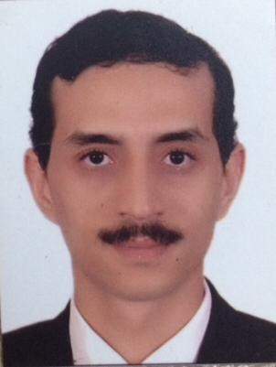

Photograph

Biography:
Dr.Mourad has worked in Banha University hospital since 2008. Now he is occupied lecturer position. He is known as a highly motivated person. He gained respect and appreciation from his colleagues and patients as well. He got his training in Germany undersupervision of prof.Marcos Tatagiba – Tübingen University.

Email: morademan@yahoo.de
Mobile no/Whatsapp no: +201558445071

Additional Details
Abstract Category: Speaker

