The relationship between extensor muscle volume and lumbar lordosis in patients with chronic back pain.
Dr Connie Hsu, MD, Spaulding Rehabilitation Hospital, Harvard Medical School
Dr Zacharia Isaac, MD, Spaulding Rehabilitation Hospital, Harvard Medical School

Abstract
Objective: To test the hypothesis that the volume of the extensor muscles of the lower spine (Erector Spinae and Multifidus) are associated with variations in lumbar lordosis in patients with chronic back pain. Methods: New patients with chronic back pain evaluated in our Spine clinic with recently completed MRIs and X-rays of the Lumbar Spine were included in the study. Lordosis angle measurements were obtained using Cobb’s method. Cross-sectional area of trunk muscles were conducted on MRI scans, excluding areas of bright white fatty atrophy on imaging, then summated across levels to create the variable “Lumbar Extensor Muscle Volume”. Correlation analyses were conducted to examine associations among demographics and study variables. Pearson’s Product Moment correlation analyses were conducted to examine correlations between Extensor muscle volume and Lumbar Lordosis angles. Regression analyses were conducted to examine if Extensor muscle volume is a significant predictor for variations in lumbar lordosis in patients with chronic back pain.
Results: The total sample was comprised of 20 patients (ages 22-78) who were predominantly female (75%) with an average BMI of 30.2. Preliminary analyses indicated that being female (r=.606, p < 0.01) and shorter (r=.600, p < 0.01) were associated with higher lumbar lordosis angles. Controlling for sex and BMI, Extensor muscle volume was found to be significantly associated with decreased lumbar lordosis angle (r = -.486, p < 0.05). From our regression analysis, Extensor muscle volume was a significant predictor for decreased lumbar lordosis angle (R Squared = .512, coefficient = -.463, p < 0.05).
Conclusion: This study concluded that extensor muscle volume is a significant predictor for decreased lumbar lordosis angle in patients with chronic back pain, which is the opposite effect seen in similar studies conducted on healthy patients. Further studies will be required to investigate an explanation for these novel findings.

Image
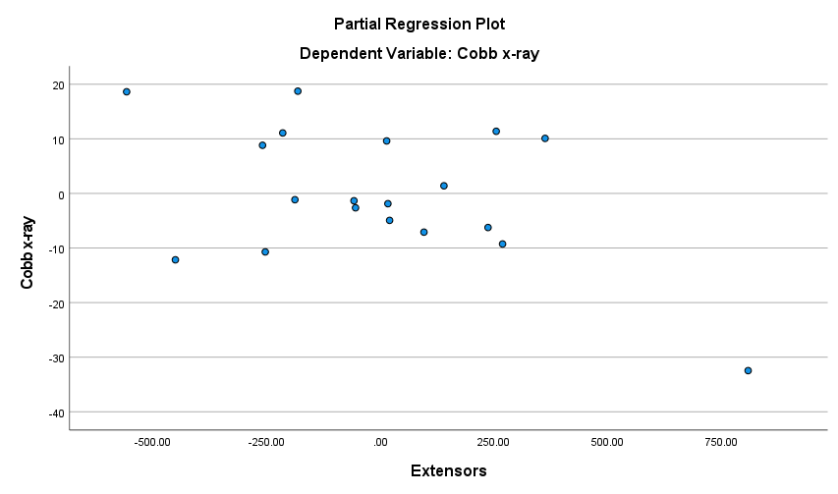
Figure 1: Partial regression plot showing a negative association between Extensor muscle volume and degree of lumbar lordosis
Recent Publications
- Hsu, C., Castillo, E., & Lieberman, D. (2015). The relationship between trunk muscle strength and flexibility, intervertebral disc wedging, and human lumbar lordosis. THURJ, 8(1), 35-41.
- Hsu, C., Loecher, N., Park, A. L., & Simons, L. E. (2021). Chronic pain in young athletes: The impact of athletic identity on pain-related distress and functioning. The Clinical Journal of Pain, 37(3), 219-225.
- Castillo, E. R., Hsu, C., Mair, R. W., & Lieberman, D. E. (2017). Testing biomechanical models of human lumbar lordosis variability. American Journal of Physical Anthropology, 163(1), 110-121.
- Romman, A. N., Hsu, C. M., Chou, L. N., Kuo, Y. F., Przkora, R., Gupta, R. K., & Lozada, M. J. (2020). Opioid prescribing to Medicare Part D enrollees, 2013–2017: Shifting responsibility to pain management providers. Pain Medicine, 21(7), 1400-1407.
- Timmers, I., Quaedflieg, C. W., Hsu, C., Heathcote, L. C., Rovnaghi, C. R., & Simons, L. E. (2019). The interaction between stress and chronic pain through the lens of threat learning. Neuroscience & Biobehavioral Reviews, 107, 641-655.

Photograph

Biography
Dr. Hsu is a resident physician at Spaulding Rehabilitation Hospital. She became interested in Physical Medicine and Rehabilitation after sustaining a back injury after swimming collegiately at a Division 1 University. Since then, she has been involved in several research projects involving the spine. She is planning on pursuing a career in neurorehabilitation after graduating residency.
Email: cmhsu@partners.org

Notes/Comments:

