CHARACTERISTIC OF ADOLESCENT IDIOPATHIC SCOLIOSIS PATIENTS IN ORTHOPAEDIC POLYCLINIC RSUP DR. M. DJAMIL PADANG
Syifaurrahmah, S.Ked, Andalas University, Indonesia
Dr. dr. Roni Eka Sahputra, SpOT (K-Spine), Andalas University, Indonesia

Abstract
The spine is a central structure that supports body. Spinal disorders or defects could affect movement. Adolescent Idiopathic Scoliosis is the most common spinal deformity in adolescents with estimated prevalence 0.47 - 5.2% in the world. AIS could cause physical limitations, disruption of body image and psychosocial. This research was an observational descriptive study using a cross-sectional retrospective method. Using medical status and radiological examination results of AIS patients in Orthopaedic Polyclinic of RSUP Dr. M. Djamil Padang over 6 years. The number of research subjects was 31 AIS patients at range 10-20 years old, average age 15.13 years old (SD ± 2.3). Most of patients were female (93.5%) with ratio 14.5: 1. Menarche mostly was >13 years old (38.7%), with average 13.11 years old (SD ± 1.6). The commonest Risser sign level was Risser 4 (41.9%). The curve-side deviation of major curve was the rightward (83.9%). Most common curve type was Main Thoracic/Lenke 1 (70.9%). The apex mostly located at level Thoracal 8-9 (41.9%). Major scoliosis curves deviates >45 ° (83.9%) with average Cobb angle 61.87 ° (SD ± 23.1) and commonest management option was surgery (51.6%). Conclusion: The majority of their age was 13-15 years old, and female. Most menarche age was >13 years old with the commonest Risser Sign level on Risser 4. Mostly, major curve deviation was to the rightward with Main Thoracic curve types, and major curve deviations >45 °. Most common of Nash-Moe grade were Class 2. The commonest management was operations.

Image
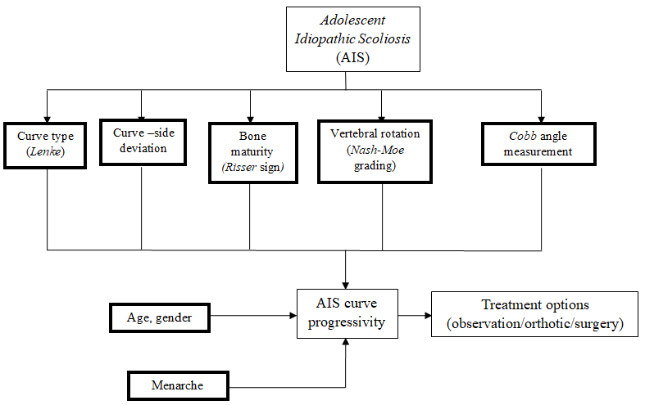
Recent Publications (minimum 5)
- Wong H-K., Tan K-J. The natural history of adolescent idiopathic scoliosis. Indian J. Orthop. 2010;44(1):9-13.
- Agung ISK, Purnomo SBD, Susilowati A. Prevalence Rate of Adolescent Idiopathic Scoliosis: Results of School-based Screening in Surabaya, Indonesia. Malays Orthop J. 2017; 11(3): 17–22.
- Lenke LG, Betz RR, Harms J, Bridwell KH, Clements DH, Lowe TG, Blanke K. Adolescent idiopathic scoliosis: a new classification to determine extent of spinal arthrodesis. J Bone Jt Surg Am 2001;83-A:1169–1181 3.
- Lenke LG, Edwards CC, Bridwell KH. The Lenke classification of adolescent idiopathic scoliosis: how it organizes curve patterns as a template to perform selective fusions of the spine. Spine. 2003;28(20):S199–207.
- Horne JP, Flannery R, Usman S. Adolescent Idiopathic Scoliosis: Diagnosis and Management. American Family Physician 2014;89(3):193-198.

Photograph

 Biography
Syifaurrahmah is a medical student at Faculty of Medicine Andalas University, currently she has just finished clinical rotation at RSUP DR. M Djamil Padang. She was actively engaged in Center for Indonesian Medical Student Activities (CIMSA) and achieved two national recognitions for the best exchange committee and the best project coordinator for standing committee on Professional Exchange in 2018-2019. For 3 years, she has been dedicating her time to volunteer as a part of surgical team in free circumcisions program organized by a social service organization in West Sumatera. A high appetite to deepen understanding in surgery, orthopaedics in particular, drives her to broaden her knowledge and unlock new skills.
Email: surrahmah@ymail.com

Notes/Comments:

