Title: The effectiveness of NeySi 3M long-term epidural electrical stimulation in patients with CRPS type 1
Author: Tsymbaliuk Iaroslav, MD, PhD, State Institution “A.P. Romodanov Institute of Neurosurgery of NAMS of Ukraine”, Kyiv, Ukraine
Co-authors: Nekhlopochyn Oleksii, MD, PhD, State Institution “A.P. Romodanov Institute of Neurosurgery of NAMS of Ukraine”, Kyiv, Ukraine
Cheshuk Ievhen, MD, State Institution “A.P. Romodanov Institute of Neurosurgery of NAMS of Ukraine”, Kyiv, Ukraine

Abstract (300 word limit)
Statement of the Problem: Chronic pain syndromes are a significant problem of society, which reduce the quality of life, social adaptation, has a negative impact on the psycho-emotional status of the patient. CRBS is no exception - it is one of the types of severe pain syndromes, which requires the choice of the optimal treatment type, which is not always an easy task. The purpose of this study is to evaluate the results of surgical treatment of patients with CRPS type 1 after implantation of systems for long-term epidural electrostimulation. Methodology & Theoretical Orientation: The results of treatment of 19 patients with type 1 CRBS with the use of epidural electrical stimulation by implantation of NeySi 3M devices manufactured in Ukraine were analyzed. The age ranged from 27 to 56 years. Gender distribution: 12 females (63,2%), males – 7 (36,8%). CRPS of upper extremities were found in 10 patients (52,6%), CRPS of lower extremities – in 9 patients (47,4%). The level of implantation in case of involving upper limbs – C5-C7 epidurally, in case of CRPS of lower limbs – Th7-Th12 epidurally. The patients underwent all the necessary complex of clinical and neurological examination, including The Budapest criteria, VAS pain scale and additional instrumental research (EMG, ENMG, neuroimaging methods). The effectiveness of epidural stimulation was evaluated at 3, 6, and 12 months after surgery. Findings: In terms of 6 months and later after surgery we got a significant results of pain relief in 16 (84,2%) of patients (from 8-10 of VAS to 1-3 of VAS) which means a noteworthy reduction of deep pain and allodynia. Conclusion & Significance: Long-term epidural electrostimulation can be considered as an encouraging method of relieving patients of pain and improves the life quality in case of CRPS type 1 pathology.

Image
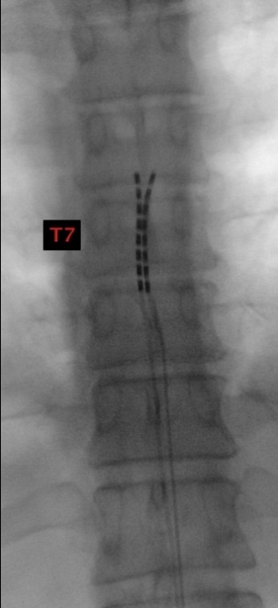
Fig. 1. Type 1 CRPS analgesic stimulation. The electrode is located at Th7 level.
Recent Publications (minimum 5)
- Gatskiy AA, Tretyak IB, Tretiakova AI, Tsymbaliuk YV. Choosing the target wisely: partial tibial nerve transfer to extensor digitorum motor branches with simultaneous posterior tibial tendon transfer. Could this be a way to improve functional outcome and gait biomechanics? J Neurosurg. 2019 Jun 7:1-9. doi:10.3171/2019.3.JNS182866. [Epub ahead of print] PubMed PMID: 31174188.
- Tsymbaliuk I, Medvediev V, Tsymbaliuk V, Tretyak І, Gatskiy О, Tatarchuk M, Draguntsova N. Comparative analysis of the nerve transfer methodologies used during surgical treatment of peripheral facial paresis. Current Issues in Pharmacy and Medical Sciences;2020;33(3):139-143. doi: https://doi.org/10.2478/cipms-2020-0025
- Tsymbaliuk VI, Strafun SS, Tretyak IB, Tsymbaliuk IV, Gatskiy AA, Tsymbaliuk YV, Tatarchuk MM. SURGICAL TREATMENT OF PERIPHERAL NERVES COMBAT WOUNDS OF THE EXTREMITIES. Wiad Lek. 2021;74(3 cz 2):619-624. PMID: 33843623.
- Nekhlopochyn OS, Verbov VV, Tsymbaliuk IV, Vorodi MV, Cheshuk IV. Neuropathic pain as a predictor of neurological disorders regression in patients with spinal cord traumatic injury. Pain Joints Spine. 2021;11(3):25-32. doi: 10.22141/2224-1507.11.3.2021.243047.
- Gatskiy, A. A., Tretyak, I. B., and Tsymbaliuk, Y. V. (2022). Transfer of the anterior C3 levator scapulae motor nerve branch for spinal accessory nerve injury: illustrative case. Journal of Neurosurgery: Case Lessons 3, 5, CASE21609, available from: < https://doi.org/10.3171/CASE21609> [Accessed 17 February 2022]
- PETRIV, T.; TATARCHUK, M.; RYBACHUK, O.; TSYMBALIUK, Y.; TSYMBALIYK, Y.; TSYMBALIUK, V. Eficacia y seguridad de las células madre / estromales mesenquimales del cordón umbilical en el tratamiento combinado de la esclerosis múltiple. Int. J. Morphol., 40 (1):143-147, 2022.

Photograph
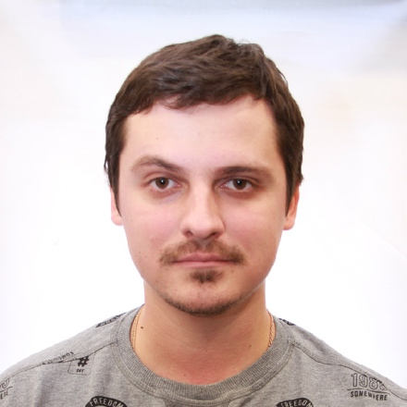
Biography (150 word limit)

Dr Iaroslav Tsymbaliuk works in the department of restorative surgery at The State Institution “A.P. Romodanov Institute of Neurosurgery of NAMS of Ukraine”, Kyiv, Ukraine. Medical Education: Bogomolets National Medical University, Kyiv, Ukraine, 2008-2014, graduated with honors, inscribed in The Book of Honor of the University
Residency: Department of Neurosurgery, Bogomolets National Medical University, Kyiv, Ukraine, 2014-2017 Research Activities: Postgraduate studies to achieve status of PhD from 2017 to 2020, topic of work: Surgical treatment of patients with facial nerve palsy. Currently working on obtaining the status of Doctor of Medical Sciences. Topic: Surgical treatment of gunshot injuries to peripheral nerves. Author of 89 scientific publications (including 10 patents). Responsible executor and participant of research works of State Institution “A.P. Romodanov Institute of Neurosurgery NAMS of Ukraine”, Kyiv, Ukraine (since 2016) Memberships: International member of the EANS (European Association of Neurosurgical Societies), member of UNA (Ukrainian Neurosurgical Association) Field of Interests: Neurosurgery of peripheral nerves, vascular neurosurgery, functional and stereotactic neurosurgery, minimally invasive treatment of acute and chronic pain syndromes, neuromodulation.

Email: yaroslav.neuro@gmail.com
Mobile no/Whatsapp no: +380937266066

Additional Details
Abstract Category: oral, track 17, minimally invasive spine surgery

