Thoracolumbar junction traumatic injury: what is the best classification to determine treatment tactics?
Oleksii S. Nekhlopochyn, MD, PhD, Department of spinal neurosurgery, Romodanov Neurosurgery Institute, Kiev, Ukraine
Vadim V. Verbov, MD, PhD; Iaroslav V. Tsymbaliuk, MD, PhD, Restorative Neurosurgery Department, Romodanov Neurosurgery Institute, Kyiv, Ukraine

The thoracolumbar junction is one of the most "typical" areas of traumatic changes when exposed to a mechanical load on the human body. Currently, a specific classification for injuries of the thoracolumbar junction has not been developed, therefore, when describing injuries in this zone, grading schemas characterizing the whole thoracic and lumbar spine are used.

Objective: to evaluate the influence of pathomorphological changes detalization level of the osteoligamentous apparatus on the tactics of treating patients with traumatic injury to the thoracolumbar junction.

Materials and methods. Within 96 cases of the thoracolumbar junction injury statistical data processing was performed using the Random Forest machine learning algorithm analyzing type of injury, neurological disorders and treatment tactics.

Results. When assessing the relationship between the nature of damage and the level of neurological disorders, the overall error rate for F. Magerl et al. and AOSpine classifications were 69.79% and 66.67% respectively. The nature of the injury makes it possible to unambiguously determine the optimal method of therapy using the classification of F. Magerl et al. with a probability of 58.33%, when applying the AOSpine classification - with a probability of 55.21%. When building models taking into account the nature of damage, the level of neurological disorders and McCormack criteria, it was found that the error in unambiguously determining the most effective method of treatment when using the classification of F. Magerl et al. is 26.04%, when using the AOSpine classification - 21.88%.

Conclusions. The type of the injury, ranked using the classifications of AOSpine and F. Magerl et al., does not allow choosing the optimal method for the treatment of traumatic lesion of the thoracolumbar junction. The use of additional predictors significantly improves the accuracy of the forecast. When applying the AOSpine classification, the best results were recorded.

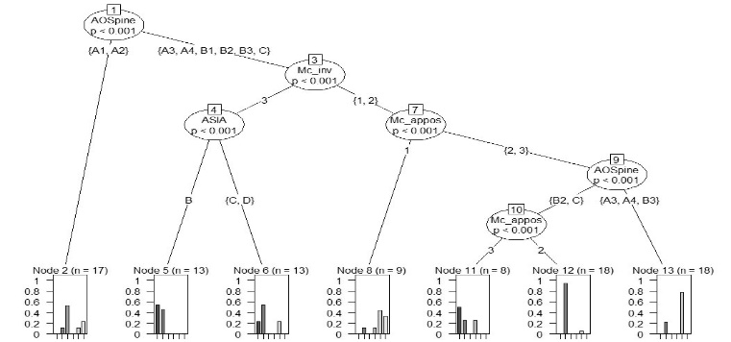
Fig. 1. The example of decision tree of random forest model

- Curfs I, Schotanus M, WLW VANH, Heijmans M, RA DEB, LW VANR, et al. (2020) Reliability and Clinical Usefulness of Current Classifications in Traumatic Thoracolumbar Fractures: A Systematic Review of the Literature. International journal of spine surgery 14(6):956-969.
- Mirza SK, Mirza AJ, Chapman JR, Anderson PA (2002) Classifications of thoracic and lumbar fractures: rationale and supporting data. J Am Acad Orthop Surg 10(5):364-377.
- Oner FC, Ramos LM, Simmermacher RK, Kingma PT, Diekerhof CH, Dhert WJ, et al. (2002) Classification of thoracic and lumbar spine fractures: problems of reproducibility. A study of 53 patients using CT and MRI. Eur Spine J 11(3):235-245.
- Pishnamaz M, Balosu S, Curfs I, Uhing D, Laubach M, Herren C, et al. (2018) Reliability and Agreement of Different Spine Fracture Classification Systems: An Independent Intraobserver and Interobserver Study. World Neurosurg 115:e695-e702.
- Verlaan JJ, Diekerhof CH, Buskens E, van der Tweel I, Verbout AJ, Dhert WJ, et al. (2004) Surgical treatment of traumatic fractures of the thoracic and lumbar spine: a systematic review of the literature on techniques, complications, and outcome. Spine (Phila Pa 1976) 29(7):803-814.



Dr. Nekhlopochyn Oleksii specialized in neurosurgery and traumatology. He is a researcher at the Clinic of Spinal Neurosurgery of Romodanov Neurosurgery Institute of National Academy of Medical Sciences of Ukraine. The main direction of scientific activity is the development and optimization of methods of therapy for patients with traumatic spine and spinal cord injuries.

Email: AlexeyNS@gmail.com
Mobile no/Whatsapp no: +380950330448

Additional Details
Abstract Category:

